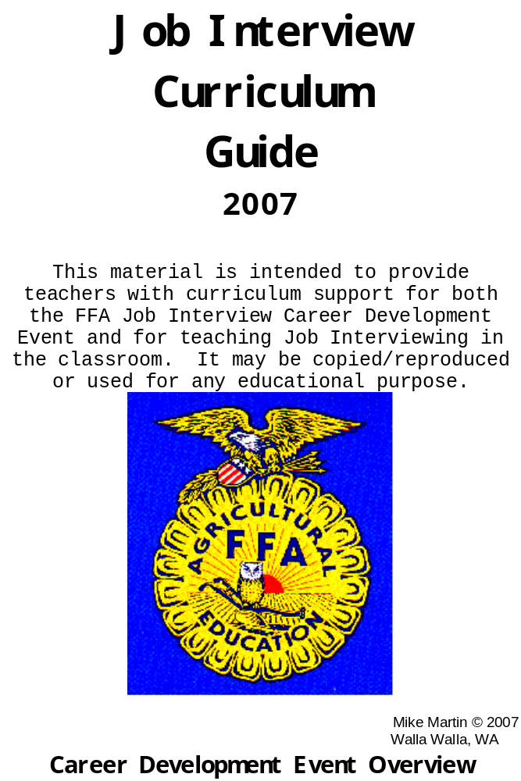

Table of Contents

 | Contest Overview | Page 3
Unit 1 | Resumes | Page 4
Unit 2 | Job Descriptions Cover Letters | Page 11
Unit 3 | Job Applications | Page 22
Unit 4 | Telephone Interview | Page 26
Unit 5 | Interviewing | Page 27
Unit 6 | Follow-Up Letter | Page 49
Unit 7 | Portfolio | Page 51
Unit 8 | National CDE Guidelines | Page 52
Unit 9 | Score Cards | Page 55
 | References | Page 60

Washington State 2007
Job Interview Career Development Event

The purpose of this CDE is to help participants in their current job search for SAE projects, part-time and full time employment. Therefore, the cover letter, resume and references submitted must reflect the contestant’s current skills and abilities. Contestants may select the career area of their choice.

**State Competition requires SIX copies of each of the
following**
- Cover Letters (addressed to Kari Toms Contest Coordinator, P.O. Box 2938, Olympia, WA 98507)
- Resume
- Reference letters
- The above (Cover Letters, Resume and Reference Letters must be RECEIVED by the State Executive Secretary by April 25, 2007 to be judged on May 1)

At contest time, each student will:
- Complete a job application
- Conduct a live job interview
Since the judges will have copies of the contestant’s cover letter, resume and three reference letters, the judges will already know the job the contestant is applying for before the student enters the interview room. The judges will ask each contestant the same 4 to 5 questions of each contestant.
- Write follow-up letter (on a computer)

In the finals round, job application, cover letter, follow-up letter and resume scores will follow with the contestant. Finals contestants will do a new interview and conduct a telephone interview.

As per National Job Interview Rules, Portfolios are NOT allowed.

Unit 1
Resumes

1. A resume is a summary of a person’s education, job objective, work history and personal history.

2. Reasons for having a resume.

- Helps you clarify your job objective
- Helps you summarize your skills and education
- Often times employers/personnel directors/human resource managers/interviewers request a resume
- A good resume communicates your skills to perspective employers
before an interview

3. Resume summary

- A good resume will get an interview
- A good resume grabs the reader’s attention. It shows him/her why they should hire you by focusing on your achievements.
- Ease of reading is a crucial, so your resume is read rather than discarded.
- The resume should take no longer than 10 to 15 seconds to be scanned
- As you create a resume be sure to promote your abilities.
- Keep it brief (preferably one page) and stress your achievements.

4. The heading

- Tell the employer who you are and where you can be contacted.
- At the top of the resume, list your name and address.
- At the top right, list your home phone number and if possible a message number or email address.

5. Job objective

- If you do not state one, how can you expect the employer to know what you want or are qualified for?
- Avoid being too specific or narrow on your objective, but at the same time, do not be too general like using the word “anything”
- If you have no real experience in that occupation, state that you are seeking an entry-level position as a...

6. Education and training

- Start with your most recent school. In the top give the date of completion, the degree or certificate awarded.
- On the second line, list the name of the school, and the school’s city, state and address.
- Directly under each school list three or four of the classes you
took which will interest the employer.
- If you have taken any special workshops or received any special awards or recognition that pertain to the job your applying for list
them as well.

7. Work history

- List your jobs in chronological order. Remember it looks good to have several jobs but too many may make you look flighty or a person who could not hold a job. A rule of thumb is a maximum of 4 and minimum of 2.
- Start with your most recent employer (on the first line), give the date you left, if your still employed list “present” and give your title.
- On the second line give the company’s name and it’s address.

Do not list your job functions, but instead list the
accomplishments you are the most proud of.

8. Personal background
- 2 options are available when referring to references

# 1 Do not list any references on your resume. State on bottom
line of resume... “References available upon request”...

#2 Do list your references on the bottom of your resume.

- You do not have to explain your age, sex, race, marital status or handicaps to anyone. That is the law.
- You may wish to list things such as:
“I am reliable, hard working and good with people.”
“I have excellent references. learn quickly and I am
willing to relocate.”

9. References

- Before you offer anyone’s name make sure you have that person’s permission to do so.
- You may wish to simply say “May I use your name as a reference?”
or “Would you feel comfortable if I use you as reference?”.

10. There are two styles of resumes

Chronological -see sample on page 6

This style of resume begins with your most recent work experiences and moves back in time. This type of format is the traditional one that has been used for many years. It is a good format if you have had several years of experience in the work place. Also, it has the advantage of being completed in about an hour.

Heading Your name, address and phone
Job objective Job your applying for
Education & training School and training
Experience Where you have worked

Skills – see sample on page 7

A skills resume is often called a functional resume. In this type of
resume, your experience is organized under key skills rather than jobs you have held. In a well done skills resume, these same
skills are the one you need to succeed on your preferred job.

Heading Your name, address, and phone

Job objective Job your applying for

Education & training School and training

Experience Where you have worked & accomplishments

Sample Resume
The Chronological Resume

Personal:
Abagail Roesler Born: March 24, 1986
1313 13th St. Health: Excellent
Anytown, Washington 99999 Marital Status: Single
Home Phone: (502) 716-2633 Email abcde@yahoo.com

Objective:
An entry level florist position.

Education:
Anytown High School, 800 Abbott Rd. Anytown, Washington 99999

Work Experience:
2000 to present: Assistant to Marketing Director, Happyville, WA
1999: Office assistant with ABC Marketing Company, Anytown, WA

References:

Phil Dirt  1005 Elm St  Anytown, WA 00000  509-555-1234 | Emery Cloth  1500 Alder St.  Mechanicsville, WA 99999  509-555-4321 | Slide Rule  1505 Maple St,  Happyville, WA 77777  Srule@yahoo.com
Sample Resume
Chronological Resume

John R. Doe
1313 13th St.
Anytown, WA. 99999
999-123-4567
johnrdoe@msn.com

Objective: Responsible position in feed store. Would consider position in sales or sales clerk.

Education: Anytown High School, 800 Abbott Rd. Anytown, WA 99999
Completed courses in Sales, Customer Relations and Computers. Participated school sponsored courses in Public Speaking and Sales.

Experience:

2001-present Anytown Feed Store
Assistant manager: assisting customers, handling customer complaints, inventory control and ordering.

2000 Anytown Feed Store
Sales clerk: assisting customers, stocking shelves and assisting with inventory.

Personal: Single Valid Drivers License

References:

Phil Dirt  1005 Elm St  Anytown, WA 00000  509-555-1234 | Emery Cloth  1500 Alder St.  Mechanicsville, WA 99999  509-555-4321 | Slide Rule  1505 Maple St,  Happyville, WA 77777  Srule@yahoo.com

Modified Skills Resume

Dan Druff
1313 13th Street
Walla Walla, WA 99362
509-527-3027
ddruff@yahoo.com

Objective: To obtain employment as an entry level florist

Education: Walla Walla High School (Graduate 2001)
800 Abbott Rd.
Walla Walla, WA 99362

Emphasis placed in Agri-Business and Floral

Work 2000 – Present
Holly’s Flowers
Anytown, WA

1999 – 2000
Onions R Us
Anytown, WA

1998-1999
Narum Concrete
Anytown, WA

Interests: Winter Sports Floriculture
Music

References:

John Deer  1313 13th St.  Anytown, WA 99362 | Phil Dirt  1234 Dirt Lane  Happyville, WA 99362 | Emery Cloth  1234 Cloth Rd  Farmington, WA 99362

Assignment: Resumes

Name_____________________

This will be a 2 part assignment. The first part will be for you to make a rough draft of your own personal resume. The second part of the assignment will be for you to make a final copy of your resume. This final copy is intended for your own personal use now and upon graduation. This will be of value as you apply for jobs or need to fill out scholarship applications. Make a minimum of 5 copies for your personal use.

Rough draft resume score sheet
(May be on notebook paper and in pencil)

Topic Points Score

Parts of a resume 10 _____
Technical correctness 10 _____
Spelling and grammar 10 _____
Neatness 10 _____
Quality of statements 10 _____
50
TOTAL _____

Final draft resume score sheet
(Must be typed)

Topic Points Score

Parts of a resume 20 _____
Technical correctness 20 _____
Spelling and grammar 20 _____
Neatness 20 _____
Quality of statements 10 _____
Five professional resumes 10 _____
100
TOTAL _____

Unit 2
Job Description
Cover Letter/Letter of Application

Objectives: Upon completion of the cover letter/letter of application unit you will be able to...

1. Understand the purpose of cover letters
2. Demonstrate the ability to write a cover letter

Information Page

Several examples of resumes and job descriptions are included in the following unit. Detailed descriptions of cover letters with a paragraph by paragraph break down that can be used as handouts or overheads are contained in this section.

Sample Job Description

Job Description

Entry Level Sales Person
Anytown Feed Store
1313 13th Street
Anytown, WA 99999
(509) 525-0000
Contact: Jerry Atrics/Manager
Wages: $9.00 per hour
Hours: Part time after school
Starts: ASAP

Description: The employee is responsible for working with customers, setting up displays and assisting with the general appearance of the store. Telephone skills and good customer relations are required.

Listed in the Agri. Times Northwest

Sample Job Description

Job Description

Sales Clerk
Larson’s Garden Center
1313 13th Street
Happyville, WA 00000
(509) 525-0000
Contact: Ima Creep/Personnel Director
Wages: $9.00 per hour
Hours: 8-5 Monday –Saturday
10 to 12 hrs. per day during peak spring planting season
Starts: May 1

Description: The employee will be responsible for working with customers, setting up displays and assisting with the general appearance of the premises, conducting inventories, loading and unloading vehicles plus delivering plants.

Listed in the High School counseling office

Sample Job Description

Job Description

Sales Clerk
Jim’s Hardware and Logging Supplies
1313 13th Street
Woodsville, WA 00000
(509) 525-0000
Contact: Dan Druff/Manager
Wages: $9.00 per hour
Hours: Part time after school & Saturdays
20 to 25 hours per week
Starts: Immediately

Description: The employee will be responsible for assisting customers, answering the telephone, setting up displays, conducting inventories, loading and unloading vehicles plus parts deliveries.

Listed Woodsville Gazette

Sample Job Description

Job Description

Entry Level Service Technician
Rocky’s Tractor Company
1313 13th Street
Mechanicsville, WA 00000
(509) 525-0000
Contact: Allen Wrench/Personnel Director
Wages: $9.50 per hour
Hours: Summer: 40+ hours a week
Part time after school
Starts: June 1

Description: The employee will be responsible for selling to customers, handling customer complaints/questions, answering the telephone, minor servicing of equipment, delivering parts and assisting with the general appearance of the premises.

Listed in the Mechanicsville Newspaper

Letter of Application - Cover Letter

The letter of application or cover letter is your letter of introduction. Because you want to make a good first impression, take the time to prepare a well written letter of application.

Address the letter to a specific person if possible. Make a phone call or two to find out who you should write to!

Introductory Paragraph

In the first paragraph, define the purpose of your letter, which is that, you are interested in the position available. Identify the title of the position and let them know where you learned of the opening (newspaper, friend, employment agency, etc...) be brief, but be clear.

Body of Letter

In the body of the letter, highlight your skills that are specific to the job you are applying for. Be sure to state you would be a good person for the position. Also, somewhere in the body of the letter refer to your resume (which would accompany the letter).

Closing Paragraph

This is a very short, but important paragraph. Be sure to ask for an interview and let them know how and when they may contact you. Be sure to include the area code in your telephone number.

Letter of application tips:

Be neat and use correct grammar!
Have another person proofread your letter for typo’s, spelling
errors, and basic grammar.

Do not send a photocopy. Use a letter quality printer and mail an original to each prospective employer.
Do sign the letter. It is an easy step to forget.

Cover Letter

Helpful Hints

- Be assertive
- The first words are the most important; they should attract the readers attention and give clear intent as to the purpose of your letter

- State your value to the employer
- State why you can contribute to the success of the employer

- Use direct and correct grammar
- Be specific and to the point
- Ask someone to proof read your letter

- Your letter should reflect your individuality
- You are writing to a stranger about a serious matter to both of you
- Avoid
- Humor
- Being too aggressive

- Send your letter to someone by name
- Determine who is to conduct your interview
- Then send your letter and resume

- Call first to obtain an interview
- Be clear as to what you want
- If you want an interview, then state it
- State clearly why they should consider you

- Be professional
- A professional, informal style is best
- Avoid the hire me now approach

- Target your letter
- Reason for sending a letter
- Responding to an ad
- Following up on a telephone call (best approach)

- Follow-up
- Direct contact with an employer is the most effective (phone call or person to person)

Don’t expect a letter to get you many interviews. They are best used to follow up after you have contacted the employer.

Sample Cover Letter

Return Address
City, State, Zip Code

Phone #
Date

Ms./Mr... Employer, Director
ABC Corporation
1000 Main Street
Anywhere, USA 00000

Dear

First paragraph: State why you are writing, name the position or type of work for which you are applying and mention how you heard of the position or the organization.

Second paragraph: Explain why you are interested in working for this employer and specify your reasons for desiring this type of work. If you have had experience be sure to point out your particular achievement or other qualifications in this field or type of work. Refer the reader to the attached application. If this paragraph becomes too lengthy break it into two paragraphs.

Third paragraph: Have an appropriate closing to pave the way for the interview by asking for an appointment, by giving your phone number, or by offering some similar suggestions to facilitate an immediate and favorable reply. You want the employer to take some action.

Sincerely.

Your name

Sample Cover Letter

Your street address
Your City, State, and Zip code
Your phone & message number
Today’s date

Mr. Jerry Atrics
Personnel Manager
Anytown Feed Store
1313 13th Street
Anytown, WA 99999

Dear Mr. Atrics,

I am applying for the position of entry level sales clerk as advertised in the latest Agri-Times Northwest.

My academic and work experiences have been directed toward a career
in Agri-Business. In high school my grades in agriculture and business
classes were excellent. I have participated in the sales contest where I
received a high score and represented our school in several contests.

I would appreciate an interview with you to discuss my qualifications for the position of entry level sales clerk. You may contact me by writing to the address above or calling (439) 555-1212. I look forward to hearing from you soon.

Sincerely,

Your name

Assignment Cover Letters

Name_______________________

This is a 2 part assignment. The first part make a rough draft of a cover letter. The second part of the assignment will be a final copy of a cover letter (use a computer) a cover letter. To receive full credit attach this score sheet to your resumes.

Rough draft cover letter score sheet
(May be in pencil, ink or computer generated)

Topic Points Score

Concise/professional format 10 _____
Ability to spark interest 10 _____
Spelling and grammar 10 _____
Targeted Skills 10 _____
Overall quality 10 _____
50
TOTAL _____

Final Copy
(Must be typed)

Topic Points Score

Concise/professional format 20 _____
Ability to spark interest 20 _____
Spelling and grammar 20 _____
Neatness 20 _____
Targeted skills 20
100
TOTAL _____

Unit 3

Job Applications

Information Page

Tips for completing your application

Read and follow directions carefully. Employers notice carelessness and assume that you will be similarly careless on the job. Work slowly and do it right.

Use a black erasable pen.

Always be honest.

Answer ALL questions. If it does not apply to you, either answer NA or draw a line through the box. [-----------] DO NOT LEAVE BLANK SPACES

If possible, take the application home and make several copies of the application. Practice filling out the copies, fill out the original and then double check for accuracy.

Be positive when filling out the application. If your truthful answer will result in a negative impression you may wish to use the phrase “Will explain later”.

Provide additional positive information. Since most applications do
not ask for your achievements or accomplishments look for a space to list them. Often times the work experience section will allow for this.

Position desired:

Applications often ask what sort of a job you want, what hours and days you want to work, the salary you expect, and other details. How you handle this can be very important. If you know of a specific job opening with this employer, you could use that job title. A safer approach would be to use the general career area or department that job is in. For example, if you were looking for a position as a warehouse manager, you might write “Business or shipping/receiving management or related tasks.” That approach would leave your options open to be considered for other jobs that might interest you. Saying “Anything” however, indicates you do not know what you want to do and will not impress an employer.

Your job objective defines how and what you emphasize on the rest of your application. If you want to work as a general maintenance employee, for example, you would emphasize experience working with your hands, training, and education that supports that job, even related hobbies. Consider every entry on your application and look for ways it can support your job objective.

Health information

Health - related absences and accidents are expensive to an employer, so you will often be screened out if you have had a history of either. The issue here is whether or not your health will keep you from doing a good job and being a dependable worker. Unless you have a problem that will keep you from doing a good job, you should say your health is “Excellent.” Do not mark “Fair” or “Good” without a good reason. Such responses will usually get you screened out.

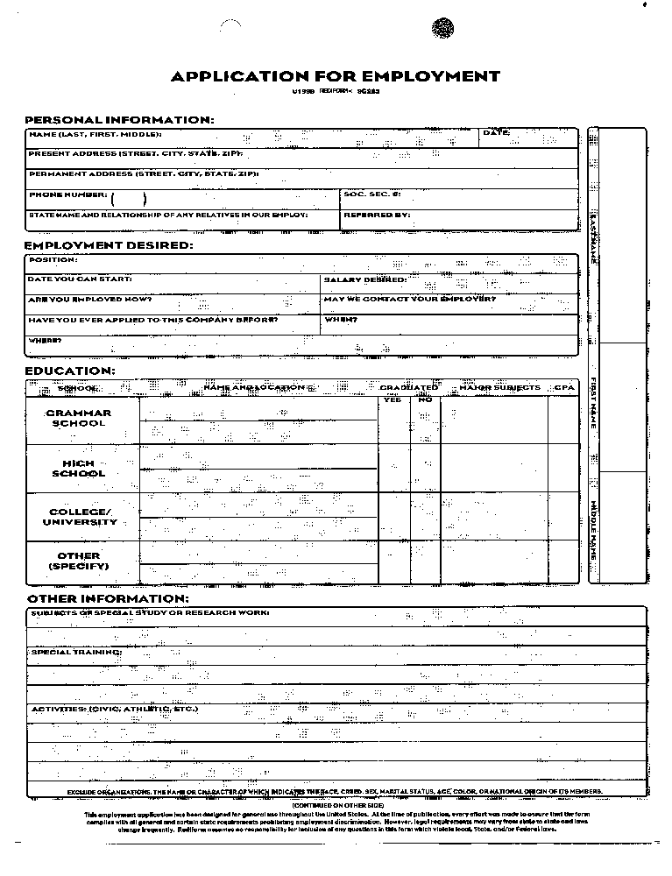

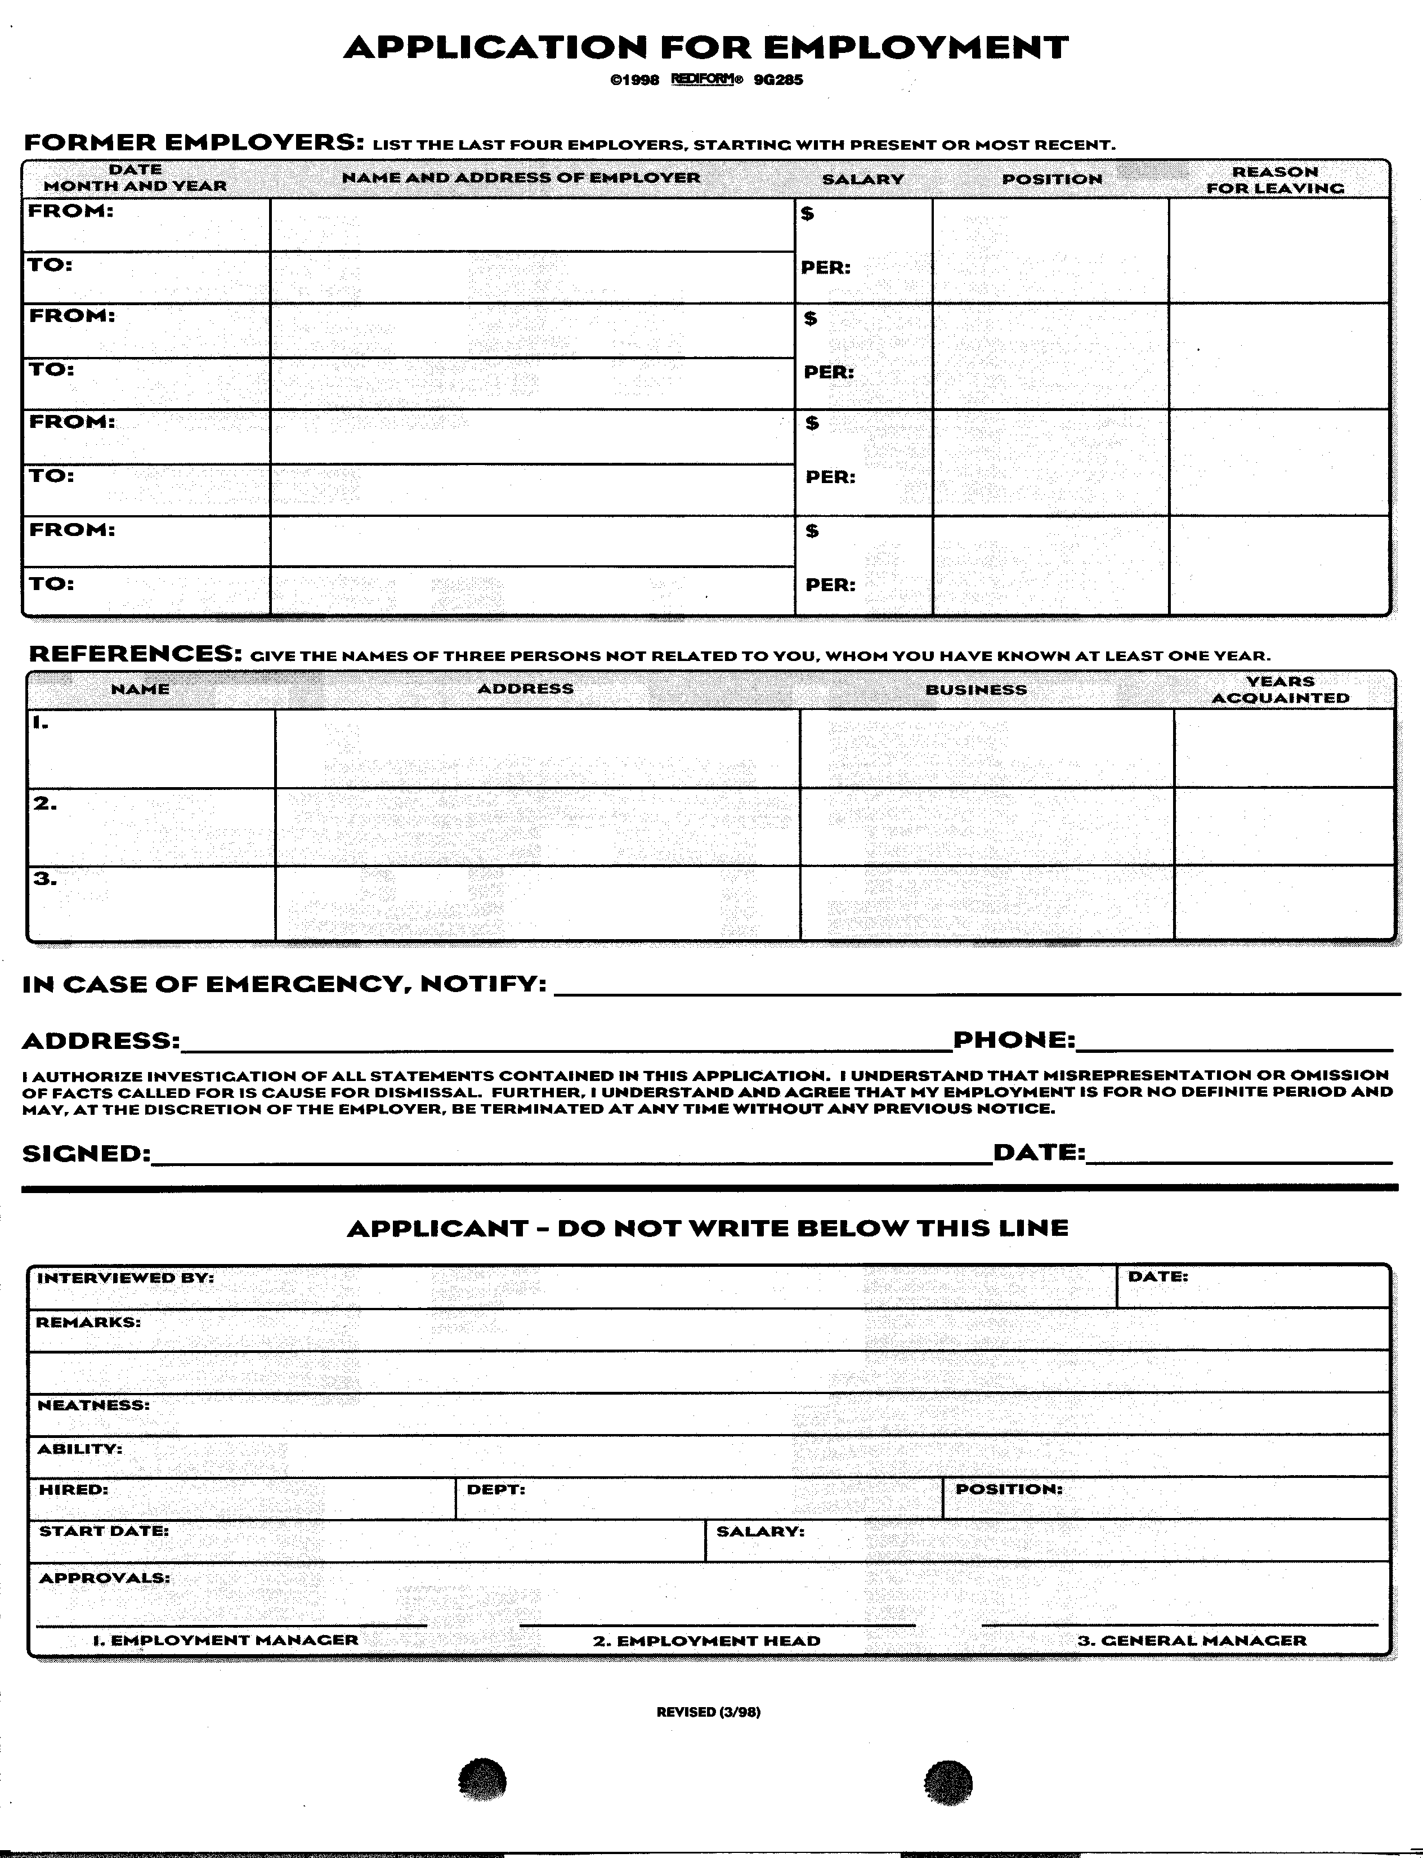
Unit 4
Telephone Interview

Sequence of events for the telephone portion of the Job Interview Contest

1 Students will interview with one of the following three people:

A Human, Fiscal and Resource personnel director

B Employer’s Assistant

C Employer

2 The telephone interview will last a maximum of three minutes

3 The contestant is to position themselves so they may obtain a personal interview with the company. The contestant is assume the company has already received their cover letter, resume and letters of reference.

4. The student should confirm the time, date and address of the interview.

Unit 5

Interviewing

Job interviewing can be non-threatening if you are properly prepared. Proper preparation will give you that extra confidence which will reward you with the job you really desire.

A good way for students (people) is to look at interviewing as a set of problems to hurdle. Listed below is a step by step problem solving approach to job interviewing.

Problem #1

How should I best prepare myself for the job interview?

1. Become informed about the company, know what it manufacturers, services, age of company, etc... in other words do research and be knowledgeable about the company.

2. Know the job description

3. Understand the necessary qualifications

4. Know the time lines for the hiring process

5. Find out the name of the person doing the interviewing

6. At least 1 day prior to the interview check out the building and parking

- Good grooming and dressing to industry standards is essential
to the successful applicant. Dress according to the job (work
clothes for a mechanics job, suit for office job)

8. Make a good first impression, job interviewers often think “This is the best this person is ever going to look”

9. A sloppy or poor appearance may be telling the interviewer, this person doesn’t take pride in him/herself and therefore would probably not do good quality work on the job.

Problem #2

How do I start the interview or what should I do as I first enter the room?

1. Look the interviewer in the eye, be careful not to stare

2. Smile

3. Greet the interviewer with a firm handshake

4. Wait to be invited to be seated or ask if you may sit

5. Sit up straight in the chair and look alert

6. Speak distinctly with complete sentences

7. Often times the interviewer will ask the ice breaker question “Tell me about yourself.”

8. Talk about those experiences that will make you a valued employee on this job

Problem #3

What are some dos and don’ts of a successful interview?

1. Do not start the interview off by asking about salary.

2. Do not criticize former employers.

3. Do be positive and stress how your skills will be an asset to the company.

4. Do be honest at all times.

5. Answer questions completely in full sentences. Do know it is time to stop when you notice you are starting to repeat yourself.

6. When asked about someone you both know, do acknowledge you know them but do not express an opinion of them.

7. Do not attempt to break the ice by telling jokes.

8. Do speak with a positive tone of voice.

9. Do not smoke, chew tobacco, chew gum or have anything in
your mouth.

10. Try to use the interviewer name.

Problem #4

Should I ask questions during the job interview? If so, what type?

This is a must! The interviewer wants you to ask a question so prepare yourself in advance.

1. How can my talents be best utilized to help this company?

2. If it is a delivery type of job or a job that requires you to be on the road it is appropriate to ask about vehicle reimbursement and/or if a company car is furnished.

- Only discuss salary/wages after the job has been offered or you
feel it is appropriate.

Problem #5

How do I end the interview?

1. Look the interviewer in the eye.

- Smile

3. Good/firm handshake.

4. Thank the interviewer for his/her time.

5. Thank the receptionist for his/her courtesy.

6. Send a follow up letter thanking the interviewer for the interview.

Questions/Answers of an Interview

Be prepared, practice questions and practice interviews

The three step process to answering interview questions

Step 1:

Understand what is really being asked. It usually relates
to the employer’s expectations, regarding your skills and
personality.

“Are you easy to get along with?”
“Are you dependable?”
“Are you a good worker?”

Step 2:

Answer the question briefly, in a non-damaging way.
Acknowledge the facts, present them as an advantage,
not a disadvantage.

Step 3:

Answer the real question by presenting your related skills.
Once you understand the employer’s real concern, you
can get around to answering the often hidden question by presenting your skills and experience related to the job.

Common Interview Questions

Question #1: Tell me about yourself?
(Often used as an icebreaker and is the most common question). Since you know this question will be asked, rehearse this until you feel confident. This will get your interview off to a good start!

The employer is asking how your talents will help his/her
company. You should state your training, education,
and experience

Question #2: Why should I hire you?
This is a direct and fair question. It is the driving question behind all other questions asked.

A direct question deserves a direct response. Why should
they hire you? This often involves providing proof that you
can help the company.

Question #3: What are your major strengths?

Your response should first emphasize your ability to adapt,
ability to work with people.,. Let the
interviewer know how your strengths will be of advantage
to his/her company.

Question #4: What are your major weaknesses?

This is a trick question. If you answer the question as it is
asked you could easily hurt your chances of getting the job.
By trying to throw you off, the interviewer maybe trying to
find out how you will handle difficult/tough situations.
A honest un-damaging response, followed by a short positive
statement to counter the negative is the best way to handle
this question. Statements like:
“I have been accused by co-workers as being
too involved in my work”
“I see myself as a little unorganized but I usually
come in a little early to organize my day.”

Question #5: What pay do you expect to receive?

** Three rules apply to this question **

Rule #1

Research salary ranges and know the salary range
for the type of job you are applying for.

Rule #2

Always bracket your stated salary range to begin with
the probable salary range and end a bit above what you
expect to settle for.

Rule #3

If you feel Rule #1 and #2 do not fit the situation, you may
ask “What pay do other employees receive with similar education and experience as I?”

If this is a professional job, with a layer of interviews, try to avoid salary or wage questions. However, if the wages were posted in the job description you may wish to negotiate your pay. REMEMBER, you are in the strongest position you will ever be to discuss pay with your employer

In the initial interview try avoiding getting nailed down on a
salary or hourly wage, unless the job type is such that it is appropriate.
Several examples are listed:

1. Are you making me a job offer?

2. What salary range do you pay for positions
with similar requirements?

3. I am very interested in the position and my
salary would be negotiable.

4. Tell me, what you have in mind for the salary range?

Question #6: What are your plans for the future?

The employer is trying to determine if you can be depended
on to stay on this job, if you will work hard at this job, if you
will be satisfied with the job, if you have family plans that will
affect your longevity and if you plan on moving up the
promotion ladder.

Question #7: What will your former employers have to say about
you?
(Teachers, reference, warden or keeper)

This question attempts to determine the employer’s
expectations of you. They want to know how easy you are
to get along with, are you a good worker, are you dependable,
and can you be counted on when the going gets tough?

Always discuss your job-search plans with former employers
and with anyone else who might be contacted for a reference.
Clearly tell them the type of job you now seek and why you are
prepared to do well in it. If a previous employer may say
something negative, discuss this openly with them and find out
in advance what they will say. If you were fired or asked to
resign still negotiate what will be said to a perspective employer,
Also, remember lots of successful people have had personality
conflicts with their employers. Sometimes it is a wise idea to
get a written letter of reference from a not-too-enthusiastic
employer. They rarely will write a negative letter.

If possible, use references that will say nice things about you.
If the boss won’t, find someone who will. Remember, “Honesty
is the best policy.” Tell it like it was at your old job but do not be too critical of your old boss. Doing that will make you sound like a person who blames others and does not accept responsibility.
Remember, you were partly at fault. Admit it but quickly take the opportunity to say what you learned from the experience.

Two options are available to you. Option number one is the best but does not fit all situations.

Option #1

I am looking to work for a company with a positive
track record that provides job security and the
opportunity for advancement.

Option #2

My three former employers will all say I work hard
and I am a reliable employee. The reason I left my
previous job, however, is the result of what I can
only call a personality conflict. I was deeply upset
by this but I decided that it was time I parted with
my former employer. You can call and get a positive
reference, if you wish, but I thought it only fair to tell
you.

Question #8: Why are you looking for this sort of position and why
here?

The employer wants to know if you are the sort of person who is looking for any job, anywhere. If you are, they will not be impressed. Employers look for people who want to do what needs to be done. They rightly assume that such a person will work harder and be more productive than one who simply sees it as a job.

Question #9: Your young, do not have a lot of experience, do not
have any work experience in this job area, do you feel
you can handle this job?

The employer is trying to find out if you are capable of adapting
and learning on the job.

A good answer maybe “I am young and full of enthusiasm.

Question #10: You are young and as I look over your employment
history you have had so many jobs. How can I know
you will be successful with us?

Situation: You are 17 or 18 years old and listed on your job
application numerous jobs such as baby-sitting, summer
jobs, part time after school jobs.

A good answer may be “I’ve held numerous jobs but they
were short term in nature, such as baby sitting for a
neighbor or a harvest type job. I am young, hard working,
willing to adapt, and get along well with others. I am also
dependable and I am sure my former employers would
state the same. You are more than welcome to contact
them. I am sure you’ll find me dependable, hard working
and an asset to your company.”
Question #11: May I contact your references?

Certainly, two options are available:
Option # 1 Preferred, be sure to have recently contacted your references (refreshed their memory) say YES.

Option # 2 If you are concerned you might not be in the forefront of your references memory this response might be most appropriate: “May I get back with a list of references this afternoon”?. This will allow you time to quickly call your references so they can be prepared to for a phone call and will be more likely to say good things about you.

Question #12: What are your plans for the next five years?

The answer can be similar to Question #6.

Question #13: Where do you want to be 5 years from now?

Do not be afraid to dream and say things like:
“I hope to have completed college in__________
degree.
“I would like to be in a management position with your firm .”
“I have a family and own a home, etc.”
This will show the interviewer you are mature and honest
enough to have and express your goals.

Question # 14: Describe your work personality.

Be positive. If you are the type of person who focuses in on your work state so. If you get along well with co-workers explain how this would be a plus for the employer

Question # 15: Have you ever been fired?

If you have, try to be as positive as possible. Remember the judge can see through you if you attempt to lie or whitewash your problem on a previous job. If you learned from your experience say so.

Question # 16: How long have you lived in the area? Do you know
people?

This question is trying to establish if you are flighty (move around a
lot) or if you are the type of person who establishes roots and stays with things, such as a job.
Question # 17: How does your work experience relate to this job?

The interviewer is asking how experiences from previous jobs will transfer over to the new job.

Question # 18: How would you handle an upset customer?

Suggested answer: review the Sales & Service Customer Relations Guide

Question # 19: What are your plans for working at this company?

The interviewer wants to know if you plan on staying with the job and if you are interested in advancement.

Question #20: Do you have any questions?

Generally, this question is asked during the wrap up time of the interviewer. Be prepared for it by doing your homework and asking intelligent questions. Remember you are trying to determine if you want to work for this firm, company etc. Employers are expecting several questions of you. If you don’t ask any questions, they will take it as a sign you lack drive/ambition.

Suggestions for “Do you have any questions?”

1. Does this job usually lead to other positions at the company?
If so, which ones?

2. Can you tell me some of the skills or attributes that you want
in the candidate for this position?

3. What does the future look like for my job position?

4. If the job requires use of a vehicle or traveling questions
pertaining to a company car, mileage or expense accounts
would be appropriate.

5. Is there anything that I can read or do to better prepare myself
for this job?

The interview is a great chance to learn about your prospective employer.

You should not ask questions about vacations, sick pay, and personal days with the interviewer, reserve this questions another time with the hiring manager.
PREPARATION FOR A JOB INTERVIEW

- Mentally—leave troubles at home.

- Check your personal appearance. Hair combed, fingernails clean, and shoes shined. Heavy makeup, strong perfume, slacks (skin tight) and party dresses are out.

- Go to the interview alone. The employer does not want to hear about your qualifications from relatives or friends. She/He will judge for herself/himself.

- Arrive early

- Know how the interviewer’s name is pronounced.

- Greet the interviewer in a friendly manner; smile.

- Establish eye contact.

- Shake hands—if appropriate.

- Be alert during the interview. Sit up straight and look alert during your interview. Try to be at ease and to answer your prospective employer’s questions in a business-like manner.

- Know your interests and qualifications. Your employer will want to know, so be prepared to discuss them intelligently and clearly.

- Know something about the firm. Do your homework before going out to the job interview.

- Bring a fact sheet. A fact sheet about jobs, dates of work, wages, kinds of work, and reasons for leaving is essential. Your fact sheet should be as brief and accurate as possible.

- Don’t argue.

- Seek advice.

INTERVIEW POINTERS

- Be sure your Application/Cover letter/Resume is complete and neat.

- Be certain of the time and place for the interview.

- If the appointment cannot be met call several days in advance.

- Arrive early.

- Bring a pen and small note pad.

- Be friendly and positive to the secretary. He/she conveys his/her impressions and is a strong influence in the hiring process.

- Remember the interviewer’s name.

- Don’t smoke, even if invited to.

- Don’t chew gum or have anything in your mouth.

- Wait to be offered a seat.

- Sell your self to the employer:
Present yourself honestly
The interviewer will control the flow of the interview
You control the content

- Show enthusiasm:
Have a positive attitude
Be sincere
Be tactful
Be courteous
Be confident, but not pushy

- Listen to the questions carefully:
If you don’t understand, ask for clarification
Think before answering
Talk as you would to a friend and act naturally
Assume every question is asked for a purpose
Prepare good answers to questions ahead of time
Don’t criticize former employers—keep personalities out of the Interview
Don’t respond to a serious question with a joke

- Send a thank you letter after the interview.

REMEMBER!! YOU ARE IN A COMPETITION FOR THE JOB.

YOU HAVE TO SELL YOURSELF!!
10 REASONS TO SELECT ONE APPLICATION OVER ANOTHER

- INTEREST SHOWN IN JOB
- PREVIOUS WORK EXPEREINCE
- RECOMMENDATIONS FROM FORMER EMPLOYERS
- TRAINING/EDUCATION/BACKGROUND
- AMBITION
- GOOD HEALTH RECORD
- PERSONAL APPEARANCE
- PERSONALITY
- MATURITY (not necessarily age)
- MANNERS AND MANNERISMS

10 REASONS TO TURN DOWN APPLICANTS

- LACK OF INTEREST IN THE JOB
- HISTORY OF JOB HOPPING
- INABILITY TO COMMUNICATE
- POOR HEALTH RECORD
- POOR PERSONAL APPEARANCE
- IMMATURITY (not necessarily age)
- MANNERS AND MANNERISMS
- POOR PERSONALITY
- OCCAISONALLY, LACK OF JOB SKILLS (MOSTLY ATTITUDE)
- POORLY COMPLETED APPLICATION/NO RESUME

DO’S AND DON’TS DURING THE INTERVIEW

DO:

- Offer to shake the interviewer’s hand when you are introduced. This demonstrates self-confidence
- Have good eye contact
- it in the conversation
- Remain standing until you are asked to be seated
- Make yourself comfortable and maintain your poise
- Be agreeable at all times
- Be courteous in your manner of approach: (Good Morning…..)
- Try to give your Resume to the employer early in the interview. (leave a copy)
- Answer all questions directly and truthfully
- Use correct “English” (avoid using slang)
- Permit the employer to lead the interview
- Ask good questions about the company (show interest)
- Ask about your duties, hours, if hired
- Express appreciation for the interviewer’s time
- Demonstrate the ability to take constructive criticism in a mature way

DON’T:

- Mumble anything, especially your name
- Place your handbag or other articles on the interviewer’s desk. DO keep them in your hand or if necessary put them on the floor near you
- Play with your tie
- Gossip or “knock” other employees
- Beg for work
- Chew gum
- Slouch in the chair
- Answer questions before questions are completely asked
- Make excuses, show evasiveness, or hedge on facts in your record
- Answer the question. “What can you do?” by saying, “Anything”. DO indicate what specific skills you have

EIGHT WAYS TO LOSE DURING THE JOB INTERVIEW

You may lose your next job, before it is offered to you, by committing some of the eight deadly sins of job interviews.

The following flubs are most apt to turn off prospective employers:

- TELLING SOMEONE HOW TO RUN HIS/HER BUSINESS.
That’s not likely to endear you to the employer

- CRITICIZING PREVIOUS EMPLOYERS
The interviewer may think you would be as ungrateful at your new job or are a chronic complainer

- FAILING TO SELF-PROMOTE
Modesty has no place in a job-interview—toot your own horn!

- VOLUNTEERING SHORTCOMINGS
Don’t shoot yourself in the foot—make the interviewer pry such admissions from you

- ASKING ABOUT SALARY AND BENEFITS IN THE FIRST INTERVIEW
You will seem more interested in the money than in the work

- ASKING TOO MANY QUESTIONS
Don’t put the interviewer on the spot

- ARRIVING LATE FOR THE INTERVIEW
There’s no good excuse

- DRESSING IMPROPERLY
Casual clothes can doom an interview from the start

Job Interview Assignment # 1

Name _________________

Answer the following questions in complete sentences.

- Tell me about yourself?

- Why should I hire you?

- What are your future plans?

- Where do you want to be 5 years from now?

5. You are young and don’t have a lot of experience, will you be able to get the job done?

6. What will your former employers and teachers have to say about you?
- What pay do you expect to receive?

- Do you have any questions? (Write down a minimum of 4)

A

B

C

D

9. List down two ways to answer the question, “May I contact your references?”

A

B

10. If you had a bad experience or didn’t get along at your old job, list 2 ways to handle this situation during an interview.

A

B

11. What are your plans for working at this company?

12. Tell me about your work experience.

How does your work/school experience relate to this job?

Job Interview Assignment # 2

Name ______________

1. List 9 items to consider when preparing for a job interview.

A

B

C

D

E

F

G

H

I

- List 5 items to do when starting an interview.

A

B

C

D

E

- List 5 items to remember to do at the end of an interview.

A

B

C

D

E

- In answering questions, what are 3 things to consider?

A

B

C

- List down 10 reasons why one person gets selected for a job over another.

A

B

C

D

E

F

G

H

I

J

- List 10 reason why a person gets turned down for a job.

A

B

C

D

E

F

H

I

J

- List 6 do’s of a job interview.

A

B

C

D

E

F

- List 8 ways to lose a job interview.

A

B

C

D

E

F
Interview Checklist
To be completed at time of interview

Circle yes or no on the appropriate number
5- Very Good 3-Average 1-Need to improve
1. | Did the student arrive 15 minutes prior to the scheduled interview time? | YES |  | NO
2. | Did the student wait to be invited to sit? | YES |  | NO
3. | Did the student sit up straight and look alert? | 5 | 3 |  | 1
4. | Did the student take friend to the interview with him/her? | YES |  | NO
5. | Did the student fill out the application forms completely and neatly? | 5 | 3 |  | 1
6. | Did the student speak distinctly with complete sentences? | 5 | 3 |  | 1
7. | Did the student criticize former employers or others? | YES |  | NO
8. | Was the student well groomed and dressed properly? | 5 | 3 |  | 1
9. | Did the student look the interviewer directly in the eye? | 5 | 3 |  | 1
10. | Was the student realistic when discussing salary? | 5 | 3 |  | 1
11. | Did the student understand the exact duties of the job, the hours of work, and the salary paid? | 5 | 3 |  | 1
12. | Has the student written a follow-up letter thanking the interviewer for the interview? | YES |  | NO
13. | Did the student thank the receptionist for her/his courtesy? | YES |  | NO
14. | Did the student smoke, chew tobacco or chew gum? | YES |  | NO
15. | Was the student pleasant and courteous? | 5 | 3 |  | 1
16. | Did the student smile? | 5 | 3 |  | 1
17. | Was the student able to answer each of the interviewer’s questions? | 5 | 3 |  | 1
18. | Did the student ask appropriate question/questions? | 5 | 3 |  | 1
19. | Did the student end the interview appropriately? | 5 | 3 |  | 1
20. | This check list is intended to act as a guide for the interviewer and a learning exercise for student.  Your comments are welcome, please use the back
21. | On the reverse side each student is to list down areas they feel they need improvement.
Unit 6
Thank You Notes/Follow-Up Letters

- Purpose of Thank You/Follow-Up Letters
- Helps build a relationship with interviewer
- Helps to project a positive image of yourself
- Keeps you name in front of the interviewer
- Demonstrates you are truly interested in the job
- Shows that you are a follow through type person
- Allows you to reinforce your key strengths
- Provides a second chance for you to mention important points you might have forgotten to mention during the interview

- Timing
- Send Thank You/Follow-Up Letters within two days

- Contents of Letter
- 1st Paragraph
- Mention the date
- Thank the person for their time
- State the position you are applying for
- If possible mention a personal item (tour etc)

- 2nd Paragraph
- State why you would be successful

- 3rd Paragraph
- Thank the interviewer again
- Two options are available to you
- # 1 State you look forward to hearing from him/her
- # 2 State you will contact them in regards to the position within (blank) number of days

Sample
Thank You Note/Follow-Up Letter
Option # 1
1 to 2 inches
down

Your address
City, State, Zip
Date
[2 to 5 lines]
[Depending on length of letter]

Mr. Jerry Attrics
Walla Walla Animal Feed Store
1313 13th Street
Walla Walla, WA 99362
[2 lines]

Dear Mr. Jerry Attrics,
[2 lines]

Thank you for the job interview on the 28th for the position of entry level sales position.

Upon seeing the Walla Walla Animal Feed Store first hand, I will be able to meet the duties of the job. As stated in the interview, my previous job experience are skills that are required on the job.

Thank you again for your time and I look forward to hearing from you in regards to the entry level sales position.
[2 lines]
Sincerely,

[4 lines]

Your Name

Unit 7
Portfolios

Introduction

A portfolio is a scrapbook that represents a student’s best work. A well-laid out portfolio presents you (student) in an attractive professional way. It becomes an essential tool when it comes to applying for a job or for college admission. In the portfolio the student has the opportunity to select work that represents a wide range of tasks or skills that shows his/her accomplishments.

Standard Contents of a Portfolio

- Cover Page
- Include your full name, address, phone number, and E-mail address
- Use creativity to design a cover page that is eye-catching and reflects you

- Resume
- One page in length
- Contact information
- Work history
- Education and training
- References
- Volunteer experience or community service
- Hobbies and activities

- Organization of Portfolio
- Use a thin 3 ring binder
- NOTE: FOR THE FFA JOB INTERVIEW CONTEST THE PORTFOLIO MAY CONTAIN A RESUME AND 5 PAGES OF BEST WORK
- Normally a student portfolio would contain 10 to 20 pages
- Pages should be clear plastic page covers with holes.
- Place work samples, pictures, etc into the plastic covers
- NEATNESS counts, make your portfolio look professional

Presentation

- Portfolios are quickly becoming an essential part of the interview process
- A well organized, quality portfolio becomes a powerful tool
- Use the portfolio to “strut yourself”
- Tell and then show the interviewer what you are capable of accomplishing

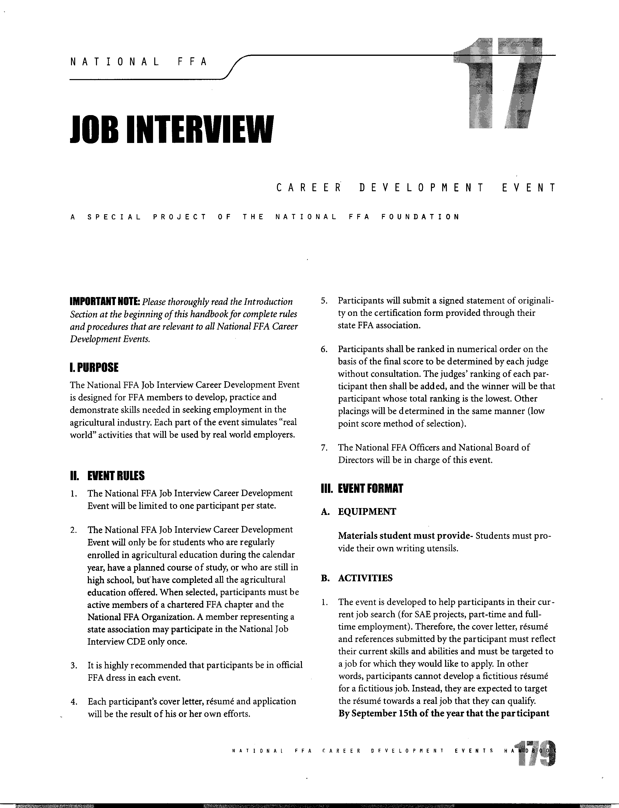

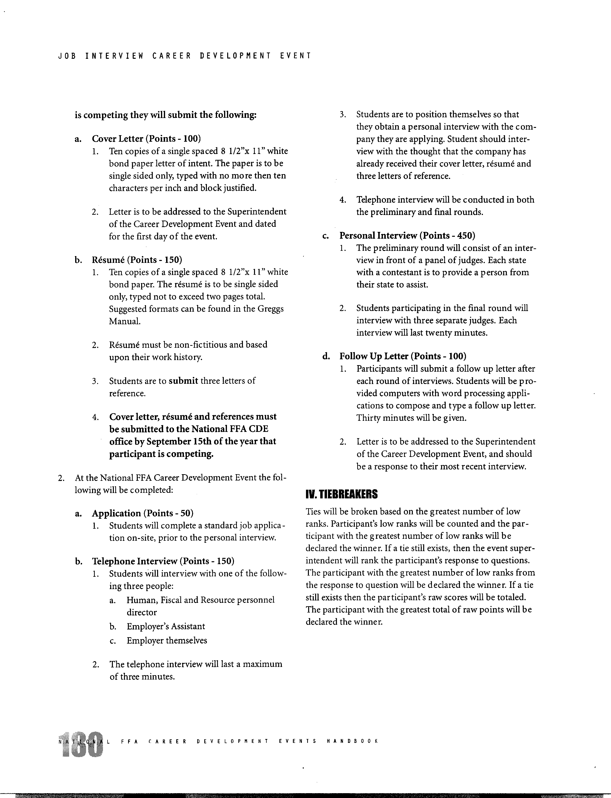

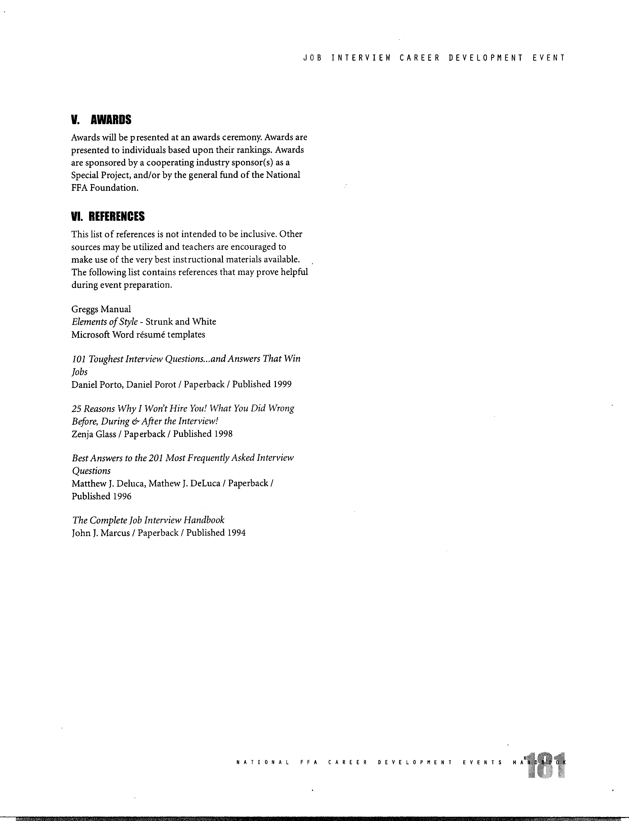

Cover Letter

Name _______________ School ___________________ No. ____

Composition | Possible Points | Score
Correct format and stationary | 10
Punctuation | 10
Grammar | 10
Spelling | 10
General Appearance | 10
Composition Sub Total | 50
Content
Career goal specified | 15
Proper qualifications | 35
Content Sub Total | 50
Grand Total | 100

Employment Application

Name________________School_____________________No____

Description | Possible Points | Score
Legible | 15
Neat  - Grammar  - Punctuation | 10
Completed accordingly | 10
Consistent with resume | 15
Grand Total | 50

Thank You/Follow Up Letter

Name _______________ School ___________________ No. ____

Composition | Possible Points | Score
General appearance | 5
Composition | 10
Express appreciation | 10
Comments on interview activities | 10
Express interest in position | 15
Review of relevant qualification | 15
Is requested information addressed | 15
Provisions for follow-up stated | 20
Grand Total | 100

Personal Interview

Name _______________ School ___________________ No. ____

Description | Possible Points |  | Score
Appearance and courtesy | 45
Greetings and introduction | 45
Speech  - Grammar  - Vocabulary  - Volume  - Enunciation | 45
Attitude and personality  - Forcefulness  - Poise  - Temperament | 45
Ability to convince or impress interviewer  - Persuasiveness  - Self-confidence | 45
Knowledge and presentation of abilities  - Educational experience  - Occupational experience | 45
Reliability  - Frankness  - Consistency  - Accuracy | 45
Poise  - Tact  - Discretion  - Questions asked of interviewer | 45
Career Objective  - Degree to which the contestant had determined career objective | 45
Conclusion of interview | 45
Grand Total | 450

Resume

Name _______________ School ___________________ No. ____

 | Possible Points |  | Score
General Appearance
Presented in proper format | 15
Pleasing to the eye  - Captures interest  - Layout  - Easily read | 40
Grammar  - Punctuation  - Typing  - Spelling | 20
General appearance Sub Total | 75
Composition
Personal data | 10
Career objective | 10
Educational background | 20
Work experience/skills | 20
Special experiences, activities, honors | 10
References | 5
Composition Sub Total | 75
Grand Total | 150

Telephone Interview

Name _______________ School ___________________ No. ____

 | Possible Points | Score
Introduction | 22
Initiative | 22
Communicated effectively | 26
Diplomatic and courteous | 26
Gathered appropriate information  - Contact name  - Address  - Date  - Time | 24
Grand Total | 100

Cover Letter, Resume & Portfolio Score Sheet

Name _______________ School ___________________ No. ____

Resume
 | Possible Points |  | Score
General Appearance
Presented in proper format | 15
Pleasing to the eye  - Captures interest  - Layout  - Easily read | 40
Grammar  - Punctuation  - Typing  - Spelling | 20
General appearance Sub Total | 75
Composition
Personal data | 10
Career objective | 10
Educational background | 20
Work experience/skills | 20
Special experiences, activities, honors | 10
References | 5
Composition Sub Total | 75
Total Resume | 150

Cover Letter
Composition | Possible | Score
Correct format and stationary | 10
Punctuation | 10
Grammar | 10
Spelling | 10
General Appearance | 10
Composition Sub Total | 50

Content
Career goal specified | 15
Proper qualifications | 35
Content Sub Total | 50
Total Cover Letter | 100

Portfolio
Description | Possible | Score
Organization/Format | 25
Creativity/Neatness | 25
Grammar/Punctuation | 25
Samples  Appropriateness to job, pictures, captions | 50
General Appearance/Impression | 25
Portfolio Total | 150

Total Points…Resume, Cover Letter & Portfolio 400

References:

Marcus, John J. The Complete Job Interview Handbook
Published 1994

Rickets, Cliff Leadership: Personal Development and Career Success. Delmar Books, 1997

Smith, Greg. “Building your career portfolio.” Career World” Highland Park, Jan 2001

WAAE Website, Orientation to Agriculture Careers. Mike Martin

