SALES
&
SERVICE
Curriculum & Contest Guide
2006 – 2010
Revised October 1, 2006


Practicums Theme Rotational Pattern
2006 Animal Industry
2007 Crop Industry
2008 Natural Resources
2009 Agriculture Mechanics
2010 Horticulture Industry

A special thank you to the Walla Walla Agribusiness community. This guide is due in large part to their contribution of ideas, examples and support.

This material is intended to provide teachers with curriculum support for the Agriculture Sales Career Development Event and for teaching Sales in the classroom. It may be copied/reproduced or used for educational purposes.

- Mike Martin 2006
Walla Walla, WA

Table of Contents
1 | General Contest Information | 2
2 | Sales Presentation  Overview  Sample Presentation | 5
3 | Customer Relations  Overview  Examples  Hedge Trimmer, Acme Garden Center, Al's Hardware,  Animal Clippers, Squeeze Chute, Clorpyralid Applied,  Curtail, Acme Crop, 2002 National example, Sam’s Guide  Service, Acme Tent Company, FFA Wreaths, Christmas  Trees | 11
4 | Order Taking  Overview  General Telephone Information  Examples  Acme Lawn & Garden, Just Roses, Bob’s Gardening,  Annie’s Flower Shop, Far Better Feeds, Tri-Cities  Ranch Supply, Acme Fertilizer and Chemical, 2002  National Example, Acme Bait & Tackle, Acme Winter  Sports, Acme Nursery, Acme Home and Garden | 44
5 | Prospecting for New Customers  Overview  Examples  Healthy Horse (Luncheon Option), Healthy Horse (Selling  Option), Landscape Contractor, Fast Grow, Far Better  Feeds, Crop (Seminar), Crop (Selling), Johnny  Appleseed, Healthy Plant, 2K2 Wheat, Dividend Extreme,  2002 National Example, Acme Bait & Tackle, Acme  Winter Sports | 97
6 | Team Activity  Overview  High End Mower example scenario, example process,  sample Power Point, Healthy Horse scenario example | 115
7 | National Tests 2003, 2004 & 2005 | 129
8 | Score Sheets | 153
Sales Contest Overview

Written Test

Sales Presentation

Each team member will do the same practicum selected from one of the three listed below. Selection shall be done by the contest coordinator at time of contest.

Group Activity
(All 4 Team Members)

Customer Relations
Prospecting Customers

Order Taking

Sales and Service Contest Overview

The Sales contest has 4 parts. Individually each team member will do:
A. Written Test 100 points
B. Sales Presentation 100 points
C. Practicum 100 points
D. Group Activity 200 points

Contest Breakdown
Written Test: A 25 point test will be given to each contestant. For Washington State, the last 3 National tests will provide the bank of questions.

Sales Presentation: The student is to select any agriculture related product or service, write a sales scenario stating the customer’s situation and make a sales presentation (maximum length of 15 minutes) by going through the sales process. During the sales presentation, the student should determine the customer’s wants and needs list the features and benefits and then close the sale.
Practicums:
Customer Relations:
A store policy and pertinent information will be given to the student as a reference guide to study. The student has 10 minutes to look over the reference material. The judge then enters the room with a problem for the students to solve. The student is to solve the problem face to face with the judge the student has ten minutes to solve the problem, a warning at 7 minutes will be given..
Order Taking:
The student will be given 10 minutes to study information listing information such a prices etc., a daily flyer listing last minute changes (out of stock items etc), and an order form. The student will then (face to face) have 10 minutes to take the judges order. A warning will be given at 7 minutes.
Prospecting for New Customers:
The student will be given a product description, a scenario and goals of the cold sales call (the goal will be to either obtain a commitment to attend an informational meeting or to make product sales). The student will have 10 minutes to study the scenario followed by 10 minutes to demonstrate their skills. A warning will be given at 7 minutes.

Team Activity: Team members will work together to demonstrate group dynamics, problem solving, data analysis, decision making and oral and written communication skills. The following information will be provided to the team as if they are a group of professional sales people:
1. A product (including features and price…if applicable)
2. Market situation (including competition)
3. Several potential customers.

The team will then develop all the strategy necessary to prepare to sell the product in a face to face sales call. This strategy should include but not be limited to:
1. Determining potential customer needs and wants. 2. Identifying features and benefits of the products to address customers’ needs and wants. 3. Identifying potential customer objections and prepare to address them. 4. Identifying potentially related products and suggested selling strategies. 5. Developing a sales plan and goals for each customer.

It is critical to remember that in addition to the final presentation being judged, teamwork and equal involvement of all team members will be judged. Also it is critical to not only state what you chose to do, but why you chose to do it. In selling there are no absolute right or wrong answers.

Demonstrating the basic fundamentals necessary to accomplish your goal is essential. Member will be expected to participate. The judges will act as the audience, but will not engage in dialog during the presentation. Participants may utilize any materials provided in the team event for t the presentation. It is important that all team members speak up during the entire process. Each team will be given 25 minutes to examine all information provided, discuss and develop ideas and prepare a presentation. Teams may bring a laptop computer and utilize PowerPoint for their presentations. If a laptop computer is utilized, the presentation will be presented on the laptop screen. PROJECTORS AND DESKTOP COMPUTERS WILL NOT BE ALLOWED. Each team will be responsible for the power supply for their computer. Each team will than have 10 minutes with a an 8 minute warning to make their presentation. They will be up to 5 minutes for judges questions.

Sales Presentation

Information



Sales Presentation
- Length
15 minutes
Warning at 12 minutes

- Product
Must be agriculturally related (does not have to match theme rotation for current year)
Select a product of interest

- Statement of situation
Provide lots of information
Information provided will allow judge to role play
Background information is crucial to the success of your presentation

- Ask questions

Determine customer’s wants and needs

- Demonstrate
Hands on

Involve the judges

- Closing
Objections part of sales process
Judges instructed to purchase product/service

The Steps of a Sales Process

Introduction
Introduce self and product/service, rapport building, determines prospect's awareness of your product/service.

Question for Need(s)
Ask numerous probing questions to build rapport and to determine customer’s wants and needs.

Features and Benefits that Fit Need(s)
Build a presentation describing your product, describing the key features and benefits that are important to the prospect.

Trial Close(s)
Trial closes should be attempted when the customer expresses a sincere interest in the product.

Handling Objection(s)
Generally this is answering the buyer’s questions. Often times it is a quick review of the benefits to the customer or just reassurance the product will fit his/her needs (explaining additional features/benefits to build more value/confidence to the product/service may also accomplish this). Listen carefully to the customer to determine their real concerns. This may also be accomplished by minimizing perceived negative issues or correcting the negative issue.
Close
A question or series of questions that assume the prospect is ready to buy and help the prospect make the decision. A sample close: "Mr. Prospect, which day would you prefer to have this delivered? Monday or Tuesday? Or "Which color would you prefer? Crimson or Gray?

Sales Presentation Information reflecting changes for the years 2006 – 2010

Representation (company, name & chapter)

Role customer is to play

Product to be sold

Features of the product

Method of demonstration

Sales call objective

Product or service price

Examples of two or more competing products and their prices

Example
Representation: Stu Dent
Anytown, WA
Carhartt Company

Role customer is to play: The judge (customer) enters the store looking to purchase a durable work coat. In the past, their coats have had problems with seams ripping, pockets tearing and colors fading. The customer wants to use the coat feeding animals and doing other routine ranch chores, plus be dressy enough to wear in town.

Product to be sold: Carhartt Jackets

Features of the product:
Features | Benefits
- Triple stitched seams | - Seam will not rip
- Pocket corner rivets | - Pockets will not tear
- Fade resistant dyes | - Colors will not fade

Method of demonstration: The contestant will interact with the judge exhibiting the features and benefits of the coats.

Sales call objective: The purpose of this sales call is for the customer (judge) to purchase a new jacket.

Product or service price: Range from $65.00 to $119.00

Examples of two or more competing products and their prices:

Walls coats/jackets
$55.00 to $120.00

Wrangler coats/jackets
$40.00 to $115.00

Sales Presentation
By providing the judge adequate information in the statement of situation, you enable them to enter a meaningful dialogue.
Sample Dialogue

Contestant: Welcome to Bonnie’s Tack & Western Wear, I’m Bonnie. How may I help you today?

Customer: I’m looking for a work coat.

Contestant: What kind of work will you being doing?

Customer: Feeding animals and other ranch work.

Contestant: What type of jackets have you had in the past and have you been happy with them?

Customer: Just regular work coats that have not worn very well.

Contestant: What kind of problems have you had in the past?

Customer: The pockets have torn, seams have ripped and the colors have faded.
At this time, the student should restate the problem in their own words. This is beneficial in several ways; it demonstrates listening skills, helps the contestant understand what the judge is saying, and acts as a way to confirm both the judge and contestant are on the same thought process.

You should be well practiced for your presentation, however, do not have it memorized as the judges will know it’s canned!
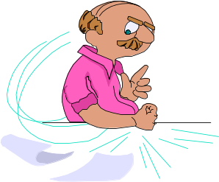

Customer
Relations

“Walking the business tight rope…, keeping the customer happy while maintaining company profit.”

Customer Relations
Overview
- Practicum time guide lines
10 minutes to study problem
10 minutes to solve problem with judges
7 minute warning

- Contest material
A typical company policy and philosophy statement will be given to each contestant along with the contest problem. The contestant is to solve the problem within the company policies.

- Problem solving
Judge brings in a product with multiple problems to be solved

- Types of problems
Defective equipment
Improper use or application
Calming & regaining customer satisfaction

- Evaluation
Primarily on human relations skills
Secondarily on technical knowledge

- Information provided
Store policy
Company philosophy

- Suggestive selling
If appropriate, attempt to gain additional sale(s)

If you have technical questions about the product, ask your judges for clarification

The purpose of the customer relation’s practicum is to provide real life situations that a student may encounter as a sales clerk, company representative or sales person.

Tips for Successful Customer Relations

Tip # 1 Read and become knowledgeable with the store policy

Tip # 2 Show empathy; treat the customer way you would want to be treated.


Remember, you are a representative of the store.

Tip # 3 If unclear or if there is any doubt in your mind. Ask the judge/customer to restate the problem (ask the judge/customer to clarify any unclear points).

Tip # 4 Restate the problem in your own words. As you restate the problem, look to the judge/customer to get a read if you are on the correct path.

Tip # 5 Determine the root of the problem (customer misapplication / misuse or defective equipment).

Tip # 6 Be positive. All suggestions or statements you make should have a positive spin.

“We can take care of this ...”
Defective Equipment
“I’m sorry you had this problem, but I’m sure we can solve this to your satisfaction”

“From what you told me, it appears you didn’t
follow the instructions on the label.”
Customer
Misue or
Misapplication

“I hope you can understand that we can’t be responsible for customer misuse, but we can help you out by (offer a discount) etc.

Tip # 7 Wrap up the discussion with the customer (judge) by asking if this solves their problem.

Tip # 8 Ask the customer if there is anything else they need to go along with their product. Be product specific (offer safety glasses, or other related products.
Customer Relations
Sample Scenarios

Problem # 1

The Acme Company policy for defects or refunds should be handled as follows:

1. A receipt if preferred
2. Clerks should try to handle complaints
3. Utilize the service department for repairs or defects
4. If item is deemed defective replace from store inventory
- Refund money if no other alternative is practical
- Federal law prohibits the return of any merchandise that has been exposed to Herbicides or Pesticides.

Assume you are a sales clerk for the above company and a customer (role played by your judge) comes into your store with the following problem.

Assume the customer is carrying a 5 gallon sprayer as they state the following scenario:

Customer:
“I purchased this 5 gallon backpack sprayer from you last week. When I used it, I discovered that it was too heavy for my back. I especially found it to be too heavy when I was walking up steep hills along the fence lines on of my ranch. Since it is too heavy and caused me back pain, I would like to return this back pack and have my money refunded.”

Solution:
Inform the customer, Federal Law prohibits taking the sprayer in as a return (store policy # 6). However, recommend they only fill the sprayer half full. Another solution is to recommend a dolly to pull it on or suggest an ATV complete with a sprayer.

CUSTOMER RELATIONS

Student Copy

Hedge Trimmer

Business: You are a floor sales person working at a local hardware store “Acme Hardware”. Your customers are generally from a mix of urban and rural population.

Situation: Two days ago, a homeowner purchased a gas powered hedge trimmer. Today, he/she comes into the store complaining it no longer works properly.

Complaint # 1:
After cutting about ½ of the hedge, the blade suddenly went dull.

Complaint # 2:
Upon refueling the gas tank, the motor ran for a short period of time and then froze up.

Complaint # 3
The starter rope is broken.

Acme Hardware Store Policy:

1. Above and beyond any Manufacturer’s Warranty, Acme Hardware carries a 30-day store warranty.
- Utilize the service department to resolve mechanical problems whenever
applicable.
3. It is the sales person’s responsibility to determine if the problem is with the operator or a manufacture’s defect.
- A receipt is preferred with all sales.
- If merchandise is deemed defective, the clerk should attempt to replace
with a similar product out of the store inventory before giving cash refund.
6. It is the customer’s responsibility to read the operating instructions before using the merchandise.

Customer Relations

Judges Copy

Hedge Trimmer

Scenario: Two days ago you purchased this hedge trimmer (have it in your hands). Explain to the student at first the hedge trimmer worked great. However, when you trimmed about ½ of the way down your 100 foot long hedge the blade suddenly went dull. Just after the blade went dull, you ran out of gas. When you refilled the tank, the engine ran for about 20 seconds then froze up. In your frustration, you pulled the starter rope so hard it broke. You are very disgusted with the hedge trimmer. You would prefer your money back but as a last resort would accept another off the shelf.

Don’t volunteer any information but if asked by the student this is what really happened.

# 1 you dulled the blade by cutting into wire that had mistakenly been installed in your arborvitae hedge.
# 2 the motor worked fine on the first tank of gas. When you refilled the fuel tank trimmer you did not mix two-cycle oil with the gas.
# 3 with the motor froze up; you pulled the rope so hard it broke.

The contestant should determine the problem was operator error. Two basic options are possible.
# 1 Sell the customer a new hedge trimmer
# 2 Check into the possibility of having the service shop repair the trimmer (at the customers expense).
# 3 The student should attempt to sell the customer two-cycle oil, safety glasses, gloves and other accessories.

CUSTOMER RELATIONS

STUDENT COPY

Acme Garden Center

You are a sales clerk for the ACME GARDEN CENTER. The Acme Garden Center’s policy is to provide quality products at a fair price.

The ACME GARDEN CENTER’S policy for defects or refunds is as follows:

A receipt is preferred
Clerks should try to handle complaints
Customer negligence is not the company’s responsibility
If item is deemed defective replace with a new one from inventory
Refund money if no other alternative is practical

CUSTOMER RELATIONS

JUDGES COPY

Acme Garden Center
Same as students info
You are a sales clerk for the ACME GARDEN CENTER. The Acme Garden Center’s policy is to provide quality products at a fair price.

The ACME GARDEN CENTER’S policy for defects or refunds is as follows:

A receipt is preferred
Clerks should try to handle complaints
Customer negligence is not the company’s responsibility
If item is deemed defective replace with a new one from inventory
Refund money if no other alternative is practical

CONTEST SCENARIO:
You as the judge are to bring in two sets of plants. The first set is unhealthy looking. You bought all of your plants 2 weeks ago. The reason the first set is looking sick is that you placed them in the garage and forgot all about them until today when you had time to work the soil and plant them. The second set of plants, you discover are annuals. When you bought your plants you wanted perennials so you wouldn’t have to plant each year. These plants (annuals) are healthy and you just want to exchange them for perennials that will look good around your house.

Solution

Customer Relations Practicum Guide 2001

Student/Judges Copy

Business: You are a floor sales person working in at "Als", a local hardware store that sells a variety of Forest and Natural Resource Products. Your customers are generally from a mix of urban and rural population.

Situation: A customer who owns a small 10-acre wooded lot purchased a 16-inch Power/Chain Saw in the last month. He comes to the store and makes the claim that it never worked properly. The chain was never sharp. The motor started and ran for a short period of time then died. When attempted to restart, the pull cord broke and it appeared the engine had locked up.

The saw costs $230.00. Al the storeowner is out of town for two weeks. Al asked that you make all service decisions. The product has a 45-day parts and labor warranty that also specifies "proper care" as criteria for the customer.

Al's Store Policy is to provide quality products, good service and have satisfied customers.

Furthermore, as a member of Al’s sales’ staffs you should remember the following in resolving the customer's complaint…

- A satisfied customer is top priority

- Utilize the service department to resolve mechanical problems where possible

- You need to be "Fair" but "Firm"

- If a product is defective replace from inventory

Customer Relations
Animal Industry
Clippers

Student Copy

You are the sales clerk for Acme Ranch Supply. The owner Mr. Acme has placed a lot of confidence in his sales staff and expects them to make the final decision dealing with customers.

The Acme Store Policy is:

- Receipts are required for all returns (no exceptions)
- All problems must be resolved by the sales clerks
- Substitutions/replacements are preferred over cash refunds
- Every attempt must be made to solve the problem to the customer’s satisfaction.

Problem:

The customer is returning a large pair of clippers complaining they are too noisy, scare her dogs, do not clip inside the ears and his/her arm gets tired before the dog is half clipped. The clippers being returned are clean and show no signs of use. The box can be easily be resealed.

Receipt for Judge

Acme Hardware
1313 13th St.
Walla Walla, WA 99362

Date __1 week prior to contest_

Description | Price
1 Pr. Cattle Clippers | $ 59.95
5 Ton Rolled Ration | $450.00
SubTotal | $509.95
Tax | 40.80
Total | $550.75

Customer Relations
Animal Industry
Clippers

Judges Copy

You are the sales clerk for Acme Ranch Supply. The owner Mr. Acme has placed a lot of confidence in his sales staff and expects them to make the final decision dealing with customers.

The Acme Store Policy is:

- Receipts are required for all returns (no exceptions)
- All problems must be resolved by the sales clerks
- Substitutions/replacements are preferred over cash refunds
- Every attempt must be made to solve the problem to the customer’s satisfaction.

Problem:

The customer is returning a large pair of clippers complaining they are too noisy, scare her dogs, do not clip inside the ears and his/her arm gets tired before the dog is half clipped. The clippers being returned are clean and show no signs of use. The box can be easily be resealed.

Judges Note

When you were in the store you told the clerk that you have 12 dogs at home and that you clip your dogs on a regular basis. The sales clerk sold you the big set of clippers even though you mentioned they looked big for your miniature poodles. The contestant should be willing to make an exchange for a smaller set of clippers that are designed for dogs, not cattle. The student should also offer to sell you oil for the clippers, see if you need any other products for you dogs such as dog food, shampoo, and any other dog supplies.

Customer Relations Practicum
Squeeze Chute

Judges Copy
Introduction:
You are the sales representative for Acme Ranch Supply operated in Walla Walla, WA. You have been asked to go to the residence of Chris Shoemaker who operates a purebred Simmental operation in the valley. Your job is to handle any customer complaints about the products that your company sells. You are to determine the proper course of action to resolve the situation within the company's policy.

Scenario:
The Shoemakers bought a new hydraulic chute from your company last November. This past weekend while using the chute a registered cow was injured. The cow was sold for $2,000 to a neighbor; now due to the injury the cow can no longer be sold. The Shoemakers want your company to buy the cow because they blame the accident on the chute. When they bought the chute it was guaranteed to be a safe, easy chute to use and would reduce cattle injuries.

Company Policy:
- All products are 100% guaranteed
- All new customers are offered 8 hours of training for new products
- Tri-Cities Ranch Supply believes in educating the customer and holds seminars that explain all the equipment they sell.
- All equipment has a one-year warranty for any defects.
- Tri-Cities Ranch Supply does not assume responsibility for misapplication, misuse, or injury caused by workers who have not had adequate training by Tri-Cities Ranch Supply.

Judges Footnote: (not to be seen by contestant)

When you bought the new chute Tri-Ciites Ranch Supply trained all of the Shoemaker’s current employees on the correct and safe use of the hydraulic chute. The chute has been used hundreds of times without injury to any cattle. However, when the cow in question was injured a new employee who had not received training was operating the chute. It appears that everything is in working order on the chute.

Do not supply information to the student if they don’t ask about it!!

Customer Relations
Clorpyralid Applied
Herbicide

Student Copy
You are the sales clerk for Acme Chemical & Fertilizer Company. The owner Mr. Acme has placed a lot of confidence in his sales staff and expects them to make the final decision dealing with customers. Presently, Mr. Acme and the management team are out of town and have turned the operation of the store over to you for the next two weeks.
The Acme Store Policy is:

Receipts are required for all returns (no exceptions)
All problems must be resolved by the sales clerks
Substitutions/replacements are preferred over cash refunds
Every attempt must be made to solve the problem to the customer’s satisfaction.
Federal Law prohibits a dealer to take containers back once the seal has been broken.
It is the customer’s responsibility to read all labels and comply with all Federal and State Guidelines

Problem:
The customer enters your store and wishes to visit with you (sales clerk) about a problem with a chemical they purchased last week. When the customer purchased the 5 gallons of Curtail (brand name for broadleaf weed killer) they told you they were planning to spray their pasture used for grazing their registered Simmentals for thistles. After spraying the pasture for thistles, they decided they no longer wished to graze the field but to make hay from the 100 acre field.

The problem they are bringing to you is: last night’s newspaper featured an article stating hay sprayed with Clopyralid can not be composted. Clopyralid is one of the active ingredients in Curtail. They now want you (Acme Chemical & Fertilizer Company) to purchase the hay since there are now composting problems with their hay.

Receipt
Acme Chemical & Fertilizer Company
1313 13th St.
Walla Walla, WA 99362
Date One week after today’s date_
Description | Price
2 Gallons Round Up | $159.00
5 Gallons Curtail | $450.00
Subtotal | $609.00
Tax | 48.72
Total | $657.72

John Q. Customer
Customer Relations

Clorpyralid Applied
Herbicide
Judges Copy

The customer is wrong in two ways.
# 1 They changed their minds, telling the clerk one thing then doing something else.
# 2 ultimately, it is the consumer’s responsibility to read the label before chemical application.

The contestant should in a nice way inform you the company can not be responsible for customer error. They should also suggest the customer should inform prospective hay buyers the hay is fine but can not be used for composting purposes.

Receipt
Acme Chemical & Fertilizer Company
1313 13th St.
Walla Walla, WA 99362

Date One week after today’s date_

Description | Price
2 Gallons Round Up | $159.00
5 Gallons Curtail | $450.00
SubTotal | $609.00
Tax | 48.72
Total | $657.72

John Q. Customer
Customer’s Signature

Customer Relations
Curtail

Student Copy

You are the sales clerk for Acme Chemical & Fertilizer Company. The owner Mr. Acme has placed a lot of confidence in his sales staff and expects them to make the final decision dealing with customers. Presently, Mr. Acme and the management team are out of town and have turned the operation of the store over to you for the next two weeks.

The Acme Store Policy is:

Receipts are preferred
All problems must be resolved by the sales clerks
Substitutions/replacements are preferred over cash refunds
Every attempt must be made to solve the problem to the customer’s satisfaction.
Federal Law prohibits a dealer to take containers back once the seal has been broken.
It is the customer’s responsibility to read all labels and comply with all Federal and State Guidelines

Problem:

A long time customer is very upset with you (sales clerk). Earlier in the week they asked you for the best way to control unwanted grass and thistles in their alfalfa field. Based on this information, you went to the shelf and sold them Curtail a broad leaf plant killer which is also very effective on thistles.

Before using the product the customer carefully read the label which clearly states Curtail will kill alfalfa, thistles and other broad leaf plants.

The customer now wants you to solve the problem.

Customer Relations
Curtail

Judges Copy

The sales clerk should take full responsibility for the problem and try to solve the problem. Show the contestant the attached “Application Instructions”

As the judge you might want to mention you are a customer in good standing with the company, how much this inconvenienced you plus the close call on killing over 120 acres of prime alfalfa.

The clerk should ask for a sales receipt but it is not required.
Since the product was unopened (the seal was not broken) it can be taken back for a full refund.
Ask for a cash refund, however, the student should attempt other solutions before returning the money.
Error: Reference source not found

CUSTOMER RELATIONS

STUDENT COPY

Acme Crop Supply
You are a sales clerk for the Acme Crop Supply. The Acme Crop Supply’s policy is to provide quality products at a fair price.

The Acme Crop Supply’s policy for defects or refunds is as follows:
A receipt is preferred
Clerks should try to handle complaints
Customer negligence is not the company’s responsibility
If item is deemed defective replace with a new one from inventory
It is the customer’s responsibility to read all labels/manufacture’s instructions before use
Refund money if no other alternative is practical

Enclosed is the label from 2-4-D which will be used in this scenario.

2-4-D
2-4-D is an effective herbicide that kills all broadleaf
plants (Dicots).

2-4-D treated plants may be fed to animals after 5 days of application
Worker re-entry time after application is 2 days.
100% effective on all broad leaf plants
Do not apply in windy conditions
Use only as directed
Satisfaction guaranteed
- It is the applicators responsibility to read the label and all other information
- Do not use this product on clover or alfalfa

The judge/customer had an infestation of weeds in his 100 acres of alfalfa. Fifteen days ago he/she purchased 3 gallons of 2-4-D from Acme Crop Supply to kill the weeds in their alfalfa (they had several different types of noxious broad leaf weeds). The spray was very effective, so effective it killed all the broad leaf weeds plus all of the alfalfa plants. The customer/judge feel Acme Crop Supply owes for the hay they should have harvested which is valued at $20,000. If Acme Crop Supply doesn’t pay the customer $20,000 for the lost crop they will be contacting a lawyer and file a lawsuit. In addition for the hay crop loss they also want Acme Crop Supply to provide new Alfalfa seed to replant the 100-acre field.
To begin the scenario the judge/customer will present a gallon jug with the label on it and start asking for damages).

If you have technical questions about the product, ask your judges for clarification.

CUSTOMER RELATIONS

JUDGES COPY

Acme Crop Supply
CONTEST SCENARIO:
You as the judge had an infestation of weeds in your 100 acres of alfalfa. Fifteen days ago you purchased 3 gallons of 2-4-D from Acme Crop Supply to kill the weeds in your alfalfa (you had several different types of noxious broad leaf weeds). The spray was very effective, so effective it killed all the broad leaf weeds plus all of the alfalfa plants. You feel Acme Crop Supply owes you for the hay you should have harvested which is valued at $20,000. If Acme Crop Supply doesn’t pay you the $20,000 for the lost crop you will be contacting a lawyer and file a lawsuit. In addition for the hay crop loss you also want Acme Crop Supply to provide you with new Alfalfa seed to replant the 100-acre field.
You are to present the student with the gallon jug with the label on it and start asking for damages. (The student has had a chance to study the label)

The Acme Crop Supply’s policy for defects or refunds is as follows:
A receipt is preferred
Clerks should try to handle complaints
Customer negligence is not the company’s responsibility
If item is deemed defective replace with a new one from inventory
It is the customer’s responsibility to read all labels/manufacture’s instructions before use
Refund money if no other alternative is practical

2-4-D

2-4-D is an effective herbicide that kills all broadleaf
plants (Dicots).
2-4-D treated plants may be fed to animals after 5 days of application
Worker re-entry time after application is 2 days.
100% effective on all broad leaf plants
Do not apply in windy conditions
Use only as directed
Satisfaction guaranteed
- It is the applicators responsibility to read the label and all other information
- Do not apply this product on clover or alfalfa

If the contestant asks for technical help, you may assist them only with technical questions about the product. By contest time, the contestant should know the roles played and other general mechanics of the practicum.

Obviously, the customer is at fault. The contestant needs to tell you this with empathy. Additionally, they should offer you a discount to take some of the bite out of the situation, offer seed at cost etc. plus attempt to sell other products to you.

2002 National FFA Ag Sales Career Development Event

"Customer Relations"
You are employed as a sales representative by ‘The Animal Store’ which focuses on products and services to customers who raise and/or keep large animals. The store also includes products/services to the people who have special needs as operators and supervisors of animals. As a sales representative your assignment is to deal with a dissatisfied customer using the appropriate customer relation techniques.

The customer you are visiting today at their home is in the process of implementing a preconditioning feeder program for the 160-180 steer and heifer calves that are retained after weaning. Each program will last for 2 months (60 days).

You sold them the pens; watering, feeding and shelter equipment 30 days ago and they received their shipment last week. You were out of town on vacation and upon your return home received a message from Bob/ Betty Jones. It was left 3 days ago and he/she mentioned they were not pleased with their shipment received.

You had previously received agreement that if all went well with the equipment purchase he/she would purchase their preconditioning feed program.

The preconditioning feeder program includes…
- A daily feed supplement of 10 lbs./head/day X 60 days =
96,000 to 108,000 pounds during October and November of each year.

They also have a nice size broiler operation you were hoping to gain their business on in the near future.
CUSTOMER RELATIONS
The Animal Store
Information and Policy

The main product categories provided at ‘The Animal Store’ are described as follows:
- Animal feed- you have a strategic alliance with a regional feed manufacturing company that provides 180 feed rations in bulk, 50 lb. bags, and smaller containers for pets. Special rations can be formulated for those animal producers who have unique nutrition requirements.

- Animal health - an array of products for preventative health care and disease control including: medicated feed antibiotics, antibiotic injections, antibiotic water solubles, vaccines, wormers, and tick & fly control products.

- Animal support products- disinfectants, tack, rope, halters, shampoos and oils.

- Plant nutrients- to produce quality hay and forages for animals, dry pelleted fertilizer products are available in bulk and bag quantities. Application of fertilizer is available.

- Fencing- Fencing and metal products including waters and feed troughs, enclosed feeders, gates, barb and net wire, electric fencing equipment, and tools.

- Clothing- denim pants & shirts, work boots, winter insulated coats, caps & hats.

Policy
In dealing with merchandise returns, you must have a receipt and then a store credit is provided. There is no cash given, it must be used on other Animal Store products. Damaged products can be exchanged for new products if the Store Manger approves the exchange.

2002 National FFA Ag Sales Career Development Event

CUSTOMER RELATIONS

"Judges Background Information"

You are serving as judge for the "Customer Relations" segment of the National FFA Ag Sales Career Development Event. Student contestants need to ask questions to determine the following information regarding your complaint and dissatisfaction with The Animal Store.

They are visiting you at your home today and you are in the process of implementing a preconditioning feeder program for the 160-180 steer and heifer calves that are retained after weaning. Each program will last for 2 months (60 days).

You were sold the pens; watering, feeding and shelter equipment 30 days ago and you received a shipment of damaged goods last week. You left a message on the sales reps answering machine 3 days ago and have not heard back. This is delaying your construction timeline.

You had previously agreed that if all went well with the equipment purchase you would purchase your preconditioning feed program through The Animal Store also.

The preconditioning feeder program includes…
- A daily feed supplement of 10 lbs./head/day X 60 days =
96,000 to 108,000 pounds during October and November of each year.

You also have a nice size broiler operation and the sales rep was hoping to gain your business on in the near future.

Your complaints are:
- It took 3 days to receive a return phone call
- Ordered 30 days ago and the shipment arrived last week –“you didn’t mention the time it would take for delivery.”
- When the equipment arrived the galvanized gates were 3 foot too short,
- The feed bunks appeared to have been used before on a farm and now were sold as NEW!

 Sam’s Guide Service 

Enjoy Fishing in Eastern Washington’s
Scenic Blue Mountains

Fun --- Sun --- Fresh Air

 Trips the family
will remember for years!!!

In the event of bad weather or other unforeseen natural events, or the family is not 100% satisfied with Sam’s Guide Service a 25% reduction on the customer’s next fishing trip will be granted.

Contestant’s Copy
Customer Relations
Sam’s Guide Service

You are the owner of Sam’s Guide Service, specializing in family fishing trips. Your goal is to provide clean, family orientated fishing trips for your customer’s.

You are just returning from a 2 day fishing trip which experienced rain and mosquitoes. Due to the rain, fishing time was limited however, a few fish were caught. Even with the steady downpour, you were able to prepare quality meals and keep the family of 4 dry at night.

The head of the household is now saying you did not live up to what was promised in the newspaper advertisement and is demanding a full refund.

Good luck!!

Judges Copy
Customer Relations
Sam’s Guide Service

You are to assume the role of a disgruntled camper demanding a full refund on the 2 day fishing trip provided by Sam’s Guide Service. Due to the rainy weather and mosquitoes you had less fun than what was expected. You are using the newspaper advertisement as your grounds for receiving a full refund and are using the following points as the basis for your refund request.

- The few fish the family caught were not nearly as big as the ones pictured
- The rain was so heavy that your son (little Johnny) caught a terrible cold when fishing late at night
- The mosquitoes were so bad everyone has bite welts
- Your wife is mad because she couldn’t get a sun tan
- The purpose of the trip was to get out of Seattle’s rainy weather and into Eastern Washington’s sunshine
- The only true part of the ad, was “A trip the family will remember for years”

Contestant’s Copy
Customer Relations
Acme Tent Company

You are to assume the role of a sales clerk at the Acme Tent Company. The judge will play the role of a customer returning a tent that leaked during a camping trip last weekend. Listed below is the store policy, use it as a guide to solve the problem.

Acme Tent Company Store Policy

- A receipt is required
- Clerks should make every attempt to solve the problem to the customer’s satisfaction
- Acme Tent has a nationally acclaimed service department, every attempt should be made to utilize this department
- If an item is deemed defective, utilize the store’s inventory for replacement
- Refunds will be granted when no other alternative satisfies the customer. They will be mailed to the customer’s home within three business days
- The store philosophy is “WHERE THE CUSTOMER IS KING”

Judges Copy
Customer Relations
Acme Tent Company

The contestant will think this will be easy to solve. You are to role play a customer who just purchased a tent from Acme Tent Company. You will show them your receipt (cut out from sample below) and request a full refund for the tent that leaked on last weekend’s camping trip.

For this practicum to play out fully, you must be steadfast in your demand for a full refund.

To receive full credit, the contestant must in this order walk you through the following 9 steps:

- Show empathy for your discomfort
- Ask you to explain what exactly happened and why the tent leaked
- Repeat in their own words what happened
- Ask for your receipt
- Ask if the service department can repair the leak
- Ask if they can replace it from one in inventory
- When offering you a refund, they must obtain your mailing address and verify the amount of the refund check
- They should see if this solves the problem to your satisfaction
- Ask if there are any other items you might need (ATTEMPT TO MAKE A SALE ON OTHER MERCHANDISE)
Acme Tent Company
Receipt

Qty Description Price
1 Tent $99.99
Tax 8.00
Total $107.99
Cash payment

Telephone
Contestant Copy

Customer Relations
FFA Wreaths

It is the holiday season and your FFA Chapter is selling wreaths to teachers and the community. As an FFA member selling wreaths, your responsibilities are to sell, deliver and handle customer complaints. As a representative of the chapter you are to be positive in your dealings with your fellow students, teachers, Advisors and community members.

FFA Chapter Wreath Policy
- # 1 Goal: Happy Customers
- No receipt is required of customers
- Always attempt to solve/fix the problem on your own first
- Replace the wreath from one in inventory if necessary
- Refund the customer’s money only after other options have been exhausted
- Always thank the teacher/community member for their support of your FFA Chapter

Everything needed to solve this CUSTOMER RELATIONS PRACTICUM is provided for you in or around your area.

Customer Relations Judges Copy
FFA Wreaths
As the judge you are to walk up to the contestant with a poorly constructed wreath, that is very thin, has a section missing and has a white ribbon on it. You are carrying your order form that clearly states you ordered a red ribbon wreath. The contestant will be located in the shop with all the tools and supplies necessary to replace the ribbon, fix the loose ornament, replace the greens and offer you a replacement out of inventory. Show the student your order form and at the same show them the wreath with the following problems:
- White ribbon
- Ornaments about ready to fall off
- Section missing (the tangs are loose and the greens have fallen out)
- ASK FOR A REFUND OF YOUR MONEY
Remember...there is a progression (store policy) they should follow
The student should:
Greet with you with Welcome to _____ FFA Chapter.... My name is ........ How may I help you?
  - Restate the problem (“You ordered a Red Ribbon, your wreath is missing a section of greens and has a loose ornament”)
The student should express empathy for your trouble and show a real desire to solve the problem and make you a happy customer.
  - State they are sorry for the ribbon mix-up, missing greens & loose ornament
  - 1st Offer to:
    - Replace the white ribbon with red
    - Tighten the ornament
    - Replace greens and attempt to fix the bad spot
  - 2nd
    - If they fix the wreath, they should ask you if this solves the problem and ask if you are happy
If they can’t fix it, they should immediately go to offering a replacement wreath

Customer/Judge: Still insist on a refund, stating that you are unhappy with the quality of the wreath:
- The contestant should offer to replace one out of inventory and ask you if this would be OK

State this is OK with you:

The student should state does this solve your problem? They should also state that they are sorry for the mix up and thank you for your support of the FFA.

Bonus points: They should offer to sell you another wreath.... it is ok if they get creative and offer the wreath at a discounted price. They should try for an additional sale while at the same time making you a happy customer.

Contestant Copy Customer Relations
Christmas Trees

You are an employee of Acme Nursery. As a sales clerk you are to stock shelves, assist on the sales floor and handle customer problems. Listed is the Acme Nursery store policy. At the new employee orientation, Mr. Acme emphasized the importance of adhering to the store policy. It is mid-December; the Acme Nursery is selling Christmas trees. The trees they sell are from their own mountain property and are well known in the community for their green color and outstanding quality.
Store Policy
Acme Nursery
# 1 A receipt is always required
# 2 Sales clerks should make every attempt to
solve the customers problem on their own
# 3 Items should be replaced out of store
inventory.
# 4 Refunds are granted only as a last resort.
# 5 Mr. Acme’s personal guarantee:
“Everybody Leaves My Store Happy”.

 Manager’s Weekly Bulletin
Due to a rash of shop lifting: all refunds will be mailed to
the customer’s home NO EXCEPTIONS

Daily Specials
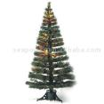
All Trees reduced to sell
NOW ONLY $15.00
Normal price range $40 to $60 .
Free
Tree Preservative with every Tree Purchase
50% Off all Ornaments
Mr. Acme’s Customer Guide:
To Keeping Fresh and Safe Christmas Trees

Your tree will look healthy and happy until New Year's if you follow the steps below:

1. | Select the freshest tree possible. Immediately place the tree in water.
2. | Cut 1 inch off the base, place the tree in a bucket of water, and stand it in a cool, shady place if you don't plan to set it up right away.
3. | Cut 1/2 inch to 1 inch off the base of the trunk when you bring it inside to set up.
4. | Place in a tree stand that holds at least 1 gallon of water. Add plain water.
5. | Water the tree every day.
6. | Avoid allowing the water level to drop below the cut end of the trunk. If it does, a seal will form and prevent any more water from being absorbed by the tree. You'll need to make another cut in the trunk if this occurs.
7. | Keep the tree away from the fireplace, vents and other sources of heat.
Use hot water in your stand..
It will melt the seal at the end of the trunk.
ALWAYS USE A TREE PRESERVATIVE
8. Miniature light sets produce less heat than the standard-size lights, so the tree will dry out less quickly if you use them.

.

 Judges Copy
Customer Relations
Christmas Trees
Let’s make the contestant think on their feet on this one. You will be bringing in a Christmas tree that has yellow needles on it. It obviously is not a good tree.

The student is to greet you with something like....Welcome to Acme Nursery, my name is........... how may I help you?

You are to tell the student the following information:
# 1 You are unhappy with the tree as it is dried out and now has yellow needles. You bought the tree November 1st, left it outside along the side of your garage in the sun without giving it any water. It dried up and now you want your money back. Show them your receipt.
Contestant should:
# 1 Restate the problem (Your tree dried out, you left it on the side of the garage in the sun without water)
# 2 Inform you (the customer) that although Acme Nursery sympathizes with you, the store can not be held responsible for your lack of proper tree care (over a month in the sun without water) and can not give you a refund.
# 3 Offer to sell you another tree, they should point out that today there is a special on trees and they are reduced to the low price of $15.00.
Judge:
Put up a little resistance, see if you can get them to bite on giving you a refund first and then agree to purchase another tree as you look back on things you didn’t do the right thing to keep your tree fresh.
Contestant should:
# 1 Sell you the tree of your choice for $15.00 (AGREE TO BUY)
# 2 Inform you that you get FREE Tree Preservative (ACCEPT)
# 3 Offer to sell you ornaments at 50% Off (AGREE TO BUY)
BUY 1 MORE ITEM IF THE STUDENT OFFERS (stop buying after this).
#4 Ask if this solves your problem and thank you for shopping at Acme Nursery

BONUS POINTS:
The contestant should offer to give you tips for keeping a tree green, they can do this verbally or offer you the information sheet so you won’t make the same mistake again.
(The receipt is attached on the next page)

Sales Receipt
Acme Nursery
Nov. 1, 2005

Customer: Chris Moss
1313 13th Street
Walla Walla, WA 99362

Item
1 Christmas Tree $50.00
1 Battery Charger $90.00
Total $140.00

Order Taking Practicum



For contests or classroom demonstration it is recommended to include the following:

Advertisement …As listed in weekly newspaper
Student information sheet
Judges instruction sheet
Order Form

Order Taking
Overview

- Practicum time guidelines
10 minutes to study scenario & supporting materials
10 minutes to demonstrate skills
Warning at 7 minutes

- Scenario
Scenario will be selected for a typical agricultural supply company

- Contest materials
Contestant will be provided with a promotional flyer, catalog, daily bulletin or other related promotional material
Contestant will be provided with an order form and any updated materials such as out of stock or priced reduced items.

- Customer comes into store
Use a pleasant and business like voice
Welcome customer to store
Ask if you can be of assistance

- Clarify and confirm order
Repeat items
Include product #’s
Confirm availability

- Suggestive/Consultative selling
Specials
Substitutions on out of stock items

- Closing the Order
Repeat the order
Ask for other needs
Confirm delivery

Tips for Successful Order Taking

1. Projecting a good image

a. Use business like phrases instead of slang. Say “Yes,” “Certainly” and “Of course” instead of “OK”.
b. Be a good listener, make notes while the caller is speaking.
c. Always acknowledge a request.
d. Show that you are interested by using the caller’s name.
e. Be tactful when it’s necessary to refuse a request.

2. Developing an effective business voice

a. Put a smile in your voice by using basic phrases of courtesy such as “Please,” “Thank you” and “You’re welcome.”
b. Try to vary your phrases to suit the condition.
c. Show a sincere interest to the customer
d. Save candy and gum until after your conversation.
e. Speak clearly and distinctly. Talk directly to the customer f. Vary your tone but avoid extremes of loudness or softness.
g. Talk at a moderate rate, not too fast or too slow.

3. Order taking
- Repeat the order as you take it down
- Review the entire order upon completion
- Suggestive selling:
- Ask if the customer is interested in any specials
- Ask if there is anything else the customer wants, try to be specific (if they are ordering animal feed ask if they need any other type of feed or feed related supplies on the order form)
- Ask for directions to their farm/home (if product is to be
delivered), repeat directions back to the customer clarifying any details.
- Thank the customer for their order and ask the generic question
“will that be everything?”

Advertisement as seen in weekend edition of local newspaper

1313 13th St.
Anytown, USA
559-591-7522
NOW taking Orders on Christmas Trees.

Tree orders received before Dec. 15 receive a 50% DISCOUNT.

Winter Spectacular Sale

All shrubs in stock

Newcomer Special
To welcome people to Anytown USA, Acme Lawn and Garden is offering Free Installation on Bedding Plants and Ornamentals Purchased in the month of December.

Order Taking

Contestant Copy

Acme Lawn and Garden

Scenario:
You (contestant) are to assume the role of a sales clerk for Acme Lawn and Garden.

Acme Lawn and Garden is your city’s largest Lawn and Garden store catering to both home owners and contractors. Presently, your city is enjoying a building boom as three new manufacturer’s have moved into town. With all of this new growth in your city, Acme Lawn and Garden has asked their sales clerks to provide helpful information to their customers.

It is now late fall—early winter. Acme Lawn and Garden has recently run a full page advertisement in the local newspaper promoting their fall—early winter specials.
Manager’s
Daily Update

OUT OF STOCK ITEMS
BEDDING PLANTS
Marigolds –Yellow—(replace with Orange Marigolds)
Alyseium (replace with English Button Impatience)

ORNAMENTAL PLANTS
Rhodadendrums (State’s largest producer experienced an unexpected early freeze which killed 100% of their crop) Acme Lawn and Garden is taking orders for next spring. Customer’s may direct order from Coyote Rhoddies at 559-591-7555.

MANAGER’S SPECIAL
Acme Lawn and Garden has just started their own professional landscaping. Customer’s will receive a 10% discount on the cost of their landscaping during the month of December.

Order Taking

Judges Instructions

Acme Lawn and Garden

You are to assume the role of a homeowner NEW to the community. You walk into Acme Lawn & Garden to place an order. You are in the process of landscaping your new home even though it is the first week of December, as you want to make your first Christmas in Anytown, USA special for you and your family.

The sales clerk will take your order. He or she has the same order form you have, plus a daily sheet with specials and out of stock information.

In the discussion of placing the order, mention that you want to have these delivered right away so you can begin the landscaping of your newly purchased home. Your family is moving into your new home within the next week and you want it looking nice and ready for your first Christmas.

The contestant is to be evaluated is to be evaluated on voice quality, pleasantness, accuracy of taking your order, and demonstrate creativity in substituting products and suggesting new products. A score sheet is provided.

You are new to anytown, be sure to mention this to get the Newcomer Special. Your address is 13 Elm St. Your cell phone # is BR5-1313. You would like this order delivered by Friday.

You are to place the following order:

15 Red Geraniums
10 Arbovatie
5 6-packs of yellow marigolds
4 6-packs of Alyseiums
4 Rhodadendrums
2 Paper Birch Trees

Acme Lawn and Garden
Order Form

Date ___________ Order taken by ______________

Customer ______________________________________________

______________________________________________

Delivery Date ________________

Product | Price | Qty | Total $
PLANTS
Geraniums 4" pot | $ 2.00
Geranium 6" pot | $ 3.50
Marigolds Yellow (6 pack) | $ 1.00
Marigolds Orange (6pack) | $ 1.00
Alyseiums (6 pack) | $1.00
English Button Impatience | $1.00
SHRUBS
Rhodadendrums | $10.00
Arbovatie (1 gallon can) | $ 5.00
Arbovatie (2 gallon can) | $ 7.50
Arbovatie (3 gallon can) | $10.00
CHRISTMAS TREES
6' Noble Fir | $20.00
7' Noble Fir | $30.00
8' Noble Fir | $40.00
4' Paper Birch | $ 4.00
Sub Total _________

Tax (8%) _______________

Total __________

Just Roses

1313 13th St.
Smalltown, WA
Red Long Stem Roses

Only $2.00

Red Mini Roses

Now

Only $1.00

Free Delivery
(City Limits Only)

Order Taking

Student Copy

Just Roses

Scenario:

You (contestant) are to assume the role of sales clerk at Just Roses flower shop. Your position includes taking orders to be delivered to customers in town.

You may also need to make recommendations to help undecided customers make decisions.

You are to use the daily update and the newspaper flyer to point out specials and featured products.

Daily Update

Out of stock items
Red mini roses (replace with red short stem roses)
All Glass vases (replace with ceramic vases)

Weekly special
20% off all Organic Roses if scheduled for delivery by Friday of next week

Order Taking
Judge’s Instructions

Just Roses

You are to assume the role of a customer looking to purchase some Roses for your wedding anniversary. You are to enter the Just Roses store and place an order for 12 long stem white roses in a glass vase, one red long stem rose, and 6 mini red roses.
The sales clerk greeting you will take your order. He or she has the same order from you have, plus a weekly sheet of specials and out of stock information.
In the discussion of placing the order, mention that you want to have them delivered the next day because your anniversary is tomorrow.
The contestant is to be evaluated on voice quality, pleasantness, accuracy of taking your order, and demonstrate creativity in substituting products and suggesting new products. A score sheet is provided.

You are living in Smalltown, your address it 489 Cell St. Your phone number is 524-6889.

Remember tomorrow is your wedding anniversary. It is imperative the flowers are delivered the next day.

Just Roses
Order Form
Date ________
Customer __________________________________
__________________________________

Delivery Time ______________________________

Product | Price | Qty | Total
Roses
Red, Long Stem | $2.50
Dozen, Red Long Stem | $30.00
Dozen, White Long Stem | $30.00
Red Mini | $1.35
Dozen, Red Mini | $11.00
Red, Short Stem | $.75
Organic, Red Long Stem | $3.25
Dozen, Organic Long Stem | $35.00
Miscellaneous
8” Glass Vase | $10.00
6” Glass Vase | $7.50
8’ Ceramic Vase | $6.00
6” Ceramic Vase | $4.00
Cards
Any Occasion | $.50
Sub-Total
Tax (8 %)

Total

Bob’s Gardening Tools and Supplies
1313 13th Street

Nowhere, USA

All Shovels

30% O ff
Wheel Barrows
$20.00 Off

Free delivery only within city limits.

$15 Dollars for outside city limits

All Sales are Final on Sales items.

Order Taking

Student Copy

Bob’s Gardening Tools and Supplies

Scenario

You are to play the role of a sales clerk at Bob’s Gardening Tools and Supplies. Part of your job will be assisting customer and taking orders for delivery to customers in the area.

You can also help customers with decisions on what they should by, and answer any questions that are brought up.

You are to use the newspaper advertisement to recommend specials that are listed for the sale.

=============================================================

Bob’s Gardening Tools and Supplies

Daily Update

Out of Stock Items

Metal wheelbarrows until Monday of next week, replace with Rubbermaid wheelbarrows.

Managers Special

Today only, 35% off all hedge trimmers.

Order Taking Practicum

Judge’s Instructions

Bob’s Gardening Tools and Supplies

You are to assume the role of a ranch owner that is looking to purchase tools for your ranch. You are to walk into Bob’s Gardening Tools and Supplies to place your order. You want your order delivered by next Wednesday.

The sales person will take your order. He or she will have the same order form as you and also the same daily sheet with specials and out of stock items.

In the discussion casually mention you will be carrying around supplies that are heavy and are looking for something to help lighten your load.

The contestant is to be evaluated on voice quality, pleasantness, accuracy of taking your order, and demonstrate creativity in substituting new products. A score sheet is provided.

You are a long-term customer in good credit standing with Bob’s Gardening Tools and Supplies. Your address is 121314 Red Street, which is two miles out of city limits. Your home number is 555-1234, your work number is 555-9876

You’re Order:
4 Shovels
2 Pitch Forks
6 Bags of Soil
30 Fence Posts
100 Feet Fencing Wire
2 Boxes of Fencing Staples

Remember to mention the heavy moving.

Bob’s Gardening Tools and Supplies
Order Forms

Date___________ Order taken by:

Customer Delivery date

Product | Price | QTY | Total $
Tools
Bucket Shovel | $12.00
Steel Shovel | $15.00
Square Shovel | $15.00
Small Shovel | $4.50
4 prong pitch fork | $13.50
5 prong pitch fork | $15.00
12 prong pitch fork | $24.50
Rubbermaid Wheel barrow | $45.00
Lawn Mower | $200.00
Metal Wheel Barrow | $55.00
Hedge Trimmer | $70.00
Chemicals
Herbicide | $5.50
Pesticides | $8.50
Fertilizer | $8.00
Slug and Worm Be Gone | $5.00
Supplies
Bags of Soil (50 lbs) | $8.00
Fence Posts | $4.99
Fencing Wire (100 foot roll) | $5.99 per roll
Fencing Staples (10 lb box) | $10
Delivery Charge ______________

Sub Total

Tax ______________

TOTAL

Local weekly newspaper ad for Annie’s Flower Shop listing specials, promotions and other sales related information

Annie’s Flower Shop
1313 13th Street
Anytown, USA

Tomato Plants

Geranium Special !!

4” pots $1.85

6” pots $3.00
Now !!

Beauty Bark
Was $5.00 a bag

This week only $4.00 a bag

On every order over $100
** Inside city limits. $10 outside of city limits

All specials subject to availability

All sales prices good for this current week only!

Order Taking Practicum

Student Copy

Annie’s Flower Shop

Scenario:

You (contestant) are to assume the role of a sales clerk for Annie’s Flower Shop. Part of your job is assisting customers and taking orders for customers within your town.

You may also help the customer and make recommendations.

You are to use the newspaper flier and daily update to recommend specials and featured products.

Daily Update

Out of stock items
Beauty Bark until next week
Begonia Baskets (replace with Strawberry Begonia Baskets at the
same price as the Begonia Baskets)

Managers Special
40% discount NOW $4.80 on all Poplar Hi-Bred Trees (make great windbreaks) if ordered now for delivery by the 1st week of next month.

Order Taking Practicum

Judge’s Instructions

Annie’s Flower Shop

You are to assume the role of a homeowner looking to purchase spring flowers for your yard. You are to walk into Annie’s Flower Shop to place a spring time order to beautify your home. You wish to have this order delivered before the upcoming weekend.

The sales clerk greeting you will take your order. He or she has the same order form you have, plus a daily sheet with specials and out of stock information.

In the discussion of placing the order, you should casually mention that you plan on planting a windbreak along your back fence sometime later this spring.

The contestant is to be evaluated on voice quality, pleasantness, accuracy of taking your order, and demonstrate creativity in substituting products and suggesting new products. A score sheet is provided.

You are a long-term customer in good credit standing with Annie’s Flowers but have recently moved. Your new address is 145 Mocking Bird Lane, which is exactly 1 block south of City Hall.

You are to place the following order:

10 Tomato Plants
- Geraniums (wait for them to ask for the size)
6” pots
3 Fuchsia baskets
2 Lincoln Douglas Fir Trees (small ready for planting)
Remember to mention your plans to build a tree wind break later in spring

Ann

Annie’s Flower Shop
Order form

Date ________________ Order taken by: __________________

Customer ___________________ Delivery date ____________________

Product | Price | Number | Total $
PLANTS
Geraniums (4” pots) | $2.00 | _________ | ___________
Geraniums (6 “ pots) | $3.50 | _________ | ___________
Fuchsia Baskets | $10.00 | _________ | ___________
Marigolds (Pack of 4) | $.50 | _________ | ___________
Tomato Plants | $ .30 | _________ | ___________
Begonia Baskets | $3.50 | _________ | ___________
Strawberry Begonia Baskets | $3.75 | _________ | ___________
ORNAMENTALS
Peony (1 gallon container) | $12.00 | _________ | ___________
Peony (2 gallon container) | $17.00 | _________ | ___________
NURSERY STOCK
Douglas Fir (1 gallon container) | $3.00 | _________ | ___________
Scotch Pine (1 gallon container) | $3.00 | _________ | ___________
Hi-Bred Poplar (1 gallon size) | $8.00 | _________ | ___________
TOTAL AMOUNT _________

$10.00 delivery charge if out of city limits _________
ORDER TOTAL _________

Order Taking Skills
State Contest 2001

Student Copy

Far Better Feeds

Scenario

You are the customer service representative for Far Better Feeds, a feed store in Ruraltown, USA. Part of your job is greeting customers and taking orders for delivery to customers in your region. Your customer today has a good credit rating with your company.

You also help customers with questions and make recommendations for their animals. You are given a daily update of the changes in inventory and products on special.

Today's update is as follows:

Horse Feeds:

Out of Senior Horse, will have the new shipment in 10 days. Replace with Mare Magic for same price.
Special on "Up and At' Em" minerals, was $20, now $18 for 25 lbs.

Swine Feeds:

Introducing "Pork Pride", a grower/finisher for maximum gains. 16% protein and high energy. $11 per 50 lbs. Buy 10 bags and get a free microwave bacon try.

Livestock Feeds:

Pasture Partner Mineral Blocks: Taking orders for minimum 10 block deliveries in May and June. Orders placed before April 1st receive a 10% discount. Deliveries can be made in May and June and billed at end of that month of delivery.

Lamb Creep 12%: Discontinues. Substitute Ewe 2, a combination lamb creep and lactating ewe supplement. Both priced at $5 per 50 lbs.

Deliveries in South County are on Thursdays. There is a $10 delivery charge for orders under $200.

Order Taking Skills

Judges Instructions

Far Better Feeds

You are Bob (or Betty) Smith, owner of a diversified livestock and hog ranch, located in the southern end of Big Valley County, Oregon. You are to enter Far Better Feeds, your supplier of bagged feeds for your operation. You wish to place an order for delivery next week.

The customer service representative will take your order. He or she has the same order form you have, plus a daily sheet with specials and out of stock information.

In the discussion of placing the order, you should casually mention that you will be turning the cattle out to pasture in May.

The contestant is to be evaluated on voice quality, pleasantness, accuracy of taking your order, and demonstrate creativity in substituting products and suggesting new products.

You are a long-term customer in good credit standing at Far Better Feeds.

You are to place the following order:

5 Trail Rider
10 Senior Horse
5 Pork Pride
10 More Boar
10 Lamb Creep
5 Brood Cow Maintenance

DON'T FORGET TO MENTION YOU WILL TURN OUT TO PASTURE IN MAY, BUT WAIT FOR THE CONTESTANT TO SUGGEST A PRODUCT FOR PASTURE CATTLE!!!

Go ahead and accept the suggestions made by the contestant, and evaluate their appropriateness afterward.

Far Better Feeds
Order Form

Date ________________________________ | Order Taken By ________________________
Customer ____________________________ | Delivery Date __________________________

Product | 50 lb./ Price | Number | Total $
Horse Feeds
Foal Fury | 7.00 | _____ | _____
Trail Rider | 4.00 | _____ | _____
Up and At 'Em | 20.00 | _____ | _____
Mare Magic | 8.00 | _____ | _____
Senior Horse | 7.00 | _____ | _____
Lard Butt | 3.50 | _____ | _____
Swine Feeds
Pork Pride | 12.00 | _____ | _____
Grow and Go | 10.00 | _____ | _____
Sow Power | 8.00 | _____ | _____
More Boar | 9.50 | _____ | _____
Livestock Feeds
Lamb Creep | 5.00 | _____ | _____
Ewe-2 | 5.00 | _____ | _____
Lamb Finisher | 6.00 | _____ | _____
Shepherd's Pride Finisher | 7.00 | _____ | _____
Pasture Partner Beef Block | 10.00 | _____ | _____
Brood Cow Maintenance | 6.00 | _____ | _____

Total Amount __________

$10 delivery charge if under $200 __________

Order Total __________

Order Taking Practicum

Student Information
Tri-Cities Ranch Supply
You are the sales representative for the Tri-Cities Ranch Supply located in Pasco, WA. Your sole responsibility is to greet customers and take orders from ranchers in the local area who purchase at your store. Each month you are supplied with an updated price list and order form that is used for telephone orders. Also, daily you are supplied with an updated bulletin that lists discounted or out of stock items as well as other needed information.

For this event you should familiarize yourself with the price list and the updated bulletin. Your judge will act as the customer and will call you to place an order. You will be evaluated on your skills in accurately taking the order, creativity, personality, suggestive selling, as well and gaining appointments for your technical consultants that suggest new products to ranchers in your area.

The customer entering your store has an established account with Tri-Cities Ranch Supply, is in good credit standing, and may charge the order to their account. Tri-Cities Ranch Supply offers free delivery for all charged orders.

Tri-Cities Ranch Supply
123 Humboldt Street
Pasco, WA 99340

Price list and order form for the month of March 2005

Customer Name __________________________
Customer Address ________________________
Delivery Date ____________________________

Grain Size Price Quantity Total Price
Oats 50# 5.00 _______ _________
Cracked corn 50# 6.00 _______ _________
Rolled grain mix 50# 7.50 _______ _________
Wheat 50# 5.50 _______ _________
Cracked grain mix 50# 6.00 _______ _________

Hay Size Price Quantity Total Price
1st Cutting Alfalfa 1 bale 5.00 _______ _________
2nd Cutting Alfalfa 1 bale 6.00 _______ _________
3rd Cutting Alfalfa 1 bale 7.00 _______ _________
Timothy hay 1 bale 5.50 _______ _________
Straw 1 bale 4.00 _______ _________

Supplements Size Price Quantity Total Price
Loomix 1 ton 125.00 _______ _________
Bloat block 20# block 6.00 _______ _________
20% Protein Blocks 20# block 7.50 _______ _________
WINTER PLUS 1 ton 145.00 _______ _________

SPECIAL DELIVERY Instructions:

Tri-Cities Ranch Supply
123 Humboldt Street
Pasco, WA 99340

Student Copy

Daily Bulletin:

Loomix supplement is out of stock this week. It is expected to be in stock on March 25th. Replace with WINTER PLUS for the same price.

Sale on oats today-buy 10 bags get two bags free.

Discontinued cracked grain mix. Replace with rolled grain mix.

10% sale on meadow hay this entire week.
20% sale on 2nd cutting alfalfa hay this entire month.

Spring special for straw-on orders received in the month of March
there will be a 10% discount, with delivery in April. The account
will not be billed until delivery.

Order Taking Practicum
Tri-Cities Ranch Supply

Judges Copy

You are Chris Shoemaker and you have account with Tri-Cities Ranch Supply. You are entering the store to place an order and you want it delivered two weeks from today to your ranch. Your address is 2020 Butte Road, Pasco, WA 99340. Your telephone number is 752-5600.

Be sure to mention somewhere in the conversation that you will start calving within the next 3 weeks and you are out of straw. Don’t order any straw unless they tell you about the special. If they do tell about the Spring Special order 100 bales of straw.

You want to place an order for the following:

3 ton of LOOMIX supplement
20 bales of 2nd cutting alfalfa
10 bags of cracked grain mix
30 bales of Timothy hay
20 bags of cracked corn
50 blocks of bloat block

You also would be interested in the technical consultant coming to the ranch to review your winter nutritional program. You will be available any weekday or Saturday in the month of March or April.

Take the student's recommendations for any replacements or suggestions for products.

Local weekly newspaper ad for Acme Fertilizer and Chemical Company listing specials, promotions and other sales related information

Acme Fertilizer and Chemical Company
1313 13th Street
Anytown, USA
Special

16 oz Spray Bottles

of Round Up

$8.95

50 lb bags of 16-16-16

Now !!

Curtail
Was $50.00 a gallon

This week only $45.00 a gallon

On every order over $100

All specials subject to availability

All sales prices good for this current week only!

Order Taking

Contestant Copy

Acme Fertilizer and Chemical Company
Scenario:

You (contestant) are to assume the role of a sales clerk for Acme Fertilizer and Chemical Company. Part of your job is assisting customers and taking orders for delivery to customers within your town.

You may also help the customer and make recommendations.

You are to use the newspaper flier and daily update to recommend specials and featured products.

Daily Update

Out of stock items
Rubber gloves
Malathion (replace with New & Improved Malathion at the
same price as regular Malathion)

Managers Special
NOW $4.80 a 32 oz box of Slug Bait

Acme Fertilizer and Chemical Company have just added crop consulting as part of their new full service image. Jim Smith is the new field man is willing to make calls updating customers on all of the newly developed products and new regulations.

Order Taking

Judge’s Instructions

Acme Fertilizer and Chemical Company

You are to assume the role of a crop farmer looking to purchase spring chemicals for your yard and farm. You are to enter the Acme Fertilizer and Chemical Company store to place a spring time order for your yard and farm. You wish to have this order delivered before the upcoming weekend.

The sales clerk assisting you will take your order. He or she has the same order form you have, plus a daily sheet with specials and out of stock information.

In the discussion of placing the order, you should casually mention that you are concerned about the new regulations and how they might affect you.

The contestant is to be evaluated on voice quality, pleasantness, accuracy of taking your order, and demonstrate creativity in substituting products and suggesting new products. A score sheet is provided.

You are a long-term customer in good credit standing with Acme Fertilizer and Chemical Company but have recently moved. Your new address is 1234 Mocking Bird Lane. Driving directions are: go south 5 miles on County Landfill road, and then turn right onto Mocking Bird Lane. Your place is the 3rd driveway on the left side of the road. You are to place the following order:

10 50 lb bags of 16-16-16
2 16 oz spray bottles of Round Up
3 Pairs of rubber gloves
2 Gallons of Malathion
1 16 oz box of Slug Bait Important Note: The student should recommend the 32 oz Slug Bait Special

During the conversation, mention you are very concerned about all of the new chemical regulations being imposed by the State.

Acme Fertilizer and Chemical Company
Order form

Date ________________ Order taken by: __________________

Customer ___________________ Delivery date ____________________

Product | Price | Number | Total $
Herbicides
Round Up |  | _________ | ___________
16 oz bottles | $11.95 | _________ | ___________
32 oz bottles | $21.95 | _________ | ___________
Curtail (gallon) | $50.00 | _________ | ___________
Malathion (gallon) | $49.95
New & Improved Malathion (gallon) | $59.95
Pesticides |  | _________ | ___________
Slug Bait |  | _________ | ___________
16 oz box | $5.00 | _________ | ___________
32 oz box | $8.00
General Supplies
Rubber gloves | $8.95 | _________ | ___________
Leather gloves | $14.95 | _________ | ___________
Rubber boots | $12.95
Fertilizers
16-16-16 (50 lb bag) | $6.95 | _________ | ___________
Urea (50 lb bag) | $7.00 | _________ | ___________
 |  | _________ | ___________
TOTAL AMOUNT _________
TAX _________

$10.00 delivery charge _________

ORDER TOTAL _________

Local weekly newspaper ad for Acme Fertilizer and Chemical Company listing specials, promotions and other sales related information

Acme Fertilizer and Chemical Company
1313 13th Street
Anytown, USA
Now !!

50 lb bags of 48-0-0

Special

2-4-D Spray Bottles

$7.95

Round-Up
was $50.00 a gallon
This week only!
$45.00 a gallon



ALL SALES PRICES GOOD FOR THIS WEEK ONLY!

Order Taking

Contestant Copy

Acme Fertilizer and Chemical Company
Scenario:

You (contestant) are to assume the role of a sales clerk for Acme Fertilizer and Chemical Company. Part of your job is assisting customers and taking orders for delivery to customers within your town.

You may also help the customer and make recommendations.

You are to use the newspaper flier and daily update to recommend specials and featured products.

Daily Update

Out of stock items
Rubber gloves
Diazonon (replace with New & Improved Diazonon at the
same price as regular Diazonon)

Customer Appreciation Special on Premium Leather Gloves
NOW 75% Off Let R Buck leather gloves

Acme Fertilizer and Chemical Company have just added crop consulting as part of their new full service image. Jim Smith is the new field man is willing to make calls updating customers on all of the newly developed products and new regulations.

Order Taking

Judge’s Instructions

Acme Fertilizer and Chemical Company

You are to assume the role of a crop farmer looking to purchase spring chemicals for your yard and farm. You are to enter the Acme Fertilizer and Chemical Company store to place a spring time order for your yard and farm. You wish to have this order delivered before the upcoming weekend.

The sales clerk assisting you will take your order. He or she has the same order form you have, plus a daily sheet with specials and out of stock information.

In the discussion of placing the order, you should casually mention that you are concerned about the new regulations and how they might affect you.

The contestant is to be evaluated on voice quality, pleasantness, accuracy of taking your order, and demonstrate creativity in substituting products and suggesting new products. A score sheet is provided.

You are a long-term customer in good credit standing with Acme Fertilizer and Chemical Company but have recently moved. Your new address is 1234 Mocking Bird Lane. Driving directions are: go south 5 miles on County Line road, and then turn right onto Freedom Lane. Your place is the 3rd driveway on the left side of the road. You are to place the following order:

10 50 lb bags 48-0-0
2 2-4-D spray bottles
3 Pairs of rubber gloves
2 Gallons of Malathion
2 pair Leather gloves Important Note: The student should suggest you
purchase the Let R Buck gloves since they are on special and are
premium quality

During the conversation, mention you are very concerned about all of the new chemical regulations being imposed by the State.

Acme Fertilizer and Chemical Company
Order form

Date ________________ Order taken by: __________________

Customer ___________________ Delivery date ____________________

Product | Price | Number | Total $
Herbicides
2-4-D |  | _________ | ___________
16 oz bottles | $11.95 | _________ | ___________
Round-Up (1/2 gallon) | $27.95 | _________ | ___________
Round-Up (gallon) | $50.00 | _________ | ___________
2-4-D (gallon) | $49.95 | _________ | ___________
Pesticides |  | _________ | ___________
Malathion (gallon) | $49.95 | _________ | ___________
New & Improved Malathion (gallon) | $59.95 | _________ | ___________
General Supplies
Rubber gloves | $8.95 | _________ | ___________
Leather Gloves | $9.95 | _________ | ___________
LET R Buck Leather gloves | $20.00 | _________ | ___________
Rubber boots | $12.95 | _________ | ___________
Fertilizers
16-16-16 (50 lb bag) | $6.95 | _________ | ___________
48-0-0 (50 lb bag) | $10.00 | _________ | ___________
TOTAL AMOUNT _________
TAX (8%) _________

ORDER TOTAL _________

2002 National FFA Ag Sales Career Development Event

“Order Taking”
Scenario

You are the customer service representative for Gain Buster Feeds, a feed store in Countryville, USA. Part of your job is assisting customers and taking orders for delivery to customers in your region. Your customer calling today has a good credit rating with your company.

You also help customers with questions and make recommendations for their animals. You are given a daily update of the changes in inventory and products on special.

Today’s update is as follows:

Horse Feeds:

Out of Giddy -up, will have new shipment in 7 days. Replace with Miracle Mare for same price.
Special on “Jump Start” minerals, was $25, now $22 for 25 lbs.

Swine Feeds:

Introducing “Hog Wild”, a grower/finisher for maximum gains. 16% protein and high energy. $11 per 50 lbs. Buy 15 bags and get a free smoked ham roast.

Livestock Feeds:

Pasture Partner Mineral Blocks: Taking orders for minimum 10 block deliveries in May and June. Orders placed before April 10th receive a 15% discount. Deliveries can be made in May and June and billed at end of that month of delivery.

Lamb Creep 12%: Discontinued. Substitute Super Ewe 2, a combination lamb creep and lactating ewe supplement. Both priced at $5 per 50 lbs.

Deliveries in Newton County are on Wednesdays. There is a $15 delivery charge for orders under $225.

Gain Buster Feeds
Order Form

Date _________________

Order Taken By ____________________

Customer _____________________ Delivery Date _______________

50 lb
Product Price Number Total $

Horse Feeds

Foal Fury $7.00 ______ _______
Trail Rider $4.00 ______ _______
Jump Start $25.00 ______ _______
Miracle Mare $8.00 ______ _______
Giddy-up $7.00 ______ _______
Lard Butt $3.50 ______ _______

Swine Feeds
Hog Wild $11.00 ______ _______
Grow and Go $10.00 ______ _______
Sow Power $8.00 ______ _______
More Boar $9.50 ______ _______

Livestock Feeds
Lamb Creep $7.00 ______ _______
Super Ewe-2 $7.00 ______ _______
Lamb Finisher $8.00 ______ _______
Shepherd’s Pride Finisher $9.00 ______ _______
Pasture Partner Beef Block $15.00 ______ _______
Brood Cow Maintenance $8.00 ______ _______

Total Amount ________

$15 delivery charge if under $225 ________

Total of Order ________

Order Taking Skills
Customer Instructions

You are Bob (or Betty) Jones, owner of a diversified livestock and hog ranch, located in the southern end of Brown County, Iowa. You are to enter the Gain Buster Feeds store, your supplier of bagged feeds for your operation. You wish to place an order for delivery next week.

The customer service representative will take your order. He or she has the same order form you have, plus a daily sheet with specials and out of stock information.

In the discussion of placing the order, you should casually mention that you will be turning the cattle out to pasture in May.

The contestant is to be evaluated on voice quality, pleasantness, accuracy of taking your order, and demonstrate creativity in substituting products and suggesting new products.

You are a long-term customer in good credit standing at Grain Buster Feeds.

You are to place the following order:

5 Foal Fury
10 Giddy-up
10 Hog Wild
5 More Boar
10 Lamb Creep
5 Brood Cow Maintenance

DON’T FORGET TO MENTION YOU WILL TURN OUT TO PASTURE IN MAY, BUT WAIT FOR THE CONTESTANT TO SUGGEST A PRODUCT FOR PASTURE CATTLE!!!

Go ahead and accept the suggestions made by the contestant, and evaluate their appropriateness afterward.

Contestant Copy
Order Taking
Acme Bait and Tackle Shop

Scenario:
You (contestant) are to assume the role of a sales clerk for Acme Bait and Tackle Shop. Part of your job description is greeting customers, taking orders for delivery and offer suggestive selling on specials.

Acme Bait and Tackle Shop is located in the heart of the best fishing area in the nation. Presently, the fishing is unbelievably good and the phone has been ringing off the hook with orders. Unfortunately, with the unusually high sales volume, Acme Bait and Tackle Shop have run out of several items. Fortunately your supplier will be making a delivery tomorrow morning.


Manager’s Update
OUT OF STOCK ITEMS
Live Worms – replace with artificial worms at live worm price
Berklee Powerbait (Salmon) replace with Berklee Powerbait (Orange)
Red Dot Special lures are out of stock for the next three weeks-replace with Green Monster at the Red Dot price

MANAGER’S SPECIAL
50% Off all fishing poles

Judges Copy
Order Taking
Acme Bait and Tackle Shop

Assume the role of a local sportsman entering Acme Bait and Tackle Shop. It is morning and you wish to go fishing at your favorite fishing hole this afternoon. Since you live 25 miles out of town, you wish to have your spouse pick up the order while in town today at noon. Your spouses name is Sam. DO NOT VOLUNTEER THE NAME, THE STUDENT SHOULD ASK FOR IT!!

The sales clerk (greeting you) has the same order form as you do and will take your order. Be willing to make the substitutions recommended by the store clerk. The store clerk sometime during the ordering process should inform you of the 50% OFF Fishing Pole Sale.

You wish to charge this order to your VISA account. Your VISA number is 1234 5678 9876 5432. Wait for the student to ask for your number - - DO NOT VOLUNTEER IT UNLESS ASKED.

Your order:

3 dozen live worms
3 Jars of Salmon colored Berklee Powerbait
2 Jars of Pautskee Red fish eggs
1 Spinning reel
1 Casting reel

Acme Bait and Tackle Shop
1313 13th St
Walla Walla, WA 99362
509-555-1234

Customer’s Name: __________________________________
Address: __________________________________________
Phone number: _____________________________________
Order Form
Description | Price | QTY | Total
Bait
Worms per dozen (artificial) | $2.99
Worms per dozen (live) | $1.59
Eggs
Pautskee (Red) per jar | $2.59
Pautskee (Orange) per jar | $2.79
Pautskee (Salmon) per jar | $2.99
Berklee Powerbait (Orange) | $2.99
Berklee Powerbait (Salmon) | $3.19
Lures
Red Dot Special | $1.99
Green Monster | $2.29
Fishing Reels
Spinning | $39.95
Casting | $42.95
Fishing Poles
2 piece | $19.95
3 piece | $24.95
Sub Total
Satisfaction Guaranteed or a FULL refund is offered to the customer
Tax
Shipping
Total

Payment Type: VISA, Master Card, Cash, Acme Bait Charge Acct.
Number: ______________________________________________
Comments: ______________________________________________________

Contestant Copy
Order Taking
Acme Winter Sports House:

You (contestant) are to assume the role of a sales clerk for Acme Winter Sports House. Part of your job description is greeting customers, taking orders for delivery and offer suggestive selling on specials.

Acme Winter Sport House is located at the base of a mountain range. Presently, the winter sport season has been unbelievably good and the phone has been ringing off the hook with orders. Unfortunately, with the unusually high sales volume, Acme Winter Sports house has run out of several items and it appears the manufacturer is completely out of stock as well.



Manager’s Bulletin

OUT OF STOCK ITEMS
Lighter fuel style hand warmers--- replace with battery powered style
Mittens—replace with insulated gloves at the mitten price

MANAGER’S SPECIAL---Today Only
$1,000 Off all snowmobiles

Judges Copy
Order Taking
Acme Winter Sports House

Assume the role of a local sportsman entering Acme Winter Sports House. It is morning and you wish to go have winter fun in the mountains. Somewhere in the conversation, mention that your snowmobile has caught fire and is a total loss.

The sales clerk (greeting you) has the same order form as you do and will take your order. Be willing to make the substitutions recommended by the store clerk. The store clerk sometime during the ordering process should inform you of the $1,000 off on all snowmobiles. If the student offers you the $1,000 off, inform them it is a great deal, but you want to take a few days to look at what other stores have to offer. If they mention the $1,000 off is only good for today buy the Yamaha snowmobile.

You wish to charge this order to your Master Card account. Your Master Card number is 5432 1234 5678 9876 . Wait for the student to ask for your number - - DO NOT VOLUNTEER IT UNLESS ASKED.

ASK FOR THE TOTAL!!

YOU WILL PICK UP THE ORDER LATER IN THE DAY

Your order:

2 lighter fuel style hand warmers
2 pairs of mittens
3 pairs of wool socks
1 quart of 2 cycle oil.

Acme Winter Sports House
1313 13th St
Walla Walla, WA 99362
509-555-1234
Customer’s Name: __________________________________
Address: __________________________________________
Phone number: _____________________________________
Order Form
Description | Price | QTY | Total
Gloves & Mittens
Mitten (insulated) | $12.99
Glove (Leather) | $11.59
Glove (insulated) | $13.95
Boots
Snow-Pack | $42.59
Hiking | $42.79
Hiking (insulated) | $52.99
Socks
Wool (individual) | $ 6.99
Cotton | $ 4.99
Hand Warmers
Battery powered | $11.99
Lighter fuel style | $12.29
Fuels and Oils
2 Cycle oil (quart) | $1.95
Gas line anti-freeze (pint) | $1.25
Snowmobiles
Yamaha | $4,500
Kawasaki | $4,750
Sub Total
Tax 8 %
Satisfaction Guaranteed or FULL refund
Shipping
Total

Payment Type : VISA, Master Card, Cash, Acme Bait Charge Acct.
Number: ______________________________________________
Comments: ____________________________________________

Local newspaper advertisement with this weeks specials

1313 13th St.
Walla Walla, WA
559-591-7522
NOW taking Orders on FFA Wreaths

Wreath orders received before Dec. 1st receive a
50% DISCOUNT.


All Christmas Tree Ornaments

Winter Spectacular
25% Off
100 Foot Outdoor
Christmas Lights

Order Taking
Contestant Copy

Acme Nursery

Scenario:
You (contestant) are to assume the role of a sales clerk for Acme Nursery. Part of your job description is answering the telephone and taking orders for delivery.

Acme Nursery is your city’s largest Lawn and Garden store catering to both home owners and contractors. Presently, your city is enjoying a building boom as three new manufacturer’s have moved into town. With all of this new growth in your city, Acme Nursery has asked their sales clerks to provide helpful information to their customers.

It is now late fall—early winter. Acme Nursery has recently run a full page advertisement in the local newspaper promoting their fall—early winter specials.

Manager’s
Daily Update

OUT OF STOCK ITEMS
50 foot outdoor Christmas lights (replace with 75 foot at the same price as the 50 foot)
25 foot indoor Christmas lights (replace with 30 foot at the same price as the 25 foot)
MANAGER’S SPECIAL
Today only: 25% off all 6 and 8 foot Noble Fir Christmas Trees

Acme Nursery
Order Form
Date ___________
Customer ______________________________________________

______________________________________________

Product | Price | Qty | Total $
CHRISTMAS LIGHTS
20 foot indoor | $ 2.00
25 foot indoor | $ 3.00
30 foot indoor | $4.00
50 foot outdoor | $ 10.00
75 foot outdoor | $15.00
100 foot outdoor | $20.00
WREATHS
Undecorated | $10.00
Decorated | $20.00
TREE ORNAMENTS
Box of 12 | $10.00
Box of 25 | $20.00
CHRISTMAS TREES
6' Noble Fir | $20.00
7' Noble Fir | $30.00
8' Noble Fir | $40.00
7’ Douglas Fir | $20.00
Sub Total _________

Tax (8%) _______________

Total __________

Payment method: Cash Check Acme Nursery Account

Credit Card: VISA Master Card Account # ___________________
Expiration Date ______________________

Order Taking

Judges Instructions

Acme Nursery

You are to walk into Acme Nursery to place an order. State that you are looking for some Christmas decorations to give your house holiday cheer.

The sales clerk will take your order. He or she has the same order form you have, the weekly advertisement plus a daily sheet with specials and out of stock information.

The contestant is to be evaluated on voice quality, pleasantness, accuracy of taking your order, and demonstrate creativity in substituting products and suggesting new products. A score sheet is provided.

You are to place the following order:

- 20 foot indoor lights
- 25 foot indoor lights
- 6 foot Noble Fir
- 100 foot outdoor lights
- Box of 12 Tree Ornaments

Mention that you hope this will give your house the holiday cheer!

The student should mention the 50% off special on the wreaths, if they do purchase two. They should ask if you want decorated or undecorated.
Finalizing the Order, the student should:
- They should restate the order, credit card # etc. They do not need to total the amount.
Plus ask if there is anything else you need and THANK YOU for shoping at Acme Nursery

Order Taking
Contestant Copy

Acme Home & Garden

Scenario:
You (contestant) are to assume the role of a sales clerk for Acme Home and Garden. Part of your job description is answering the telephone and taking orders for delivery.

Acme Home & Garden is your city’s largest Lawn and Garden store catering to both home owners and contractors. Presently, your city is enjoying a building boom as three new manufacturer’s have moved into town. With all of this new growth in your city, Acme Home & Garden has asked their sales clerks to provide helpful information to their customers.

It is now early winter. Acme Home & Garden has recently run a full page advertisement in the local newspaper promoting their early winter specials.

Manager’s
Daily Update

OUT OF STOCK ITEMS
25 lb bags of winter fertlizer, replace with 50 lb bags at same price as 25 lb
Yellow Pansies, replace with Yellow & Blue Pansies at the same price as Yellow

MANAGER’S SPECIAL
Today only: Free Delivery

Local newspaper advertisement with this week’s specials.

Offers good the week of Dec 1 thru Dec 7

800 Abbott Road
Walla Walla, WA
559-591-7522

- All Winter Pansies

 Christmas Trees
Reduced for quick sale
Now 50% OFF

Winter Spectacular
25% Off
All Winter Fertilizers

Acme Nursery
Order Form
Date ___________

Customer ______________________________________________

______________________________________________

Product | Price | Qty | Total $
WINTER PLANTS
Winter Yellow Pansies (Flat of 6) | $ 5.00
Winter Yellow & Blue Pansies (Flat of 6) | $ 6.00
Winter Blue Pansies (Flat of 6) | $ 5.00
WINTER FERTILIZERS
25 lb bag | $6.00
50 lb bag | $10.00
CHRISTMAS LIGHTS
25 foot indoor | $5.00
50 foot indoor | $8.00
30 foot outdoor | $6.00
50 foot outdoor | $10.00
CHRISTMAS TREES
6' Noble Fir | $20.00
7' Noble Fir | $30.00
8' Noble Fir | $40.00
7’ Douglas Fir | $20.00
Delivery Charge $8.00
Sub Total _________

Tax (8%) _____________

Total __________

Order Taking

Judges Instructions

Acme Home & Garden

You are to walk into Acme Home & Garden to place an order. The sales clerk will take your order. He or she has the same order form you have, the weekly advertisement plus a daily sheet with specials and out of stock information.

The contestant is to be evaluated on voice quality, pleasantness, accuracy of taking your order, and demonstrate creativity in substituting products and suggesting new products. A score sheet is provided.

You are to place the following order:
State the item first, then wait for them to ask you how many.

- Flats of 6 Yellow Pansies
5 Flats of 6 Blue Pansies
2 25 lb bags of Winter Fertilzer
2 boxes Indoor Christmas tree lights (they should ask you the length)
State that you are looking for some Christmas decorations to give your house holiday cheer

The student should mention the 50% off special on the Christmas Trees, if they do purchase one. They should ask if you what size and type.

Next: They should ask you how you wish to pay.

Pay for this with your Master Card. They should ask for your Credit Card Number: It is 1234 – 5678 - 9123 - 4567 Expiration date: 11-27-08

Ask to have this order delivered. They should mention free delivery and ask for your address. It is 1313 13th Street, Walla Walla, WA

Finalizing the Order, the student should:
- They should restate the order, credit card #, your address and set a time for the delivery. They should also ask for a phone number at the delivery site. They do not need to total the amount.
- Plus they should ask if there is anything else you need and THANK YOU for shoping at Acme Nursery.

Prospecting
For
New Customers

Prospecting for New Customers

- Time Guidelines
10 minutes to study product description & scenario
10 minutes to interact with judge(s)
7 minute warning

- Contest Materials
Contestant will be given a product description, product background
information and the goal of the sales call

- Goals
Each student will be asked to complete one of two goals.
- Goal # 1 is to take the sales process to the next step (not necessarily to make a sale). This by might be to arrange for an appointment where an expert is to provide technical advice, set up for a follow up visit or to invite the customer to attend an informational meeting.
- Goal # 2 from the product information provided and information gathered by asking questions sell the product to the judge. Remember the contestant will be asked to do either one of the goals.

- Scenario
Contestant will approach judge(s) face to face to make a cold sales call.
By interaction determine if the customer is a prospect. Depending on the goal listed, the contestant will attempt to gain an appointment for a future sales call, invite to an informational meeting, or in some way take the sales call to the next step as clarified in the practicum directions or deemed appropriate for the situation or to sell the product.

- Greeting/opening statement
Clearly identify self and company
Build interest in product/service

- Qualify the prospect
Question for customer needs
Demonstrate good listening skills

- Provide features and benefits
Describe features and benefits appropriate to the prospects needs

- Close the interview or sale
Ask for the order
Ask for an appointment
Review the order or commitment

If you have technical questions about the product, ask your judges for clarification

Prospecting (Presentation/Luncheon Option)
Animal Industry

Healthy Horse

Acme Ranch Supply in Walla Walla, WA has hired you to be their outside salesman. Your job is to qualify customers that may benefit from products that your company carries. You are traveling through the Walla Walla Valley making cold calls to horse ranchers that may benefit from a new product that is given to growing horses. You have a newly developed growth supplement called Healthy Horse. Healthy Horse grain mix is fed to young horses. Healthy Horse is specially formulated to build strong bones and muscles. Horses that have been fed Healthy Horse have 50 % fewer bone splints and disabling bone spurs. Healthy Horse growth supplement fed daily promotes healthy feet. Research studies show that Healthy Horse horses have 60% fewer hoof problems. Additionally, horses that have been fed Healthy Horse do noticeably better in racing events (horse tracks, barrel racing, and other rodeo events). This successful product has been in research for 5 years; however this is the first year Healthy Horse has been available to horse owners.

You are to meet with Koby Proctor, the manager of the Walla Walla Valley’s largest horse ranch. You drive up to the horse ranch and see a person in front of the foaling barns. You have never met anyone associated with this horse ranch and they do not know who you are as well.

You are to prospect the potential customer to see if they may benefit from Healthy Horse. A successful visit will include having her commit to attending a luncheon/presentation at the local Elks Club the last week of this month. At this luncheon hosted by Acme Ranch Supply, the scientist who invented Healthy Horse grain will make a presentation explaining how Healthy Horse is a beneficial to the horse industry.

In addition to Healthy Horse, you have a new internal and external parasite wormer product that lasts for a full year (all others only last for 3 months). This new wormer will be offered at 50% off for those who attend the luncheon.

Prospecting (Selling Option)
Animal Industry

Healthy Horse

Acme Ranch Supply in Walla Walla, WA has hired you to be their outside salesman. Your job is to qualify customers that may benefit from products that your company carries. You are traveling through the Walla Walla Valley making cold calls to horse ranchers that may benefit from a new product that is given to growing horses. You have a newly developed growth supplement called Healthy Horse. Healthy Horse grain mix is fed to young horses. Healthy Horse is specially formulated to build strong bones and muscles. Horses that have been fed Healthy Horse have 50 % fewer bone splints and disabling bone spurs. Healthy Horse growth supplement fed daily promotes healthy feet. Research studies show that Healthy Horse horses have 60% fewer hoof problems. Additionally, horses that have been fed Healthy Horse do noticeably better in racing events (horse tracks, barrel racing, and other rodeo events). This successful product has been in research for 5 years; however this is the first year Healthy Horse has been available to horse owners. The cost of Healthy Horse is $8.99 for a 50 pound bag

You are to meet with Koby Proctor, the manager of the Walla Walla Valley’s largest horse ranch. You drive up to the horse ranch and see a person in front of the foaling barns. You have never met anyone associated with this horse ranch and they do not know who you are as well.

You are to prospect the potential customer to see if they may benefit from Healthy Horse. A successful visit will include having her commit to purchasing Healthy Horse for her horse ranch.

In addition to Healthy Horse, you have a new internal and external parasite wormer product that lasts for a full year (all others only last for 3 months). This new wormer will be offered at 50% off for those who purchase Healthy Horse.


Remember: suggestive selling is good for both the salesman and the customer!

Prospecting New Customers

Contestant Copy

Landscape Contractor

Representing Acme Wholesalers Inc.
You are making a cold call to your cities largest Landscaping Business (Landscaping by Design). Neither you nor your company has done business with this contractor before: or do you know each other. You have driven into the company headquarters and approach the receptionist’s desk. The owner and manager of Landscaping by Design is Nikki Smith.

You are to represent Acme Wholesalers Inc., a supplier of trees, shrubs, ornamental plants, bedding plants, sod, construction materials etc. Your products are of the highest quality and you provide the best warranty of any supplier in the area. Two weeks from now, your company Acme Wholesalers, Inc. will be sponsoring a luncheon and mini trade-show displaying the newest products and techniques in the landscaping business. These new techniques are saving landscapers approximately 10% on both labor and materials. On this cold sales call, you are attempting to get a commitment from Nikki Smith to attend the free luncheon and spend time at the Trade Show looking at your wide selection of plants and the newest ideas in landscaping. The trade show will have factory representatives and Nationally renowned experts demonstrating the latest landscaping techniques. Your goal for this sales call is to get a commitment from Nikki Smith to attend this luncheon/mini-trade show.

In your vehicle you also have a close out special of Azaleas. You are offering a new customer special at half price. This year Azaleas are extremely hard to find due to a freeze in the prime azalea growing area of the country.

Prospecting for New Customers

Judges Notes

Acme Wholesalers

- Judge/Customer shows indifference and is presently satisfied with current
supplier and fertilizer products.

- Contestant must develop a need or desire.

- You must find the right person on the place of business that makes financial and operational decisions.

- You must develop an interest to come to the store or set-up a meeting with the specialist.

- Judges Role

- Contestant must dig out information
- Contestant arrives without on appointment
- Buyer is currently satisfied with what they are doing
- Jude/customer shows indifference.
- Contestant must develop a need or desire
- Note additional sales opportunity with the Azaleas

Prospecting for New Customers

Student Copy

Nursery “Fast Grow”

You are making a cold call to a large nursery operation. Neither you nor your company has done business with this nursery farm; nor do you know each other. You have driven into the driveway and have observed an adult in front of the nursery operation. You know the nursery operation is owned and operated by Samuel Jones. You will make your initial greeting to this person and inquire to speak to Mr./Mrs. Jones.

You represent Far Better Products, a supplier of horticulture products.

Your product line, “Fast Grow” will improve (reduce) growing time by 5%. It can be purchased in liquid or granules. It can be added to any fertilizer product as a supplement or the customer can purchase a complete fertilizer sold by Far Better Products that has the supplement included. In most cases Fast Grow adds about 2% to the total fertilizer cost.

Before a sale can be made, a thorough analysis of the current program should be conducted. Successful first sales call is to get enough commitment from the nursery owner to come to a luncheon and listen to a fertilizer specialist give a talk about Fast Grow. The producer should bring current program information for the fertilizer specialist to evaluate.

You also have another computer software program called Easy Track that will make bookkeeping easy. It can be sold without any substantial training to the customer. It costs $490 and this does come with limited set up and training.

Prospecting for New Customers

Judges Notes

Fast Grow

1. Judge/Customer shows indifference and is presently satisfied with current
supplier and fertilizer products.

2. Contestant must develop a need or desire.

- You must find the right person on the place of business that makes financial and operational decisions.

- You must develop an interest to come to the store or set-up a meeting with the specialist.

- Judges Role

- Contestant must dig out information
- Contestant arrives without on appointment
- Buyer is currently satisfied with what they are doing
- Jude/customer shows indifference.
- Contestant must develop a need or desire
- Note additional sales opportunity such as a computer program and the possibility of getting the whole fertilizer program

Sample Ag. Sales Prospecting

Student/Judge Copy

Far Better Feeds

Theme for year: Animal Industry

You are making a cold call to a hog producer. Neither you nor your company has done business with this farm nor do you know each other. You have driven into the driveway and have observed an adult in front of one of the barns. You know the farm is owned by Chris Jones. You will make your initial greeting to this person and inquire to speak with Mr./Ms Jones.

You represent Far Better Feeds, a supplier of hog supplements.

Your product line, Big Pig, will improve feed conversion by 5%. It can be added as a supplement to the grains on farm, or can be added to a complete mix at the feed mill, depending on the needs of the producer. In most cases, Big Pig adds about 4% to the cost of finishing a hog.

Before a sale can be made, a thorough analysis of the current program should be conducted. A successful first sales call is to get enough commitment from the producer to come to a luncheon and listen to your nutritionist give a talk about Big Pig. The producer should bring their current program information for the nutritionist to evaluate.

You also have another product called Odor Scrubber. It reduces manure odors by neutralizing ammonia. It can be sold without technical analysis of the current program. It costs $50 per gallon and one treatment lasts a month in most operations.

Good luck.

Prospecting for New Customers

Student/Judge Copy

Johnny Appleseed, Inc.

Theme for year: Horticulture

You are making a cold call to an apple producer. Neither you nor your company has done business with this producer nor do you know each other. You have driven into the driveway and have observed an adult in front of the buildings. You know that the farm is owned and operated by Shawn Smith. You will make your initial greeting to this person and inquire to speak to Mr. / Mrs. Smith.

You represent Johnny Appleseed Inc., a supplier of pesticides, fertilizers, and other products used by apple growers.

One of your products, Bug Zap, is new on the market this year and you are the only company selling it. The product is more expensive than others on the market but will reduce the total number of applications to 1/3 of normal or even less. It is applied by spraying on the trees.

Before a sale can be made, a thorough analysis of the current program should be conducted. A successful first sales call is to get enough commitment from the grower to come to a seminar and listen to your company’s expert’s talk about Bug Zap, as well as some other well known products in your product line. The grower should bring along records of his past practices for evaluation and comparison.

Your company also offers custom application of Bug Zap, which will guarantee the results.

Good Luck!

Prospecting (Seminar Option)
Crop Industry

Healthy Plant
Acme Fertilizer and Chemical Supply in Walla Walla, WA have hired you to be their outside salesman. Your job is to qualify customers that may benefit from products that your company carries. You are traveling through the Walla Walla Valley making cold calls to crop farmers that may benefit from a new product that is given to growing plants. You have a newly developed fertilizer/chemical supplement called Healthy Plant. Healthy Plant mix is applied as a post emergence (after the crop is 2 to 3 inches tall) supplement. Healthy Plant is specially formulated to build strong stems and roots. Plants that have been fed Healthy Plant grow 15 % faster. Research studies show that crops using Healthy Plant also are better able to withstand insect attacks and are 25% more disease resistant. Additionally, plants that have received Healthy Plant have increased yields of 20 percent. This successful product has been in research for 5 years; however this is the first year Healthy Plant has been available to farmers. The cost of Healthy Plant is $6.00 for a 100 pound bag which covers 1 acre.

You are to meet with Koby Proctor, the manager of the Walla Walla Valley’s largest diversified crop farmer. You drive up to the ranch and see a person in front of the equipment barns. You have never met anyone associated with this ranch and they do not know who you are as well.

You are to prospect the potential customer to see if they are willing to attend a luncheon at the local Elks club where the inventor of Healthy Plant will be making a presentation. A successful visit will include having her commit to attending this luncheon/presentation hosted by Acme Fertilizer and Chemical Supply.

In addition to Healthy Plant, you have a new style of disposable glove that will protect hands from all types of harmful chemicals and acids. This new disposable glove normally sells for $10.00 for a box of 20, but be offered at 50% off for those who purchase Healthy Plant.

Remember: suggestive selling is good for both the salesman and the customer!

Prospecting (Selling Option)
Crop Industry

Healthy Plant

Acme Fertilizer and Chemical Supply in Walla Walla, WA have hired you to be their outside salesman. Your job is to qualify customers that may benefit from products that your company carries. You are traveling through the Walla Walla Valley making cold calls to crop farmers that may benefit from a new product that is given to growing plants. You have a newly developed fertilizer/chemical supplement called Healthy Plant. Healthy Plant mix is applied as a post emergence (after the crop is 2 to 3 inches tall) supplement. Healthy Plant is specially formulated to build strong stems and roots. Plants that have been fed Healthy Plant grow 15 % faster. Research studies show that crops using Healthy Plant also are better able to withstand insect attacks and are 25% more disease resistant. Additionally, plants that have received Healthy Plant have increased yields of 20 percent. This successful product has been in research for 5 years; however this is the first year Healthy Plant has been available to farmers. The cost of Healthy Plant is $6.00 for a 100 pound bag which covers 1 acre.

You are to meet with Koby Proctor, the manager of the Walla Walla Valley’s largest diversified crop farmer. You drive up to the ranch and see a person in front of the equipment barns. You have never met anyone associated with this ranch and they do not know who you are as well.

You are to prospect the potential customer to see if they may benefit from Healthy Plant. A successful visit will include having her commit to purchasing Healthy Plant for her diversified farm.

In addition to Healthy Plant, you have a new style of disposable glove that will protect hands from all types of harmful chemicals and acids. This new disposable glove normally sells for $10.00 for a box of 20, but be offered at 50% off for those who purchase Healthy Plant.

Remember: suggestive selling is good for both the salesman and the customer!

Prospecting
Crop Industry

2k2 Wheat

Acme Fertilizer and Chemical Supply in South East Washington have hired you to be their outside salesman. Your job is to qualify customers that may benefit from products that your company carries. You are traveling through South East Washington making cold calls to crop farmers that may benefit from a new wheat variety. You have a newly developed variety of wheat called 2k2 Wheat. 2k2 Wheat was specifically bred to build strong stems and roots plus be disease resistant. Since 2k2 Wheat stems are stronger than traditional varieties, 2k2 Wheat resists lodging making harvest on the average 20% faster. Research studies show that 2k2 Wheat also is 30% more disease resistant. Additionally, 2k2 Wheat has increased yields of 20 percent. This successful product has been in research for 5 years; however, this is the first year 2k2 Wheat has been available to farmers.

You are to meet with Koby Proctor the owner of a large wheat farm. You drive up to the farm and see a person in front of the equipment barns. You have never met anyone associated with this farm and they do not know who you are as well. It is common knowledge that recently wheat in South East Washington has been prone to lodging and diseases.

You are to prospect the potential customer to see if they are willing to attend a luncheon at the local Elks club where the inventor of 2k2 Wheat will be making a presentation. A successful visit will include having her commit to attending this luncheon/presentation hosted by Acme Fertilizer and Chemical Supply. The luncheon is scheduled for the last Friday of this month.

In addition to 2k2 Wheat, you have a new style of disposable glove that will protect hands from all types of harmful chemicals and acids. This new disposable glove normally sells for $10.00 for a box of 10, but will be offered at 50% off for those who attend the workshop the last Friday of this month.

Remember: suggestive selling is good for both the salesman and the customer!

If you have technical questions about the product, ask your judges for clarification.

Prospecting
Crop Industry

Dividend Extreme

Acme Crop Supply in Walla Walla, WA has hired you to be their outside salesperson. Your job is to qualify customers that may benefit from products that your company carries. You are traveling through the Walla Walla Valley making cold calls to crop farmers that may benefit from a new product that is a seed treatment (Seed treatment is when seeds are chemically treated to provide maximum protection as the seed germinates and begins to grow). You have a newly developed seed treatment called Dividend Extreme. Dividend Extreme is specially formulated to help prevent foot rot and other diseases that have been greatly reducing yields for Eastern Washington farmers. Research studies show that crops using Dividend Extreme also are better able to withstand smut attacks and are 25% more resistant to diseases found in Eastern Washington. Additionally, plants that have received Dividend Extreme have increased yields of 20 percent. This successful product has been in research for 5 years; however this is the first year Dividend Extreme has been available to farmers.

You are to meet with Koby Proctor, the manager of the Walla Walla Valley’s largest diversified wheat farmer. You drive up to the ranch and see a person in front of the equipment barns. You have never met anyone associated with this ranch and they do not know who you are as well.

You are to prospect the potential customer to see if they are willing to attend a luncheon at the local Elks club where the inventor of Dividend Extreme will be making a presentation. A successful visit will include having her commit to attending this luncheon/presentation hosted by Acme Crop Supply.

In addition to Dividend Extreme, you have a new style of disposable glove that will protect hands from all types of harmful chemicals and acids. This new disposable glove normally sells for $10.00 for a box of 20, but be offered at 50% off for those who attend the luncheon.

Remember: suggestive selling is good for both the salesman and the customer!

2002 National FFA Ag Sales Career Development Event

"Prospecting for New Customers"

You are employed as a sales representative by ‘The Animal Store’ which focuses on products and services to customers who raise and/or keep large animals. The store also includes products/services to the people who have special needs as operators and supervisors of animals. As a new sales representative your assignment is to identify potential customers via appropriate prospecting techniques.

The main product categories provided at ‘The Animal Store’ are described as follows:

- Animal feed- you have a strategic alliance with a regional feed manufacturing company that provides 180 feed rations in bulk, 50 lb. bags, and smaller containers for pets. Special rations can be formulated for those animal producers who have unique nutrition requirements.

- Animal health - an array of products for preventative health care and disease control including: medicated feed antibiotics, antibiotic injections, antibiotic water soluble, vaccines, wormers, and tick & fly control products.

- Animal support products- disinfectants, tack, rope, halters, shampoos and oils.

- Plant nutrients- to produce quality hay and forages for animals, dry pelleted fertilizer products are available in bulk and bag quantities. Application of fertilizer is available.

- Fencing- Fencing and metal products including waters and feed troughs, enclosed feeders, gates, barb and net wire, electric fencing equipment, and tools.

- Clothing- denim pants & shirts, work boots, winter insulated coats, caps & hats.

You are to make a face-to-face call to a potential customer at their home and determine if they qualify as a customer for ‘The Animal Store’. (The customer’s home is located in a sub-division; however, you have heard they have ties to a farm.)

2002 National FFA Ag Sales Career Development Event

Prospecting for New Customers

"Judges Background Information"

You are serving as judge for the "Sales Prospecting" segment of the National FFA Ag Sales Career Development Event. Student contestants need to ask questions to determine the following information regarding your needs for
Animal related products.

You are a potential customer with the following characteristics:
They are visiting you in your home – located in a sub-division.

You own and manage a multi-enterprise animal operation including:
- Confined broiler (poultry) 100,000 head per house rotating every 6 weeks with each 6 week batch requiring 1,200,000 lbs of feed and 7 batches per year = 8.4 million pounds per year. High quality feed and timely deliveries are extremely important to the grower. Your contract with the poultry processing company allows for feed and animal health products to be purchased from other companies.

2. A 200 head herd of mother cows that rely upon poultry litter to meet the nutritional needs of the land and cows;

- You are planning to implement a preconditioning feeder program for
the 160-180 steer and heifer calves that are retained after weaning. The program will last for 2 months (60 days).

The preconditioning feeder program includes…
- A daily feed supplement of 10 lbs./head/day X 60 days =
96,000 to 108,000 pounds during October and November of each year.
- Construction of pens, watering, feeding, and shelter facilities will begin in 6 weeks.

Contestant Copy
Prospecting
Acme Bait and Tackle Shop

Aussie Bait Company of Sidney Australia has hired you to be their sales representative for the Pacific Northwest.

Your job is to find sporting goods store owners willing to attend a regional informational luncheon. You want to be very selective as to the stores you select to carry your product line as Aussie Bait Company will grant an exclusive to one store per trading area (this means only one store per town or shopping area will be allowed to carry the products).

You are traveling through the Pacific Northwest making cold calls to sporting good stores that may benefit from carrying this new product line that is taking the fishing industry by storm. The Aussie Bait Company has a newly developed line of fishing lures, artificial worms and bait scent that is guaranteed to catch fish anytime of the day, regardless of the fishing conditions. The company feels so strongly about the success of their products they will actually give a written warranty with each one of their products sold guaranteeing the catch of fish!!

As you walk into the store you ask to speak with the store manager Rob Trout
(the two of you have never met before). You are to ask him to attend a luncheon presentation hosted by the Aussie Bait Company in the next town (25 miles away). At this luncheon a presentation explaining the technology behind the new fishing product line (lures, artificial worms and bait scent) will be completely explained. Also, at this luncheon a representative of Aussie Bait Company will be explaining the conditions of the contracts granting the exclusive rights to this new product line.

Since your (sales persons) income will be based on a percentage of the store’s sales it is critical that you only select stores that will have a significant sales volume. Remember, due to the way the contract will be written you will only be able to have one store per trading area carry Aussie Bait products.

 If you are uncertain about the product being sold, ask the judges or contest coordinator for clarification.


Contestant Copy
Prospecting
Acme Winter Sports Equipment Inc.

Acme Winter Sports Equipment Inc. has hired you to be their sales representative for the Pacific Northwest.

Your job is to find new clients to attend a luncheon at the local Elk’s club. At this luncheon the inventor of the material used to make the tents will explain all about this new material and factory representatives will explain the contractual agreements with Acme Winter Sports Equipment.

These new winter tents are made out of a new material that is water proof and 100% tear/rip proof. Acme Winter Sports Equipment has also devised a new zipper that has a 5 year warranty against breakage. Since the tents are made out of this new cutting edge material they are approximately 10% more expensive than other similar tents.

You walk into the local sporting goods store “Thunder Sporting Goods” and wish to speak with the owner Dan Price. Neither of you know each other nor have you ever met.

Team Activity



Theme Rotational Pattern
2006 Animal Industry
2007 Crop Industry
2008 Natural Resources
2009 Agriculture Mechanics
2010 Horticulture Industry

A. Team Sales Situation (200 Points)

The Team Sales Situation is the team activity. Members work together to demonstrate group dynamics, problem solving, data analysis, decision making and oral and written communication
skills.
The following information will be provided to the team as if they were a group of professional salespeople:
1. A product (including features and price – if applicable)
2. Market situation (including competition)
3. Several potential customers

The team will then develop all the strategy necessary to prepare to sell the product in a face to face sales call. This strategy should include but not be limited to:
1. Determining potential customer needs and wants.
2. Identifying features and benefits of the products to address customers’
needs and wants.
3. Identifying potential customer objections and prepare to address them.
4. Identifying potentially related products and suggested selling strategies.
5. Developing a sales plan and goals for each customer.

It is critical to remember that in addition to the final presentation being judged, teamwork and equal involvement of all team will also be judged. Also it is critical to not only state what you chose to do, but why you chose to do it. In selling there are no absolute right or wrong answers.

Demonstrating the basic fundamentals necessary to accomplish your goal is essential. Members will be expected to participate. The judges will act as the audience, but will not engage in dialog during the presentation. Participants may utilize any materials provided in the team event for the presentation. It is important that all team members speak up during the entire process so that the judges can hear what is being said, and so they can observe how the team is working together.

Each team will be given twenty-five (25) minutes to examine all information provided, discuss and develop ideas and prepare a presentation. Teams may bring a laptop computer and utilize PowerPoint for their presentations. If a laptop computer is utilized, the presentation will be presented on the laptop screen. Projectors and desktop computers will not be allowed. Each team will be responsible for the power supply for their computer. Each team will then have ten (10) minutes with an eight (8) minute warning to make their presentation
followed by five (5) minutes for questions.

Scoring Criteria for Team Sales Situation

1. Teamwork Evaluation (50 points), 25%
a. Leadership roles easily perceived.
b. Participation by each member of the team.
c. Members demonstrated effective listening and communication skills.

2. Analysis of the information (40 points), 20%
a. Clearly identify the product features and the market for that product.
b. Provided information and data is analyzed and utilized.
c. Demonstrate the use of basic sales skills

3. Quality of the Team’s Solution
(70 points), 35%
a. Identify sales goal for each customer and or market segment.
b. Identify the key benefits of the product.
c. Identify potential customer objections and develop strategies to address those objections
d. Possible solutions are discussed and analyzed.
e. Justify decisions

4. Presentation (20 points) 10%
a. Presents team’s solution.
b. Overall delivery professional and well
thought out.
c. Presentation is clear and effective.
d. All team members participated.

5. Questions are Taken From: (20 points) 10%
a. Teamwork evaluation.
b. Analysis of the information.
c. Presentation

TOTAL - 200 POINTS

Team Activity
High End Mowers

Your team will have 25 minutes to prepare a presentation to the Home Improvement Store Board of Directors.

Your team has been asked to develop a Sales strategy for high end mowers for a large Home Improvement Chain. High end mowers cost $600 which is triple the cost of regular/low end mowers. The life expectancy of low end mowers is 3 years while your companies high end mowers last 20 years. High end mowers have:
- Stronger transmissions
- Larger motors
- Double blades for munching
- Bearings in all the wheels
- A “Stop Feature” that stops the blade while allowing the
motor to continue running (extremely useful when changing bags).

Research shows many high end homes are being constructed and that 25% of these homes have large lawns and want high end mowers to maintain their yards. Additionally, lawn companies are growing at a rate of 10-15% per year.

As the Sales Team, develop a Sales Strategy that takes into consideration the following points:
- Develop potential customers
- Identifies features and benefits
- Identify customer objections
- Identify related products
- Develop a sales plan and goal for each customer

Your team will have 10 minutes to present your plan to the Board of Directors and have 5 minutes for questions.

Team Sales Process
A note of thanks to Ron Crawford for his assistance developing this material.

No. | Category | Description
1. | Teamwork | - Leadership roles defined  - Each member participates  - Effective listening and communication skills | - One member suggests a chairperson  - Chairperson asks/designates other roles | - Chairperson  - Secretary  - Flip Chart person  - Manager/Timekeeper
2. | Identify the Problem | - Clearly identify the problem  - Write on Flip Chart | - Secretary adds to discussion in notes | - Start a new line of high-end lawn mowers in an existing store in Thurston County
3. | Objectives and Goals | - What are the goals in starting a new line of high end lawn mowers | - Short Term Goals  - Long Term Goals  - Production Goals  - Target Market  - Features of Product | - Short Term might be to focus efforts in Thurston County  - Long Term Goals expand to Lewis, Grays Harbor and Pierce  - Our store sells 350 Lawn Mowers per year. Our goal is to sell 100 high end lawn mowers this season  - Do a market analysis of potential market and identify the wants and needs of customers  - Develop a market/advertising plan that spells out the features of product.
4. | Market Analysis | - Analysis of market potential of medium and high-end customers.  - Survey needs and wants of grounds maintenance companies | - Many new high priced homes coming into Thurston County  - Research shows 25% of these people have large lawns and want a high end mower  - Grounds maintenance companies are expanding by 15% per year. | - Grounds maintenance people want mowers that have mulching capabiliti3es  - High End homes want perfect lawns.
5. | Features and Benefits | - High End Mowers have the following features and benefits | - Longer Lasting—20 Years  - Better Transmission and larger motor  - Bearings in all wheels  - Stop feature  - Composite Deck  - Mulching control bar | - Stop feature allows the engine to run when you stop to remove clippings  - Composite deck will last a lifetime
6. | Key Objections and solutions | - High Priced  - Uses more gas | - A $200 mower lasts about 3 years or about $65 dollars per year  - A $600 mower lasts 20 years or about $30 per year | - It uses more gas but mows faster and has a wider deck.  - The mulching feature saves on lawn fertilizer  - Develop an advertising program with flyers, radio spots, and spring store sales to promote the high benefits
7. | Add-ons or companion sales items | - Add-ons or companion sales items should be pushed to add to store profits | * Items include a Free Pick-up Winter Care Program | * Other items might be safety goggles, trimmers, gas cans and edgers.

Sample Power Point Presentation

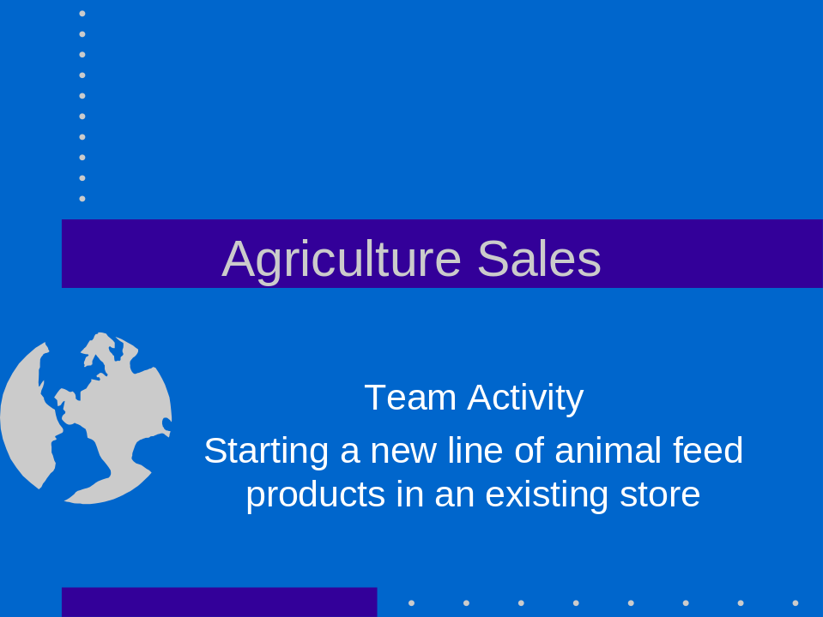

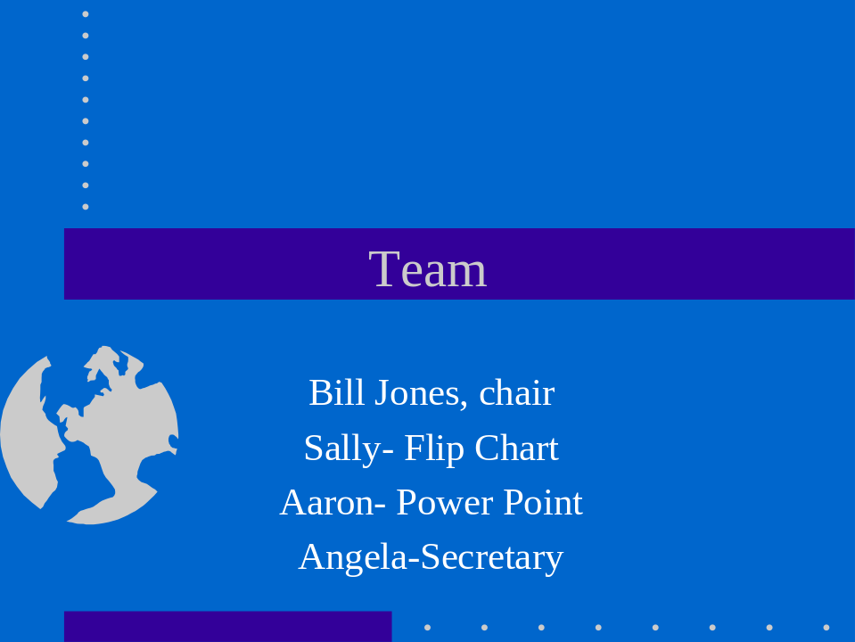

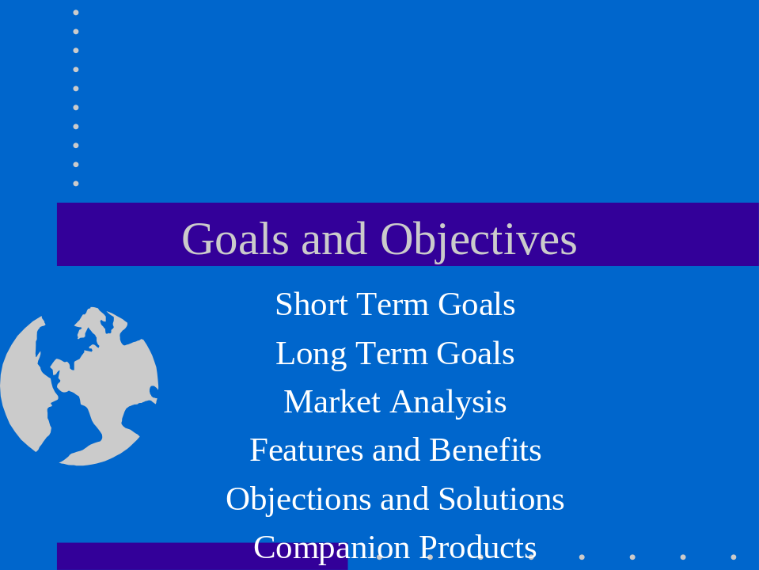

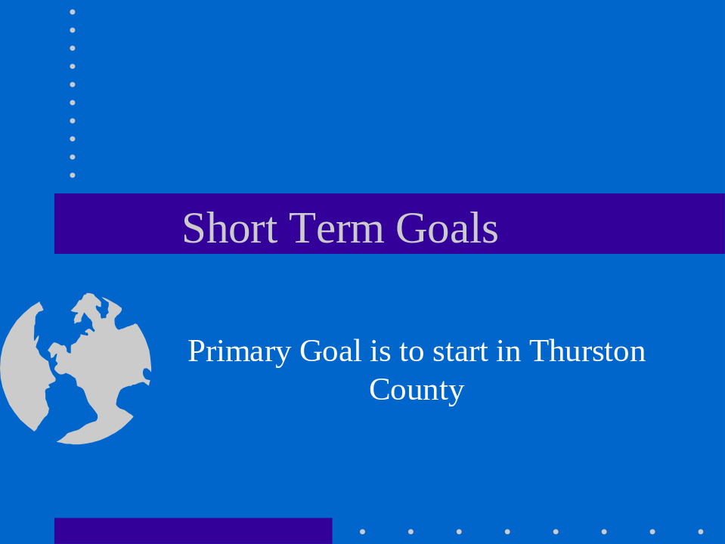

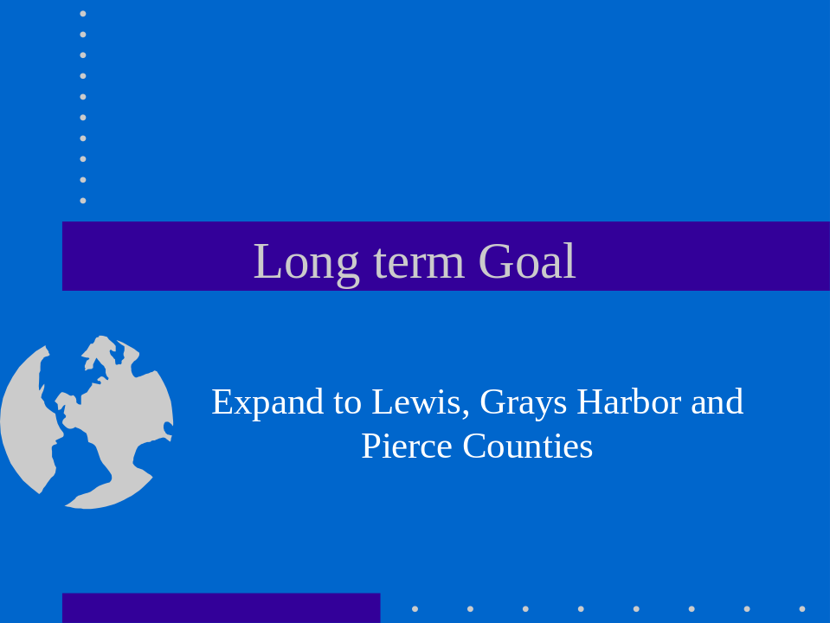

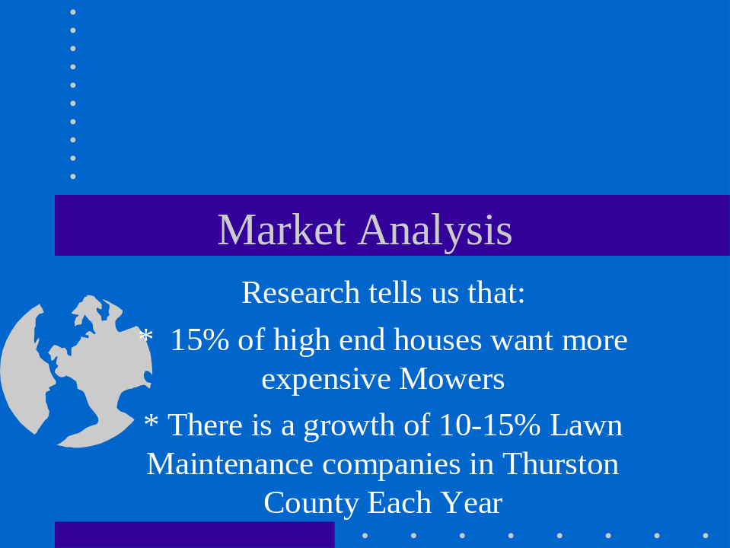











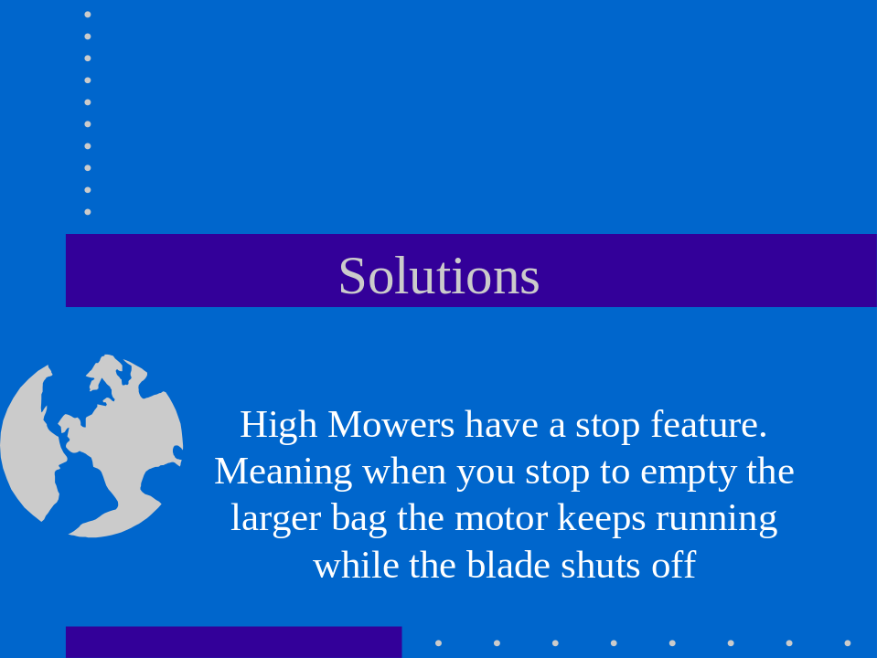




Team Activity --- Animal Industry

- Special note: Laptops may be used by team members for recording and presenting. LCD projectors are not allowed.

You have been hired to develop a strategy to prepare your company to sell a new product called Healthy Horse. Healthy Horse is a supplement (feed additive) that is mixed in the grain that promotes foot and joint health. There numerous horse feed additives on the market, however Healthy Horse is the first (only) product that promotes both joint and hoof health. With Healthy Horse the hooves stay moist and cracks heal faster, it also reduces joint inflammation, increases flexibility and reduces joint pain. This feed is very palatable and readily mixes with other grains.

Cost comparison:

3 lb tub of “HOOF CARE” $35.00
3 lb tub of “JOINT CARE” $55.00
3 lb tub of “HEALTHY HORES” $90.00.

Your team will have 25 minutes to prepare a presentation to the board of directors of the company who has developed Healthy Horse.

As the sales team, the following items should be taken into consideration:
- Determine potential customers
- Identify features and benefits
- Identify potential customer objections
- Identify related products
- Develop a sales plan and goals for each customer

Your team will have 10 minutes to present your plan to the board of directors and 5 minutes for questions.

Sales Tests



2003 National FFA Sales Career Development Event

“National Sales Test”

1. Which of the following would be considered as an objection?
A. I think your service is quite good
B. Why does the bill show $107.00
C. I can’t wait I need to talk with her today
D. When will it be in stock
E. All of the above

2. Reaching a compromise that is acceptable to both your organization and the caller would be a(n):
A. Action Issue
B. Objection
C. Statement
D. Negotiation
E. None of the above

3. Which of the following is an example of an open question?
A. Would you like Roundup Ultradry or Roundup Ultramax?
B. Do you grow corn and soybeans?
C. What are your crop rotation practices?
D. Will you attend our grower meeting?
E. None of the above

4. Which of the following is a form of nonverbal communication?
A. Eye contact
B. Posture
C. Gesture
D. Movement
E. All of the above

5. Closing is a _________part of the selling process, not a stand-alone technique.
A. Optional
B. Necessary
C. Fake
D. Hidden

6. Which of the following words can start an open-ended question?
A. Who
B. When
C. Where
D. Why
E. All of the above

7. You get _________chance(s) to make a great first impression?
A. Ten
B. Two
C. One
D. Five

8. In depth probing for the interview phase of the closing process will help you identify your buyers________:
A. Needs and Wants
B. Core information
C. Additional Needs
D. Concerns, Likes, and Dislikes
E. Both A & C

9. The following phase would be considered as a:
“Which means you’ll benefit by…”
A. Fact/Feature
B. Transition
C. Benefit
D. All of the above
E. None of the above

10. When you can not close on a sale you should always close on a future appointment to___________:
A. Close the sales
B. Bring a gift
C. Drop off your business card
D. None of the above

11. Which of the following is the first step of the closing process?
A. Ask for additional orders
B. Meet objections head on
C. Build rapport
D. None of the above

12. After you satisfy all objections during the closing process you should :
A. Build rapport
B. Meet objections
C. Ask open ended questions
D. Ask for the sale
E. None of the above

13. In handling customer complaints, the ‘Three F’s’ refer to”:
A. Forgot, forgive, forcast
B. Feel, Forgot, Forgive
C. Feel, Felt, Found
D. Forget, Forgive, Found

14. Which of the following is the best way to handle a difficult customer?
A. Show slight disgust on your face so the customer will know you consider him or her a problem.
B. Challenge the customer with your eyes.
C. Become distant and less communicative.
D. None of the above

15. Endorsement letters and intellectual proofs can consist of:
A. Charts and graphs
B. Statistical summaries
C. Vendor Endorsements
D. Consumer ratings and reports
E. All of the above

16. What is a product feature?
A. Answers the question, “What is it?”
B. A specific quality or characteristic of a product or service
C. Something you can see, feel, hear, smell, or taste.
D. Consumer ratings and reports
E. All of the above

17. Suggested Selling should not be done to:
A. Merchandise special
B. Larger quantities of the same item
C. Related Merchandise
E. push something on your customers that they do not want or
Need

18. When preparing to meet your customer, which of the following are important:
A. Wear appropriate clothing
B. Know the prices of the products
C. Show a positive caring respectful attitude
D. Be prepared
E. All of the above

19. Which of the following is true?
A. Salespeople should discourage objections
B. Few sales happen without customer objections
C. An objection is a barrier to completing the sale
D. Both B and C

20. Which of the following is false?
A. Objections show that customers are interested in buying, but that they lack certain information
B. A good salesperson must be able to show that value outweighs price
C. The salesperson should stress the value that exists in the mind of the customer
D. All are true
21. When your customers make objections, you should:
A. Listen carefully.
B. Show concern
C. Respect their opinion
D. All of the above

22. A hidden objection is defined as:
A. Details the salesperson is withholding
B. A sales presentation without disclosing the price
C. A customer’s reluctance to listen
D. A customer’s unspoken concern

23. Objections are overcome by:
A. Reviewing the advantages of the product or service
B. Offering clarification
C. Both A and B
D. Neither A and B

24. Skillful salespeople are
A. Problem solvers
B. Product pushers
C. Both A and B
D. Neither A and B

25. To make the buying decision easy for your customer, you must:
A. Use a sales presentation directed at their buying motives
B. Concentrate on the needs of your customer
C. Avoid discussing the price of the product
D. All of the above
E. Both A and B

26. The time to close a sale is when
A. The customer is loosing interest and the conversation is dragging.
B. You believe the customer’s needs have been determined and you have selected the right item to meet those needs.
C. You have discussed all the features and benefits of the product you sold to the neighbors.
D. All of the above

27. Which of these is a quality of good advertising?
A. It must grab people’s attention
B. It should be easy to read and visually pleasing
C. It should create a desire to buy
D. All of the above
E. Only A and B

28. You capture the reader’s attention in an advertisement in which portion of the ad?
A. Body
B. Headline
C. Subhead
D. Border

29. Which of the following criteria is not part of qualifying a prospect?
A. Do they have a need for your product or service
B. Do they have the authority to make buying decisions for the business
C. Do they have a college degree
D. Do they have the ability to pay for your product or service
E. All of the above

30. A buyer benefit is:
A. Anything that promotes the well-being of the buyer
B. Anything the buyer can see
C. Anything the buyer can feel
D. Anything the buyer can smell
E. None of the above

31. A point of purchase ad might be found
A. On a billboard
B. In a magazine
C. In the newspaper
D. In the supermarket

32. A name, symbol, or trademark designed for easy and definite recognition is called
A. A logo
B. An introduction
C. A headline
D. A corporate signature

33. The area of an ad receiving a high degree of attention is found slightly above and to the left of center. It is called:
A. The “Sweet Spot”
B. The “Focal Point”
C. The body
D. The subheading

34. In which order should a sales presentation progress?
A. Introduction, ask questions, offer features and benefits, ask for the order
B. Introduction, offer features and benefits, ask for the order
C. Introduction offer features and benefits, ask questions, ask for the order
D. Introduction, ask for the order, handle objections

35. The difference between an open ended and closed ended question is:
A. Open ended questions are only used at the beginning of the presentation
B. Closed ended questions are only used at the end of the presentation
C. Open ended questions encourage the customer to talk more
D. Both A and B

36. Closed ended questions are useful when:
A. The customer does not like to talk
B. You seek general information
C. Both A and B
D. Neither A or B

37. Stating a product’s feature should always be followed by:
A. Asking for an order
B. Asking the customer’s opinion
C. Offering a benefit for the customer that applies to the feature
D. All of the above

38. A good time to offer a closing question is:
A. When a customer asks about delivery
B. When a customer asks about payment terms
C. Both A and B
D. Neither A or B

39. The characteristics of a successful salesperson are:
A. Individuals who are more concerned about commissions than their prospects
B. Those who learn and then practice accepted sales techniques
C. Those who maintain a positive attitude
D. Both B and C
E. All of the above

40. Some of the common personality characteristics found in successful sales people are
A. Ambitious
B. Strong and forceful
C. Easily frustrated
D. Domineering
E. None of the above

41. Most customers decide to buy by asking questions. How should questions be handled?
A. By giving answers that emphasize only the positive aspects of the product
B. Always emphasize that the product being asked about is the best product for their needs but don’t question their needs
C. Discourage questions that you do not know the answer to
D. All of the above
E. None of the above

42. An example of related selling is:
A. Selling a printer along with a personal computer
B. Selling ground meat along with a sweater
C. Offering a free car wash with a purchase of new tires
D. Offering free paper with a printer
E. None of the above

43. Name several sources of referrals:
A. Cold Calls
B. Direct Mail
C. Referrals from prospects that said no
D. None of the above
E. All of the above

44. Nonverbal communication is defined as:
A. Loud talking
B. Telephone conversations
C. Any direct communication we have other than words
D. None of the above
E. All of the above

45. Prospects should be prioritized. How should they be prioritized?
A. By the amount of potential business they represent
B. In the order the calls were received
C. In order of e-mail responses received
D. Both B and C
E. None of the above

46. What could cause a customer to become upset?
A. Achieving maximum customer satisfaction
B. They have expectations that have not been met
C. Functioning in an abstract environment
D. Viewing related projects
E. Processing integral information

47. When calming upset customer’s phrases, what phrases should be avoided?
A. I can’t
B. What’s your problem
C. It’s not my job
D. None of the above
E. All of the above

48. Customers want to be:
A. Disrespected
B. To be put off
C. To be taken seriously
D. To be ignored

49. After an upset customer has left what should you do?
A. Forget the incident and return to work
B. Review the incident
C. Punish the employee who created the problem
D. Notify the sheriff’s department
E. Non of the above

50. When a customer makes an excuse during a buying decision they are:
A. They are stalling the decision
B. They do not want to buy the product
C. They want to buy the product but make you lower the price
D. They are going to buy the product

51. The best Career Development Event the FFA has to offer is:
A. Agriculture Sales
B. Agriculture Sales
C. Agriculture Sales
D. All of the above

National Sales Test 2003
Answer Key

1 | C |  | 28 | B
2 | D |  | 29 | C
3 | C |  | 30 | A
4 | E |  | 31 | D
5 | B |  | 32 | A
6 | E |  | 33 | B
7 | C |  | 34 | A
8 | E |  | 35 | C
9 | B |  | 36 | A
10 | A |  | 37 | C
11 | C |  | 38 | C
12 | D |  | 39 | D
13 | C |  | 40 | A
14 | D |  | 41 | E
15 | E |  | 42 | A
16 | D |  | 43 | E
17 | E |  | 44 | C
18 | E |  | 45 | A
19 | B |  | 46 | B
20 | D |  | 47 | E
21 | D |  | 48 | C
22 | D |  | 49 | B
23 | C |  | 50 | A
24 | A |  | 51 | D
25 | E
26 | B
27 | D

National FFA Ag Sales CDE- October 2004
Written Test

1. You just received a phone call offering you a customer service job for a retail store. The following items are important factors in dealing with upset customers. As you prepare to start your job select the first three areas you need to address from the list below.
- Type of transaction
- Nonverbal communication skills
- Personal Presentation
- Knowledge of company policy
- Customers name
- Review the customer encounter

a.1, 2, &3
b. 5, 4, & 2
c. 3,6,& 4
d.2, 3, & 4
e. none of the above

2. You are a customer service representative for a retail store. You recognize Ms. Johnson from previous visits to the store. She approaches you and states she has a complaint. What should you do at this point? Select all of the appropriate actions from the list below.

- Call for manager
- Ignore her due to her many complaints
- Speak with a calm and caring tone
- ask what is the complaint
- Greet Ms. Johnson by name
- Maintain a straight, open body posture
- Due to many complaints ask her to leave
- Listen attentively

A 2, 4, 7, & 8
B 3, 4, 5, 6, & 8
C 8, 7, 5, 2, 3 &1
D 2, 7, 3, & 4
E None of the above

3. After dealing with an upset customer one should:
- Forget about the incident
- Take the customer’s comments personally
- Tell your coworkers
- Review the incident
- None of the above
4. What are some of the questions you should answer before a face-to-face appointment?
- What do I know about the prospect’s organization?
- What is my objective with this appointment?
- When is the next company sales meeting?
- Both a & B
- None of the above

5. When you first call or meet a woman who is a prospect, how should you address her?
- Mrs.
- Ms.
- Miss
- By her first name
- None of the above

6. You make an error as a salesperson you should:
- Be honest with the customer
- Ignore the error if you feel the customer probably will not discover it
- Do not tell the customer
- Transfer the issue to a customer service specialist
- None of the above

7. You are meeting a new customer in a cold call situation. During the call, you sell the customer 300 lbs. of rib eye steak. Your company currently is introducing a new line of steak seasoning. Since this is a new customer which of the listed actions is the best approach?
- Not attempt to sell the steak seasoning since it is your first contact.
- Ask open-ended questions about how the customer plans to season the steaks
- Boldly state the steaks require an additional purchase of seasoning
- State to the customer about how superior your product is over their current choice
- None of the above

8. When first meeting a prospective customer some of the important thing that you should do are:
- Establish rapport
- Get their attention
- Qualify the prospect
- None of the above
- All of the above

Use the following information to answer questions #9-#11.

Your ranch offers the following tours:

Product: Wildlife walking tour Product: Wildlife hiking tour
Features: Two (2) miles in length Features: Five (5) miles in length
Easy walking Extensive Climbing
Many Elk, birds, and buffalo Many elk, deer, and buffalo

Product: Short Wildlife bus tour Product: Wildlife bus tour
Features: Two (2) hrs in length Features: Six (6) hours in length
Many antelope, deer, and birds Many elk, deer, and waterfowl
Includes lunch at a historic mining area

9. A customer calls and requests information on your tours. Which of the following questions would be applicable and acceptable to identify your potential customer’s needs and wants?
- Can you walk?
- How much do you want to pay?
- Do you want to pay by credit card?
- All of the above
- None of the above

10. This is your customer’s information:
-An experienced hiker and climber
- Interested in antelope and birds

What should you do now as a salesperson?
- Try and sell the wildlife hiking tour
- Try to sell the short wildlife bus tour
- Ask questions to further define customer’s wants
- Try and sell the wildlife bus tour
- None of the above

11. This is your customer’s wants:
- Interested in deer and elk
- Physically handicapped

Which product would you recommend to your customer:
- Wildlife walking tour
- Wildlife hiking tour
- Short wildlife bus tour
- Wildlife bus tour
- None of the above

Use the following information to answer questions #12 thru #14.

Mr. Jones calls and complains that the birdseed he purchased had spoiled. He went on to say that the seed was moldy and the birds would not eat it. He is very upset and normally a good customer. He states he purchased the seed approximately four weeks ago.

12. Should you automatically offer to replace the birdseed?
- Yes
- No

13. If you offered to replace the birdseed what was your reasoning for doing so?
- Mr. Jones is a good customer
- The relative cost of the birdseed is low and it would be better to keep a good customer
- We automatically knew the problem was our fault
d. Both A & B
e. None of the above

14. If you offered not to replace the birdseed what was your reasoning for doing so?
- It was purchased too long ago to replace
- The customer was to upset to deal with
- Due to the amount of time since the seed was purchased,
more information was required before a decision could be made.
- Both A&B
- None of the above

15. Involve the customer in the sales demonstration to:
- Demonstrate specific benefits of interest to the customer
- Help the customer develop a sense of ownership
- Get the customer to answer questions to determine additional needs and wants
- All of the above
- None of the above

16. Suggestive selling is:
- Suggesting products that relate to the original purchase
- Suggesting unrelated products
- Selling products that the customer doesn’t need
- All of the above
- None of the above

17. When you start the selling process you should be ready to close:
- At the end
- After you discuss price
- At any time
- All of the above
- None of the above

18. Every customer has objections. You should be prepared to address objections by:
- Ignoring them
- Selling suggestive products
- Having a complete knowledge of the product/products you are selling
- All of the above
- None of the above

19. To get the applicable information, you should ask which type of questions in a sales call:
- Close-ended questions
- Open ended questions
- Interviewing questions
- All of the above give you in-depth good information
- None of the above.

20. Most people have poor listening skills, which of the following are
examples of poor listening skills?
- Criticizing the speaker
- Tuning out difficult or confusing information
- Tolerating or creating distractions
- Both a and b
- All of the above

21. being punctual for a sales appointment
- Builds trust
- Allows you to relax and prepare
- Shows respect for your customer
- Demonstrates that you are professional
- All of the above

Use the following information to answer question 22.

You are selling flea and tick products for dogs and cats. You drive past a veterinary office and supply store that you have never been to before. They list five veterinarians on the sign, you decide to stop in and see if they currently use any of your products or would like information on your products.

22. This type of call is considered:
- Follow-up call
- Cool call
- Delayed call
- None of the above

23. Upon meeting Dr. Stoner, you learn he is interested in hunting dogs. You have a product that works great for outdoor dogs. Upon meeting Dr. Stoner your most appropriate response would be which of the following:
- Ask dr. Stoner what he is currently recommending so that you can complete product comparison sheet.
- Provide Dr. Stoner with a free product sample of an indoor dog product
- Provide Dr. Stoner with tickets to Friday nights high school football team
- All of the above
- None of the above

24. Dr. Stoner suggests a meeting with the other vets in the clinic. Your most appropriate response is:
- Bring them out here
- What day of the week and time of day works best
- What would you like for me to cover
- I’m not interested in meeting them
- Both b and c

25. Dr. Stoner has a complaint about your competitor. He tells you they never show up on
time, never follow-up on his request and he doesn’t ever care if he sees them again. Your
most appropriate response is:
- I agree they are worthless
- I can’t speak to their behaviors; however, I can promise I’ll do everything I can to be here on time and follow-up on all of your requests
- Join in and speak negatively about your competition, their products don’t work either
- Ask about his expectations and interest in a pharmaceutical company
- Both b and d

National FFA Ag Sales CDE- October 2004
Written Test – KEY

Multiple Choice

  - D
  - B
  - D
  - D
  - B
  - A
  - B
  - E
  - E
  - C
  - D
  - B
  - D
  - C
  - D
  - A
  - C
  - C
  - B
  - E
  - E
  - C
  - A
  - E
  - E

National 2005 Sales Written Exam

1. A feature-benefit sales presentation is based on ____________? (Ditzenberger, p. 159
a. Customer credit rating
b. High margin products
c. Needs and wants of a customer
d. None of the above
e. All of the above

2. Which of the following is the most important skill when dealing face to face with a customer?
a. Dress
b. Listening skills
c. Socio-economic status
d. Previous purchase
e. All of the above

3. Determining customer’s needs and wants is very important. Which of the following will help you determine them? (Ditzenberger, p.48)
a. Analyze a customers responses and comments
b. Ask the customer questions
c. Observe the customer’s reaction
d. None of the above
e. All of the above

4. Mr. Jones comes into your greenhouse to purchase cut flowers for his wife.
Using suggestive selling which of the following products would you recommend?
(Ditzenberger, p.47)
- Peat moss
- Vase
- Compost
- Plant warmer
- None of the above

5. Which of the following is a product feature? (Ditzenberger, p.161)
a. 12 gallons per minute
b. Excellent description
c. Hydrostatic transmission
d. Both A & C
e. All of the above

6. While Mr. Jones is at your greenhouse he stops and looks at the nicely landscaped entrance. What should you do?
a. Wait for Mr. Jones to come in
b. Go out and sell landscaping services
c. Go and ask Mr. Jones if he has found something of interest
d. None of the above
e. All of the above

7. Mr. Jones calls you to complain that the tomato plants that he bought died
even before she could plant them. Which of the below is your best response
to him? (Morgan, p. 27)
- You should have watered them more
- You should have called me sooner for help
- You can bring them in and we will replace them
- Ask him the purchase and planting date
- All of the above

8. You work for XYZ nursery. You receive a phone call for your manager.
How do you most professionally say he is unavailable? (Finch, p.54)
- I’m sorry, he is at lunch
- He went home early
- He is not in yet
- He is in the midst of major problems, would you like to leave a message
- None of the above

9. An upset customer comes into your nursery upset about the quality of your
products. What response is your customer looking for from you?
- To be taken seriously
- To be respected
- To get immediate action
- To clear up the problem to never happen again
- All of the above

10. Which of these is an attribute of a successful salesperson? (Morgan- Professional Selling, p.3)
a. Commitment
b. Effective listening skills
c. A health ego
d. A and B
e. A, B and C

11. A salesperson finds prospects by (Morgan-Professional Selling, p. 9-10)
a. Yellow pages
b. Current customers not purchasing all products from you
c. Referrals from prospects that said no
d. Competition
e. All the above

12. A good plan for a telephone cold call includes (Morgan-Professional Selling,
p. 18)
a. Having a clear objective before calling
b. Writing down notes about what you know about the prospect
c. Both a and b
d. Neither a or b

13. The receptionist of a prospect (Morgan-Professional Selling, p. 18-19)
a. Can provide guidance to help you find the appropriate person in the organization
b. Has great influence in whether you have access to the person you are trying to reach
c. Should hear your sales presentation before you ask to be transferred
d. Both A and B
e. A, B, and C

14. Some good rules to use when making a first telephone call to a prospect includes (Morgan-Professional Selling, p. 20)
a. Waiting until you know the prospect’s needs before placing the call
b. Get permission before asking questions
c. Verify the person you are talking with is the decision maker
d. Both b and c

15. Which of these if the proper way to ask if your call is at a good time for the prospect? (Morgan, Professional Selling, p. 20)
a. Do you have a minute?
b. Are you in the middle of something important?
c. Are you in the middle of something urgent?
d. All of the above

16. Objections demonstrate (Ditzenberger, p. 197)
a. A customer is interested in buying but they lack information
b. Complete lack of success by the sales person
c. That the salesperson has been rejected
d. Both B and C
e. All of the above

17. Which of the following is a key component to cause buyers to actively participate in the selling process with a salesperson? (Thornton, p. 7)
a. Cheap price
b. Reservations
c. Feeling of trust and rapport
d. All of the above
e. None of the above

18. Which of the following is an open-ended question? (Thornton, p.44)
a. How would this make the loading of the grain faster?
b. Would this work for you?
c. Do you want to buy?
d. All of the above
e. None of the above

19. In preparing for a face to face sales call, you ask yourself the following questions (Morgan-Professional Selling, p. 31)
a. What do I know about the prospect’s organization
b. What questions do I need to ask
c. What products do I think the prospect should be interest in?
d. A and C
e. A, B, and C

20. Anticipating a prospects objections (Morgan-Professional Selling, p. 32)
a. Should be avoided because it reinforces negative thinking
b. Prepare you with positive responses
c. Are usually a poor use of time
d. Both A and C

Match the following statements with the corresponding letter.
21. Mr. Johnson, our hydroponics tomatoes
will produce 15-20 lbs. per plant.
A. Product Benefit
B. Objection
C. Probing Question
D. Trail Close
E. Product Feature
22. Mrs. Clark, what color pattern are you
looking for in your garden?

- Mr. Davis, our pruning tools are ergonomically
sound which mean you can garden longer
with less pain.

24. Mrs. Smith, will these fertilizer benefits
work into your lawn fertilizer program?

25. Mr. Jones, this Christmas tree is just what
I am looking for, however, I don’t seem to
have a way to get it home

National FFA Agricultural Sales CDE
2005
Exam Key

- C
- B
- E
- B
- D
- C
- D
- A
- E
- E
- E
- C
- D
- D
- C
- A
- C
- A
- E
- B
- E
- C
- A
- D
- B

Agricultural Sales

Chapter: ___________________________ State: ______________________

TEAM SALES SITUATION

CATEGORY | POSSIBLE | SCORE
Teamwork Evaluation  - Leadership roles easily perceived  - Participation by each member of the team  - Members demonstrated effective listening and communication skills | 50
Analysis of the Information  - Clearly identify the product features and the market for that product  - Provided information and data is analyzed  and utilized  - Demonstrated the use of basic sales skills | 40
Quality of the Team’s Solution  - Identify sales goal for each customer and/or market segment  - Identify the key benefits of the product  - Identify potential customer objections and develop strategies to address them  - Possible solutions are discussed and analyzed  - Justify decisions | 70
Presentation  - Presents team’s solution  - Overall delivery professional and well  thought out  - Presentation is clear and effect | 20
Questions are Taken From:  - Teamwork evaluation  - Analysis of the information  - Presentation | 20
Total score: | 200

Judge’s Signature: _____________________________ Date:_______________

Agricultural Sales

Name: Contestant No.:

Chapter: _________________________ State: _______________________

SALES CALL

CATEGORY | POSSIBLE | SCORE
Pre-call Planning  - Anticipating customer needs(5)  - Product Knowledge (10) | 15
Approaching the customer  - First impression  - Create Customer Attention  - Establish Rapport | 10
Determining Customer’s Wants and Needs  - Ask Leading Questions  - Demonstrate good listening skills | 15
Demonstration  - Product Features and Benefits relevant to customers wants  - Allow Customer to Participate | 20
Customer Objections  - Identify Customer Objections  - Handle Customer Objections | 20
Closure  - Confirming Customer Interest trial close  - Recognize Closing Opportunities  - Ask for a buying decision | 20
Total score: | 100

Judge’s Signature: _____________________________ Date:_______________

Agricultural Sales

Name: Contestant No.:

Chapter: ___________________________ State: __________________

CUSTOMER RELATIONS ACTIVITY

CATEGORY | POSSIBLE | SCORE
Introduction  - Identify yourself  - Purpose of call (if applicable)  - Establish Rapport | 10
Attitude  - Pleasant  - Friendly  - Professional  - Empathetic | 20
Information via Customer Interaction  - Probing to Determine the Problem  - Clarify the Problem | 25
Develop Solution  - Evidence of Product Knowledge  - Overcome customer objections | 30
Closing  - Get customer agreement  - Review and closure | 15
Total score: | 100

Judge’s Signature: _____________________________ Date:_______________

Agricultural Sales
Name: Contestant No.:

Chapter: ___________________________ State: __________________

ORDER TAKING/CUSTOMER SERVICE PRATICUM

CATEGORY | POSSIBLE | SCORE
Introduction  - Identify yourself  - Establish rapport | 10
Attitude  - Pleasant  - Friendly  - Professional  - Empathetic | 20
Clarify  - Repeat each item  - Include product numbers (if appropriate)  - Confirm availability | 30
Suggestive/consultative selling  - Suggest related products  - Note items on special  - Offer substitutes for no stocks | 25
Close the order  - Repeat the order  - Ask for other needs  - Confirm delivery date | 15
Total Score: | 100

Judge’s Signature: _____________________________ Date:_______________

Agricultural Sales

Name: Contestant No.:

Chapter: ___________________________ State: __________________

PROPECTING FOR NEW CUSTOMER

CATEGORY | POSSIBLE | SCORE
Introduction  - Clearly yourself  - Establish rapport | 10
Attitude  - Pleasant  - Friendly  - Professional  - Empathetic | 20
Qualify the prospect  - Probing for customer needs  - Demonstrate good listening skills | 25
Provide features and benefits  - Describe features and benefits appropriate to the prospects needs | 25
Closing  - Ask for a buying decision, i.e., the order or appointment  - Reviewing the order or commitment | 20
Total Score: | 100

Judge’s Signature: _____________________________ Date:_______________

